ABOUT WATERCOLOUR PAPERS

Although modern watercolour papers may be made from all sorts of exotic materials, we may, for our purposes, divide watercolour papers into two main groups:
“It is more important to use artist’s quality paper than artist’s quality paint”.
Jim Sampson, Durham based artist.
Artists’ quality papers made from 100% cotton fibres (known as 100% rag). This makes them hard wearing and capable of handling rough treatment.
Students’ quality papers made using a proportion of wood pulp. They are softer and more prone to damage as a result. The term “wood-free” may be used to describe a student paper, this generally means that it is acid free, but contains wood pulp!

Terms used by paper manufacturers:
- Hot Pressed – this is a smooth finish, very good for line and wash, and for fine detail.
- NOT – stands for “not hot pressed” and has a noticeable surface texture. Texture is known as “tooth” in respect of papers. NOT papers are called “cold pressed” in the U.S.A.
- Rough – texture is as the name suggests.
- Deckle Edge – a rough, possibly torn, edge which is the result of hand making a paper or representing a paper to look like a handmade one.
- Ream- 480 sheets (imperial ream) or 500 sheets (metric ream)
- Size/sizing – essentially the glue that holds together the fibres of the paper, size has become more sophisticated and papers are surface or tub-sized to affect the way in which they accept paint. Tub sizing means the paper is sized on both the surface and internally. Received wisdom states that one should hold up the paper to the light to read the watermark. If the writing is the right way round then this is the side to paint on. But most papers are tub sized nowadays so, within my experience, it matters little which side you paint on.
- Blocks- pads glued on four sides with a tiny unglued section to allow removal of the sheet by inserting a blade and running it around the perimeter. Gives some resistance to cockling when wet.
- Cockling -buckling of the paper when wetted
NOTE: Finishes vary between makers. One maker’s NOT may be rougher than another’s Rough.

Weight
Watercolour papers are further defined by their weight. The imperial system quotes the weight of an imperial ream of full imperial size papers (imperial = 30” X 22”). The metric system quotes weight in grams per square metre (gsm). The conversion between the two is imperial= metric X 0.47 (accurate to two decimal places).
Imperial weight- 90lb 140lb 200lb 300lb
Equivalent metric weight 190gsm 300gsm 425gsm 640gsm

Buying Paper
The cheapest way to buy paper is in full imperial size sheets. Suppliers on the web or mail order will normally cut them to half or quarter imperial for free – check instructions in catalogue/on site. There will be a minimum order restriction if buying full imperials sheets via mail order.
A quick look at a mail order catalogue (Ken Bromley Art Supplies Issue 40, Spring/Summer 2013) gives the following price comparison for ten square inches of Bockingford 140lb paper (postage is ignored).

Full Imperial Spiral Pad 10” X 14” Gummed Pad 10” X 14” Block 11” X 15”
2.42p 5.58p 5.30p 4.98p

These prices are for comparison only. Your local art shop will probably charge differently, will not be able to carry stocks of every paper known to artist kind, but should be able to supply single sheets of a number of full imperial papers

Other Papers
We can paint on a great variety of papers, cartridge paper for example. Pastel paper, Bristol board, handmade (including exotics such as Indian papers with fibres or flower petals visible), even rice paper – all have been used for watercolour.
It is interesting to experiment with strange papers, but some may need sizing. Gelatin is a good size, but if you mix up a quantity and leave it bottled up for any length of time, it will smell appallingly. Wall size from the local D.I.Y. store (used for sizing walls before papering) seems to work well and contains a fungicide to protect your art work.

Stretching Watercolour Paper

We stretch watercolour paper to counter the effects of water on the fibres of the paper. When paper is wetted the fibres expand and we often encounter the familiar corrugations of cockling.
Received advice is that stretching is necessary for lightweight papers only, but I tend to stretch any weight of paper even the 300 lb weights, which are almost as thick as cardboard.

Basic Needs

To stretch watercolour paper effectively you will need:-
- Paper – do not try to work without this, it’s absolutely essential.
- A board – you can use anything suitable. Recently I have favoured thick MDF, for no better reason than that I had some left over from some diy that I completed. Plywood, chipboard and all manner of strong backing boards are acceptable BUT hardboard and thin ply will bend when the very substantial forces that are generated when the paper dries take effect. Your chosen board should suit the size of your paper and your method of fixing the paper to the board.
- Water
- Kitchen towel – some recommend sponges, but I am suspicious of them absorbing gum over time and then transferring it to the surface of the watercolour paper.
- Fixing material- either gummed paper from an art supplier or, my preferred method, a stapler and staples

An alternative to this is a commercial stretcher.

The Procedure

Using a homemade board:

The board: cut your board to suit your paper and chosen method. Most of us use ¼ imperial size paper (15” X 11”) for the majority of our painting, so-
- If you are using a stapler to fix paper to board cut a little over the size of ¼ imperial sheet say 15 ½” X 11 ½”.
- For gummed paper fixing allow an inch all round, say 17” X 13”.

Soak the paper: The best way is to drop the sheet(s) into a bath and cover with about 2” of cold water (warm/hot water will remove the size from the paper and you will come back to a bath of grey porridge).
As a guide- allow one minute soaking time for every ten full pounds in weight of the chosen paper so a 140lb paper allow about 10 to 14 minutes soaking, 200lb allow 20 minutes.

Cut Gummed paper:
- Measure off lengths of gummed paper equal to the four sides of your watercolour paper i.e. 2 X 15” strips and 2X 11” strips for ¼ imperial size of paper.
- Using a stapler? Just check you have staples available.

Let the paper drip: Hold the paper by one corner and allow it to drip. When it stops, place it flat on your board.

Dry the paper’s surface: Lay kitchen paper towel over the entire surface of the wet paper, gently pat it dry- don’t rub/scrub with the kitchen paper.

Fix the paper to the board:
- Scrunch up the paper towel and dip in water, squeeze out excess water. Lay a strip of gummed paper shiny (gummed) side up and moisten with the paper towel. I find it best if the gummed paper is just tacky to the touch, the important thing is to ensure that you do not remove all the gum with a soaking wet wad of paper. Lay the gummed strip shiny side down on the edge of the paper allowing half the width on the paper and half on the board. Smooth out with the paper towel from the centre outwards. Repeat for the other three sides.
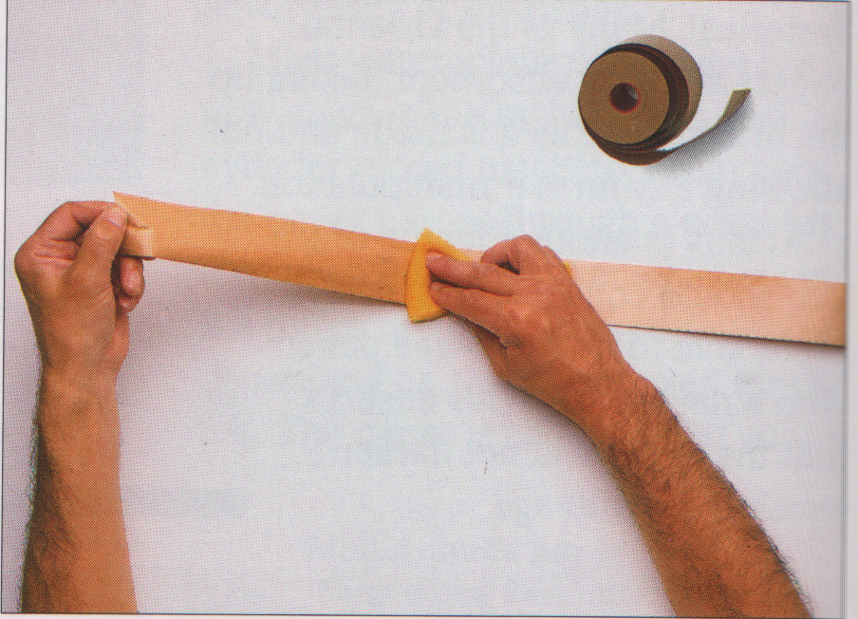
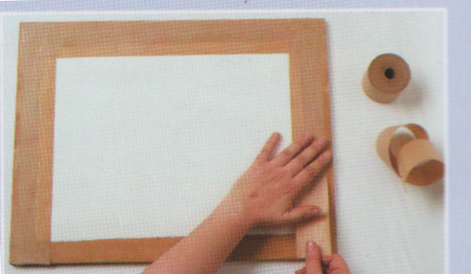

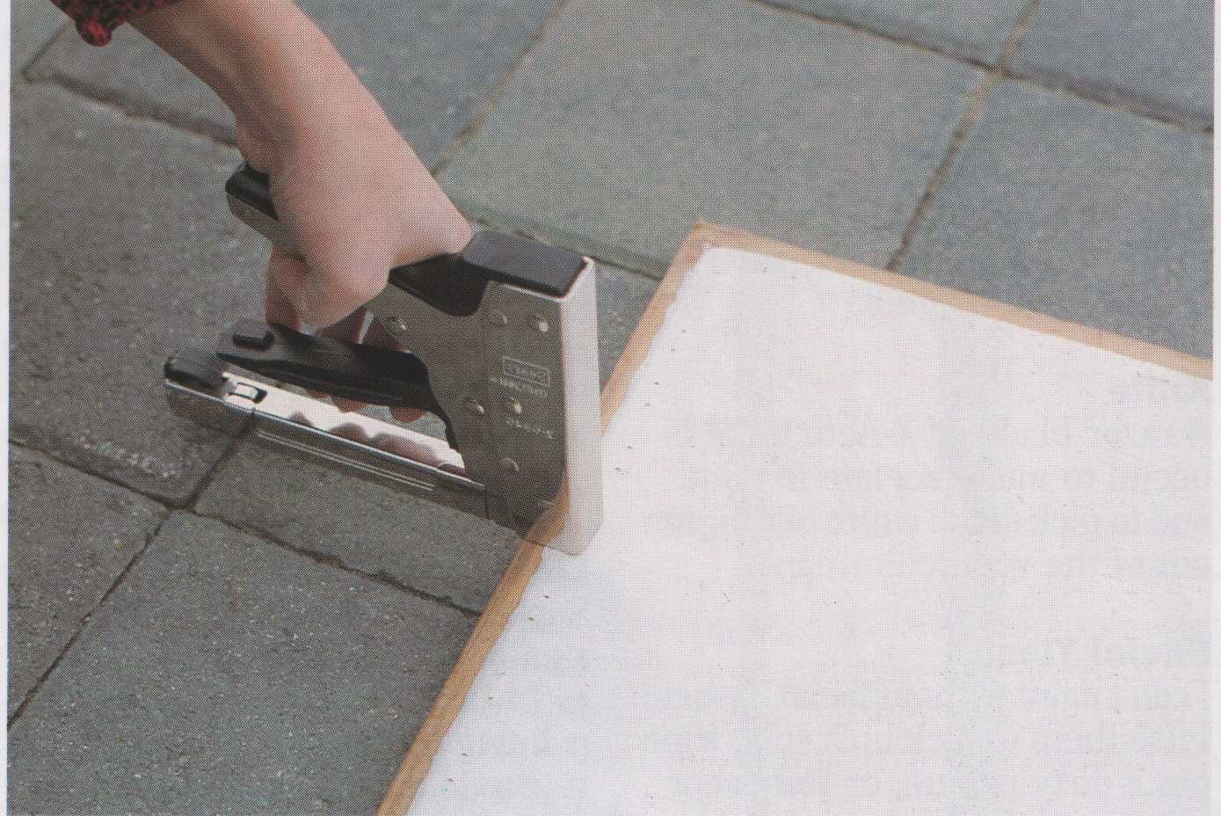

- Staple the paper to the board. Use a staple every 2” (or a little less) and come in from the edge of the paper ½” or a little more. When the paper dries, some impressive forces will be generated so don’t skimp on staples, they are cheap, a ruined paper is not.

Dry out the paper:
- For gummed stretching you should dry out the paper overnight. It is important that you lay the paper flat – under the bed in the spare room is ideal- if the board slopes, water will creep down under one side and lift the gummed strip, ruining your efforts.
- Stapled papers can be stored overnight upright to dry or dried with a hairdryer if you are in a hurry. It’s actually quite difficult to dry a paper completely with a hairdryer when it has been absolutely soaked, so the best advice is give a night to dry out.

That’s it, start painting your masterpiece.

A word about the images above. It’s a long time since I did the first version of this info-page and I think that the photos are my own, but if you know differently, please let me know via the contact form and I will apologise and replace them if you own the copyright on them and object to their use.

Commercial Paper Stretchers

All commercial stretchers work on the same principle as gummed strip and stapling, i.e. soak paper, present to board, fix around all edges to stretch paper as it dries. Some are better than others for a number of reasons, but all have advantages and disadvantages:-
- The Keba Artmate is very effective, but is dearer than the alternatives.
- Jacksons Art Supplies have produced a version similar to the Keba. It is simpler in design and lacks the patented features of the Keba .
- The Ken Bromley is quite popular and has been around for a long time..

All commercial stretchers have one thing in common, they can only handle the size of paper they were designed for. You can stretch an A4 piece of paper in the middle of a board if you fix with gummed strip or staples but if you buy a commercial stretcher of ¼ imperial size it will only handle ¼ imperial papers and no other. The Keba is reasonably versatile and different stretchers can be combined in a variety of ways, but this requires buying more than one stretcher and a bit of ingenuity.

