Butterfly on Flower
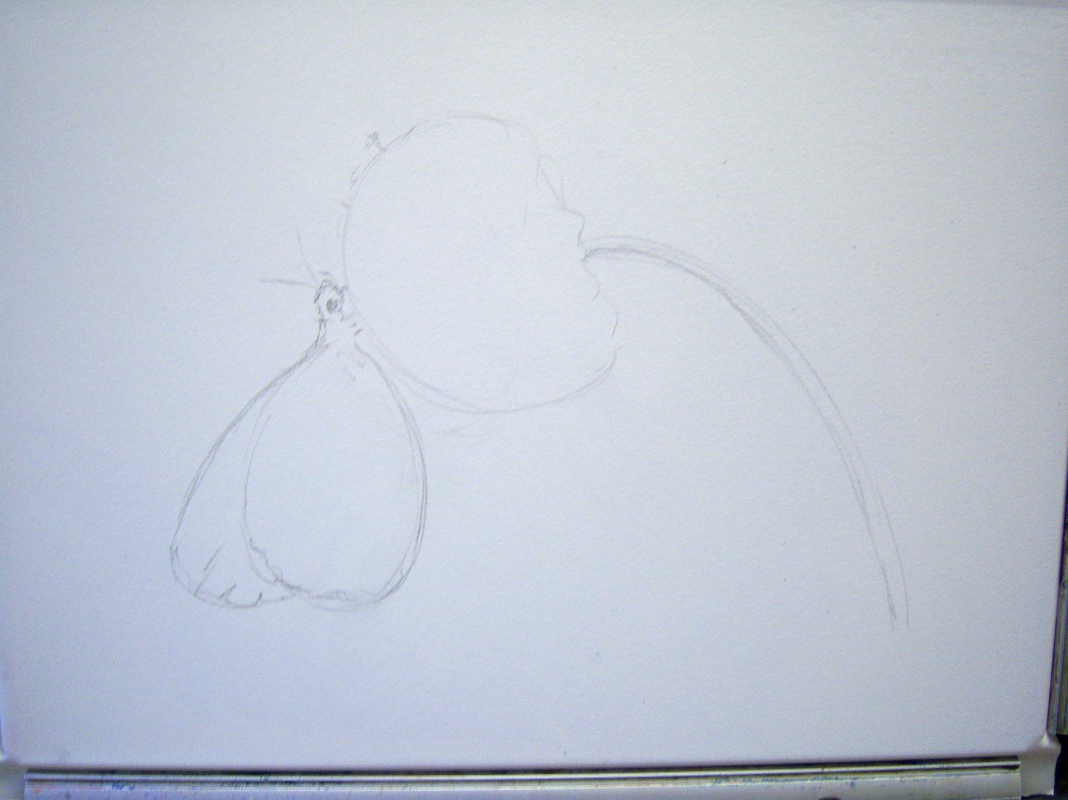
Watercolour
The first decision was how to present the composition. It was decided to try a study; that is, omitting the background to see if this gave the image more impact.
The first stage proper was to sketch in the shapes very simply in pencil.
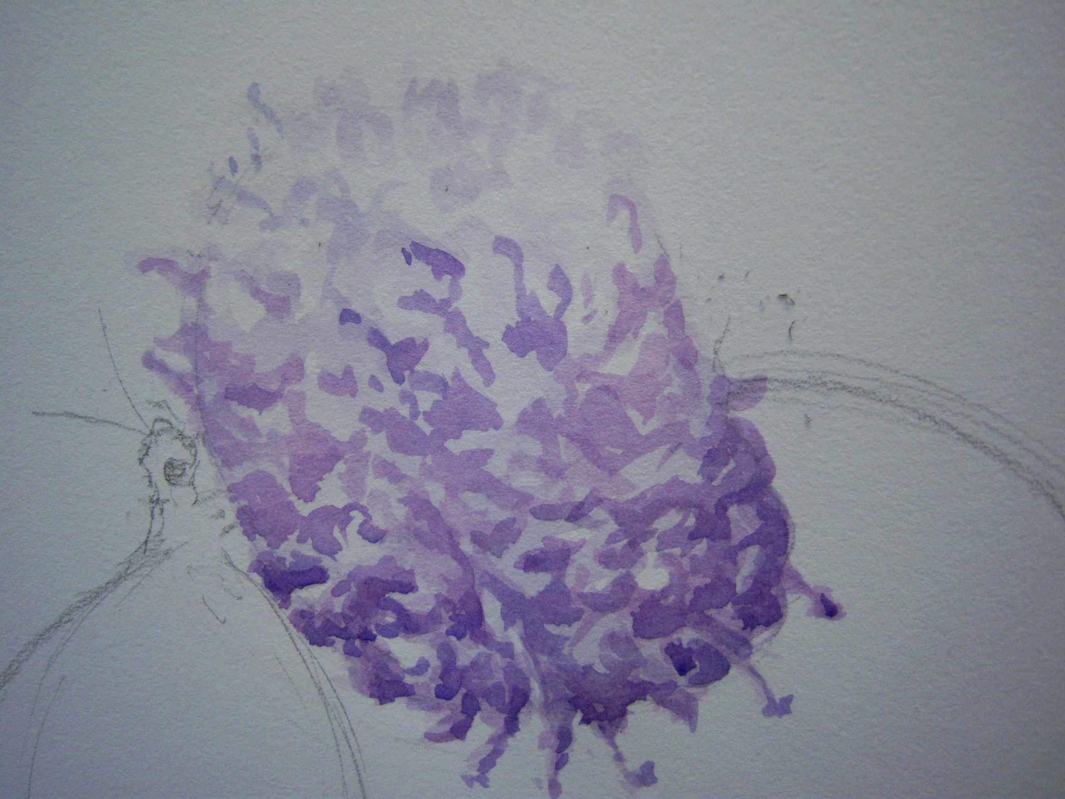
The palette was Cobalt blue, manganese blue, raw sienna, burnt umber, permanent rose and light red. Alternatives are- for cobalt blue use ultramarine; for manganese blue, cerulean; raw sienna, yellow ochre; burnt umber, raw umber or Van Dyke brown; permanent rose, alizarin crimson; light red, burnt sienna.
Stage two: the bloom was simply indicated with a mix of manganese and permanent rose. Paint was applied in marks to indicate the contours of the flower and then a moist brush was used to drag the pigment towards the top of the flower. Once dry, a stronger mix of cobalt and permanent rose gave a deeper tone which was then used to create darker contouring.
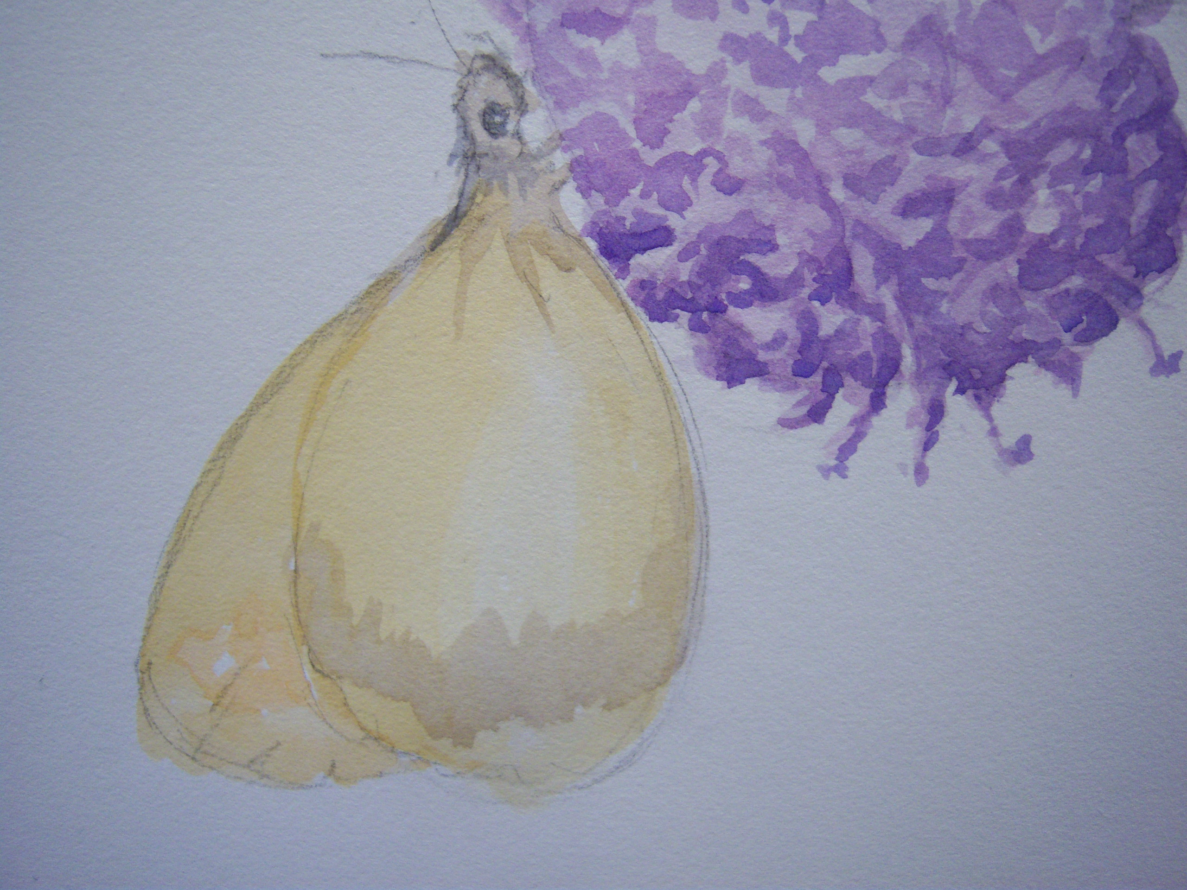
The butterfly was blocked in using raw sienna with a touch of burnt umber. The grey on the wings was indicated with a mix of burnt umber, cobalt blue and permanent rose and the brighter mark on the wing to the left was indicated with a thin mix of light red on its own.
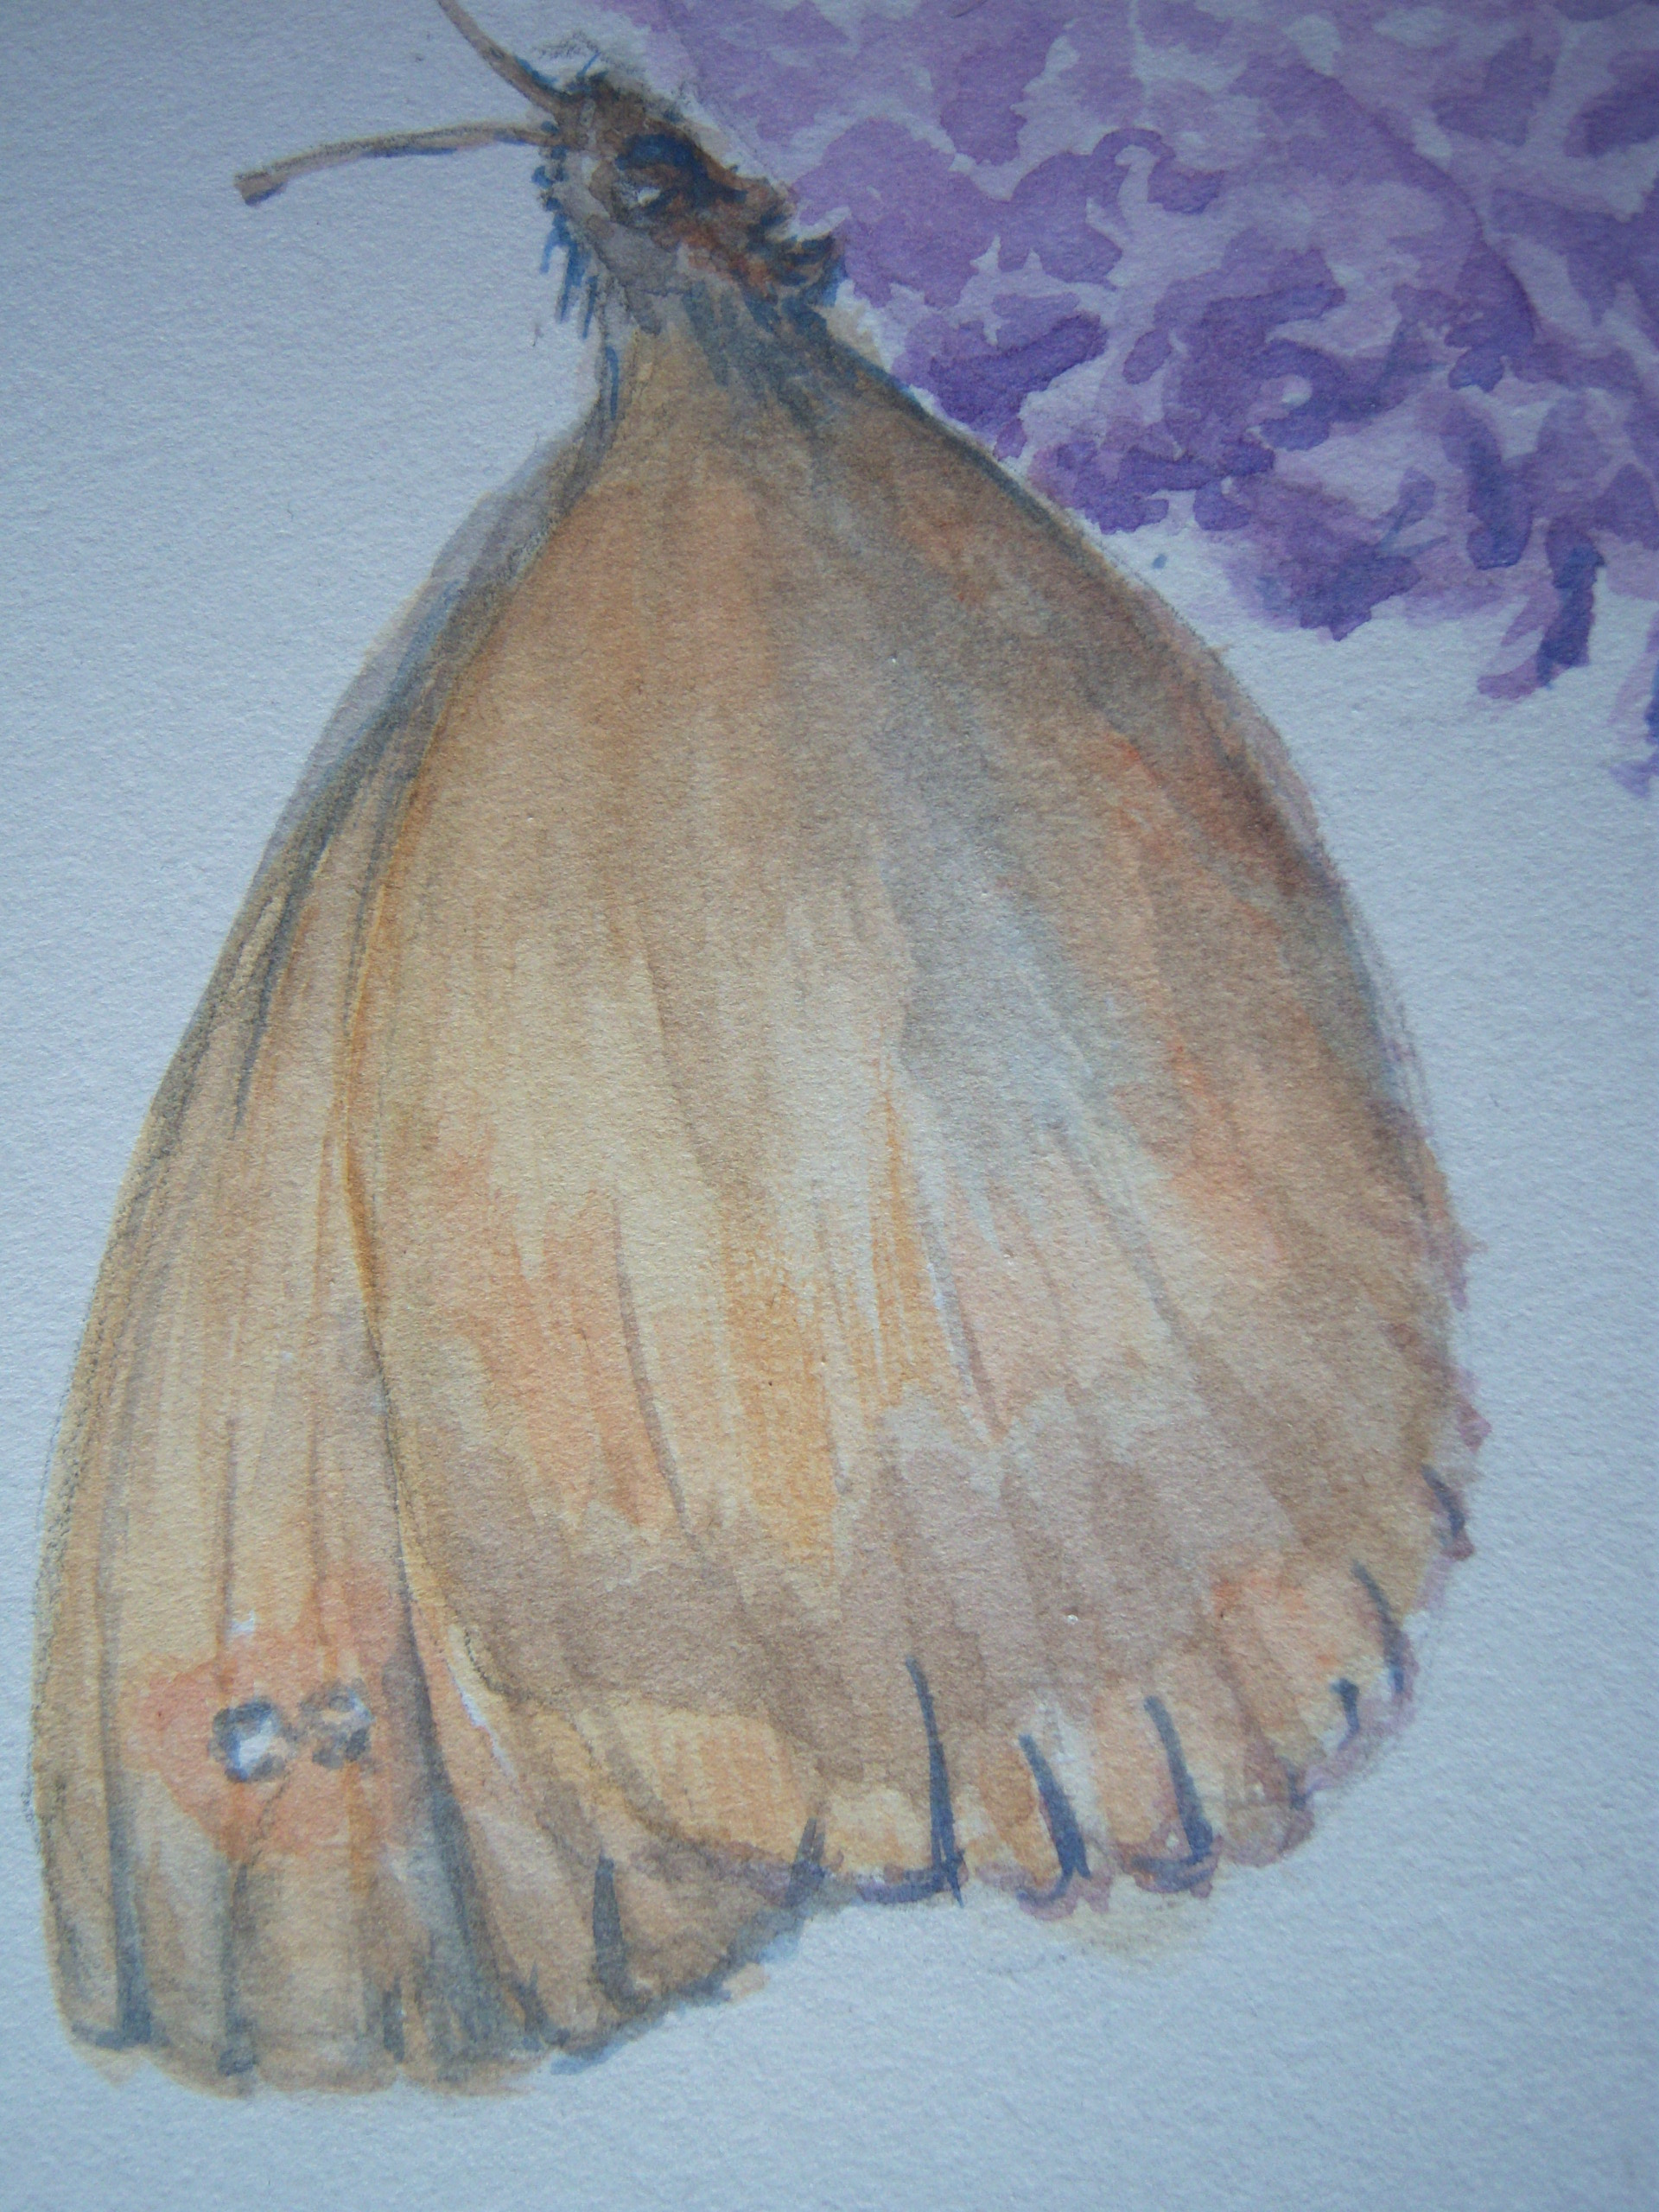
The grey was painted over for the insect’s body and pulled into the wing with a moist brush.
The wings were detailed and interpreted with the colours already mixed. Generally a mark was made and then modified with a moist brush to blend into the wing and create a more natural look.
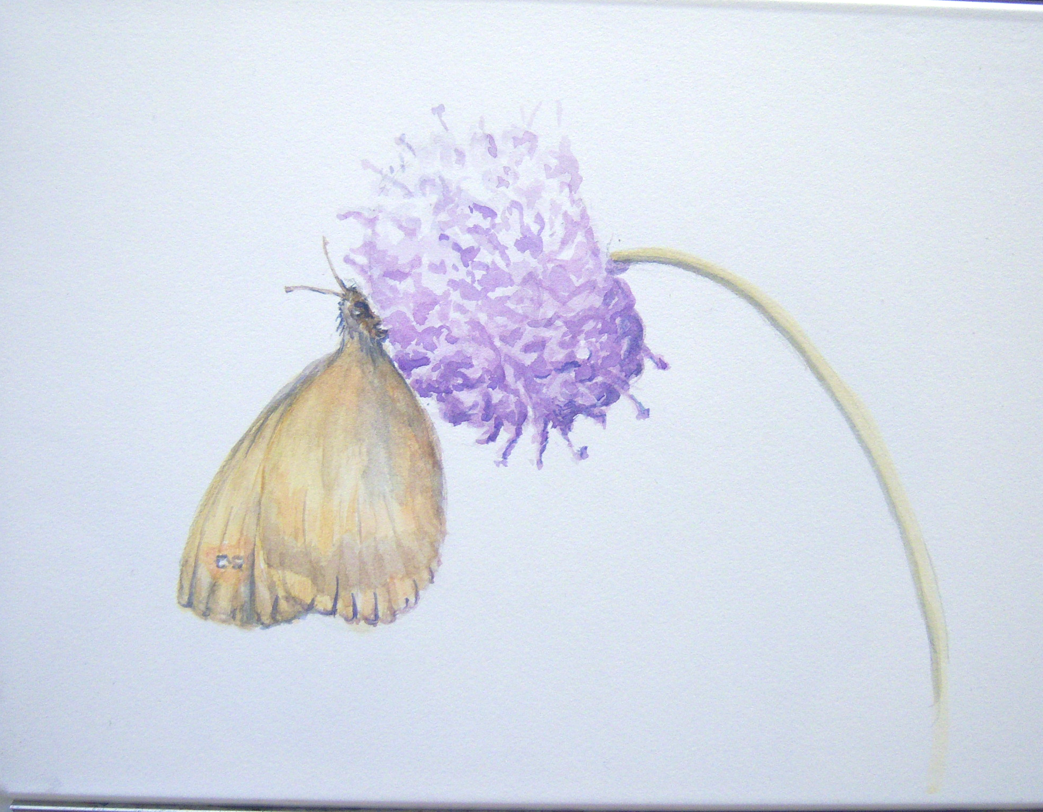

Finally the stem was blocked in with raw sienna on its own. This was allowed to dry and then a shadow was added down one side with a mix of cobalt blue and raw sienna. This was allowed to dry and then a thin mark of cobalt blue was used to strengthen the shadow side. The whole image was assessed and small marks added as deemed appropriate.

