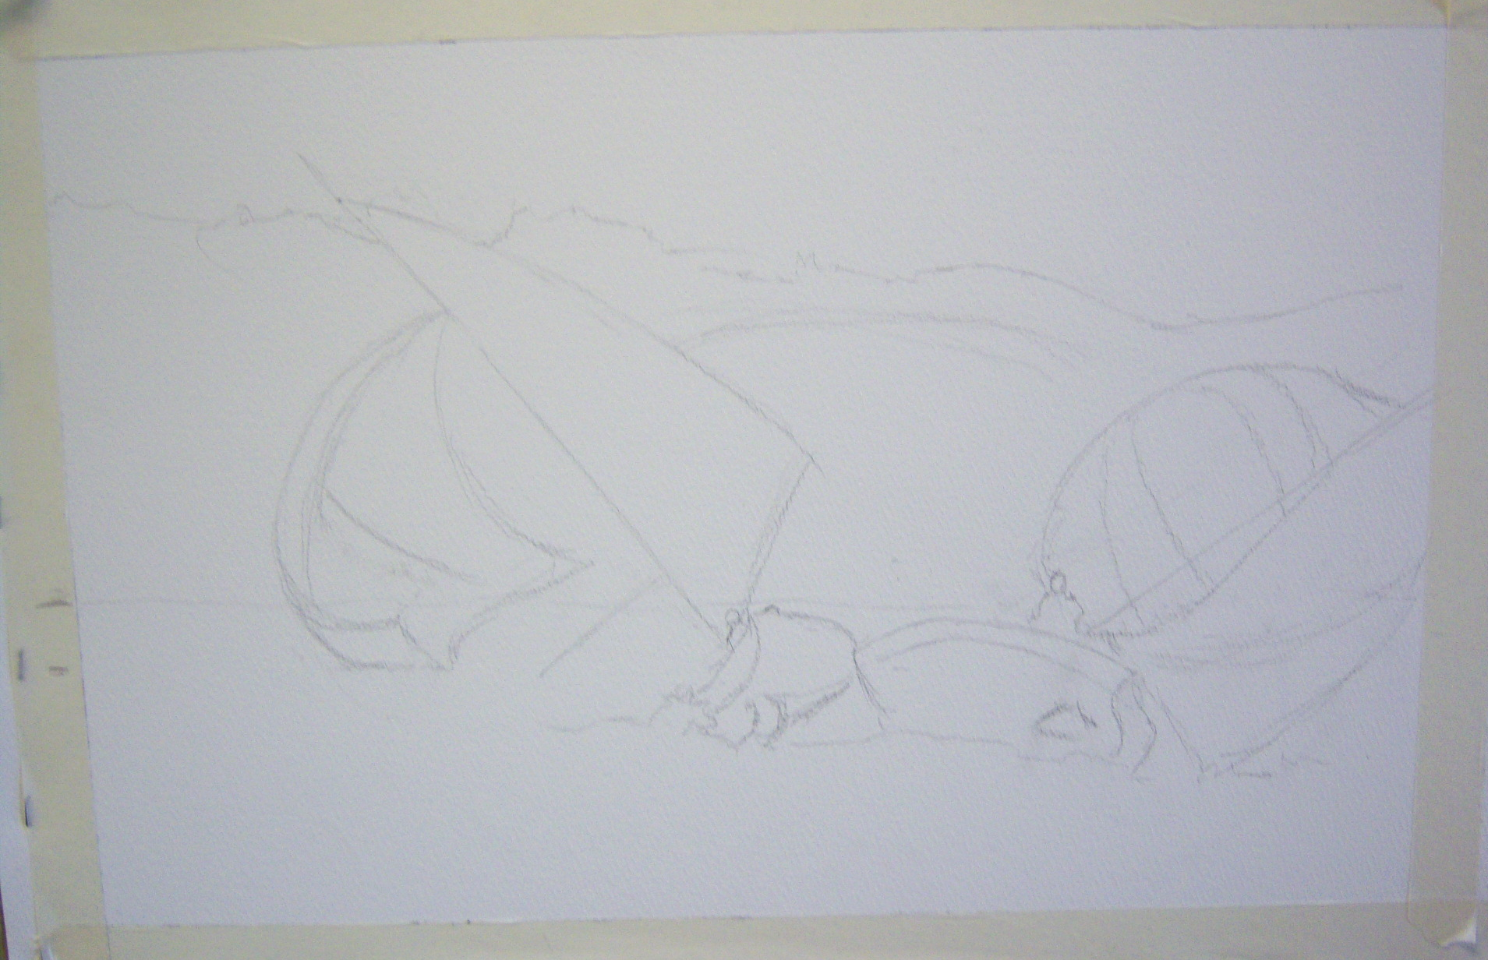
Colliding Boats
As ever, we began by considering the composition. Unusually the main subject is located in the centre of the picture, although the billowing sail and spinnaker (left) cross the centre line to unite the two halves . Discussion covered whether we should include the shore and distant hills or settle for a blue sky down to the water. It was left to individual decision.
The demo used the background trees etc to provide a dark counter change to the white of the sails. (This was to prove troublesome).

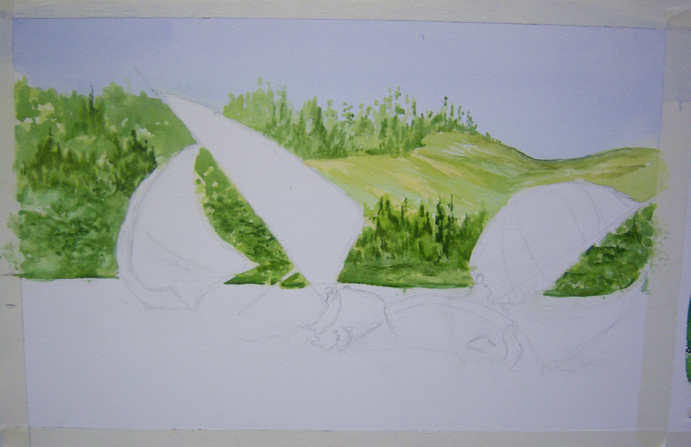
We began painting with the sky. The sky area was wetted right down to the shoreline, leaving the sails dry. Cobalt Blue (CB) on its own was dragged across the top of the picture then this was clipped with Manganese Blue (MB) on its own and finally a fairly dilute Raw Sienna (RS) was dragged horizontally to just clip the MB. The RS was chased down to the shoreline.
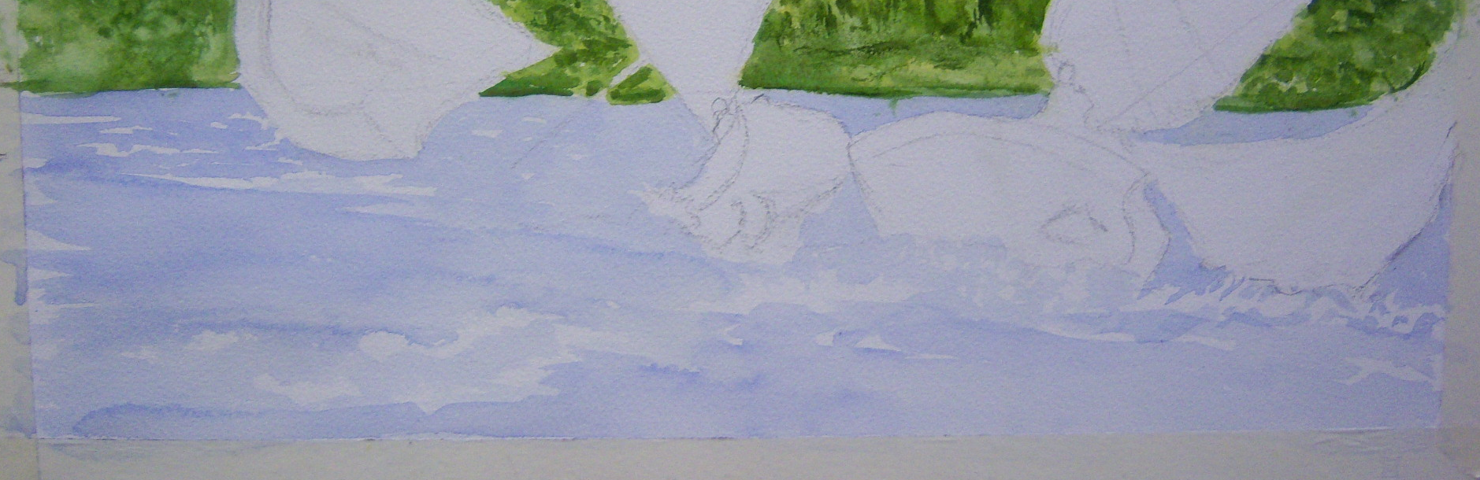
When dry, mixes were prepared of RS + Hookers Green (HG), Burnt Umber (BU) + HG and a stronger RS on its own. The hill was painted with RS and random marks of RS+HG and BU+HG were dabbed on the hills to indicate brush and trees. This was not too successful and we employed a simple device that has never been known to fail- there’s a first time for everything. A natural sponge was loaded with BU+HG and gently dabbed over the first attempt. Having dug a deep enough hole, it was time to stop digging and the painting was allowed to dry. Once dry, trees were indicated with a rigger loaded with BU+HG and selective lifting out helped to suggest highlights on the foliage etc. The hill at top right was left as open hillside with the contours simply indicated with RS+HG and BU+HG.
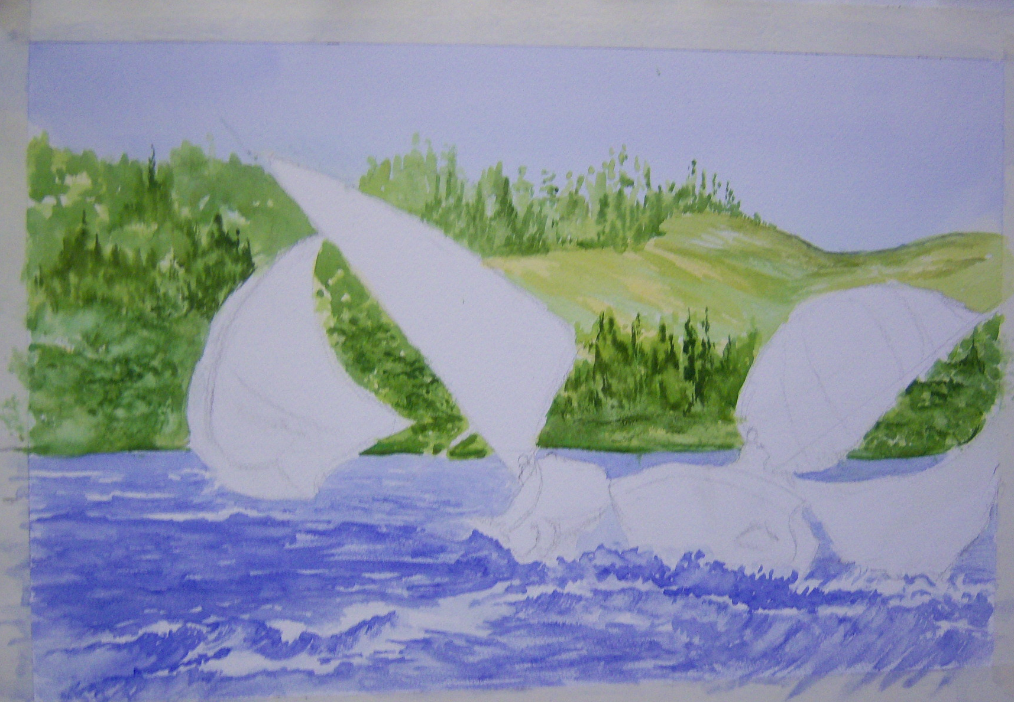
Using a thin mix of CB on its own, the water was painted in wet onto dry, carefully avoiding areas where there was white water (actual or invented to assist the composition).
Next, a mix of CB and Scarlet Lake (SL) was prepared. The aim was to produce a blue tending towards indigo and, to achieve this, the SL was added in minute quantities until the desired hue had been achieved. The indigo was applied with a rigger, particularly under the white water of breaking waves, and then pulled out with a moist brush. In the distance only horizontal lines were used and they became less frequent the nearer they approached the distant shore until only the original CB wash was remaining.

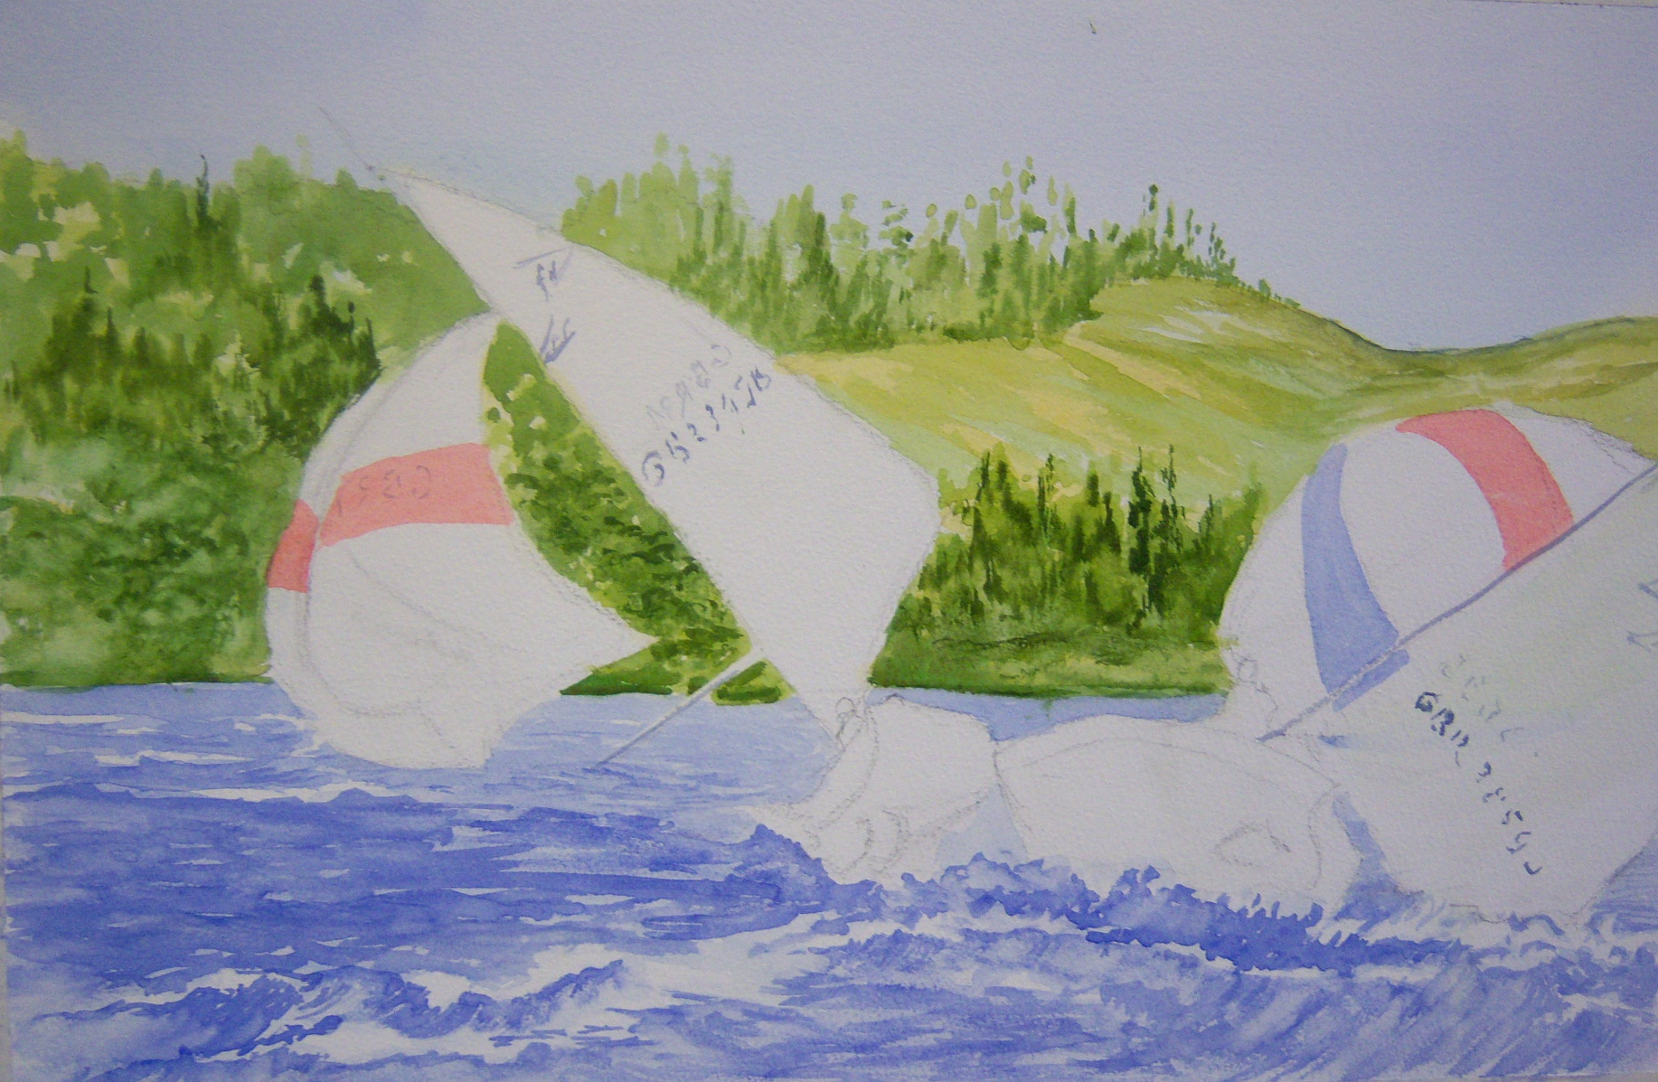
Time to paint the sails. The red bands were simply blocked in with a flat wash of SL. Note on the left spinnaker that the red is stronger where the sailcloth bends and shows its front. The major part of the spinnaker is showing us its back.
CB plus Light Red (LR) was used to make a black for the lettering on the sails. The letters were not written on, more hinted at with appropriate blobs and dashes. Again, there are two sides to the sails and lettering occurs on both, darker on the side facing.
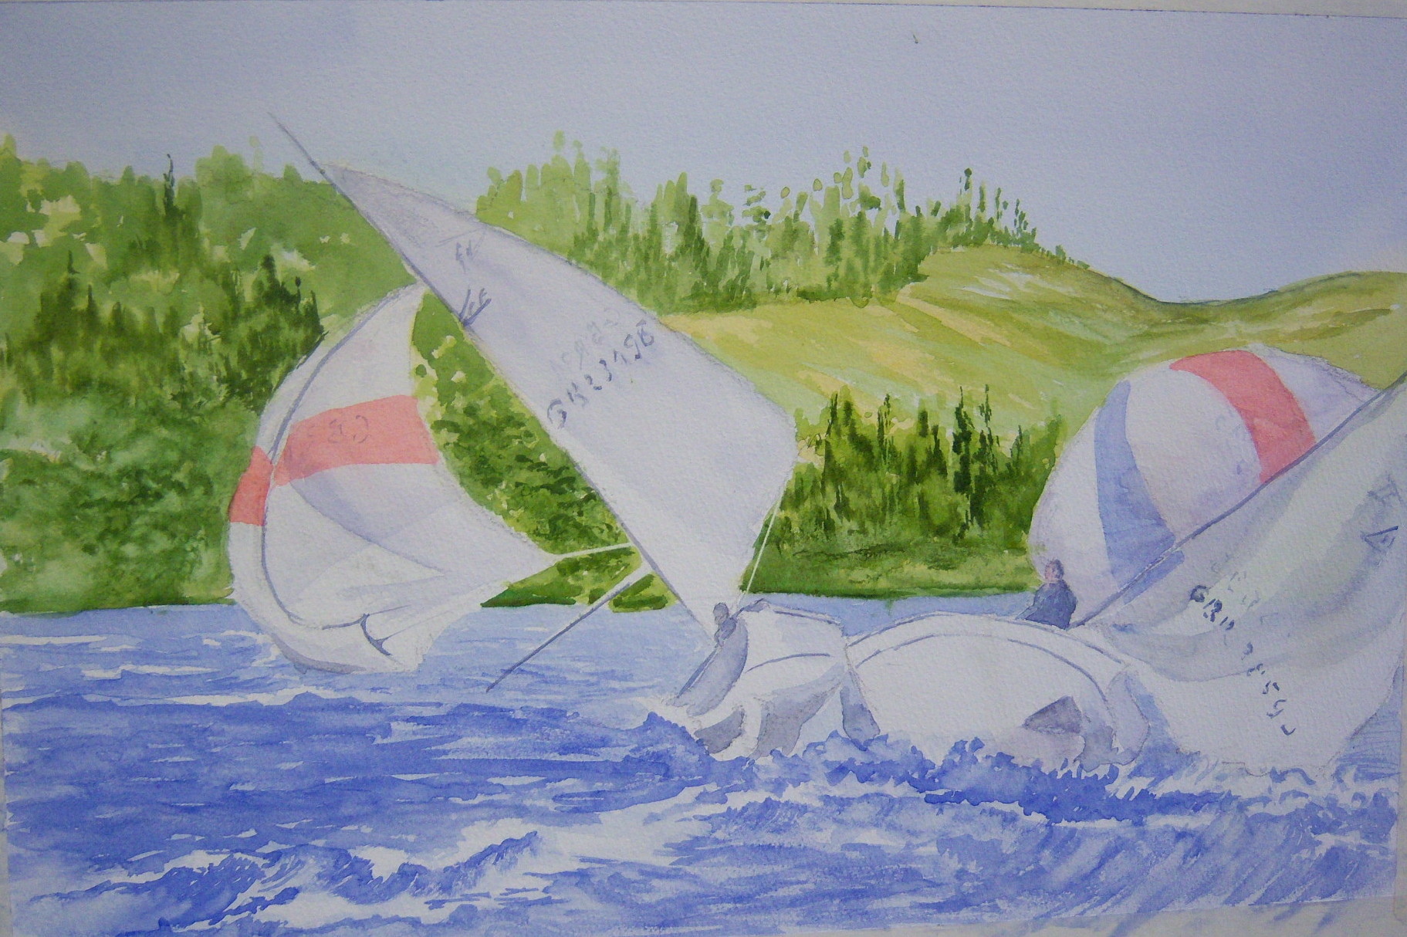
A thinner version (ie the same with more water) of the black and a separate mix of CB plus SL gave the greys for the shadows on the boats and the sails.
The two unfortunate captains of the craft were simply blocked in with greys.
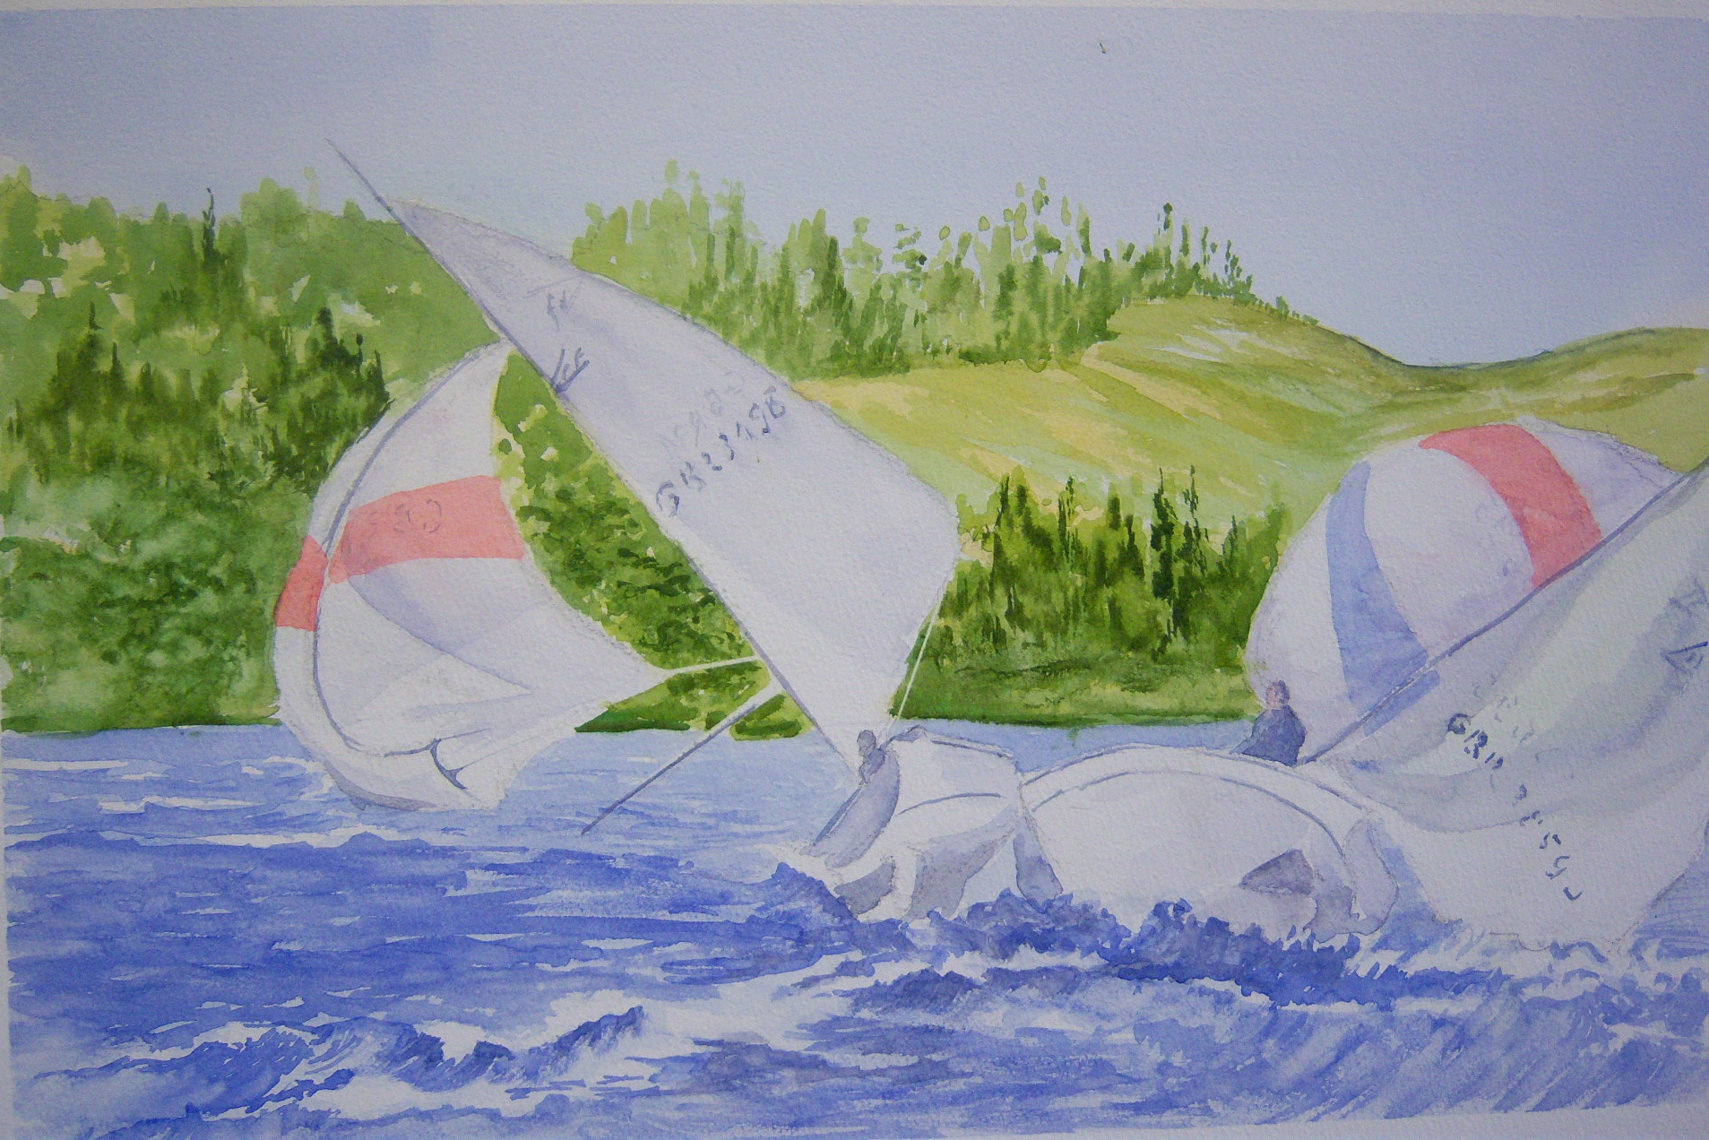
The white boom on the left boat was indicated simply by applying masking tape to either side of the intended line. A “magic” erasing sponge** was then wetted and gently dragged over the area of paint that was to be removed. This was dabbed with kitchen paper. When the masking tape was removed a white boom was left behind

Finally the black was used to emphasise the shadow under the white water leading to the left boat. A thinnish line was painted under the foam with a rigger and then this was pulled down with a moist brush to indicate wave contour(s). This gives a good contrast with the white and helps lead the eye to the action.
Darker marks were added where helpful
**These sponges may be available from your local art shop, but a cheaper, still serviceable alternative is on sale for removing stains from surfaces in the home. You may find these in your local Pound Shop near to those sponges that have a rough material on one surface.
Acknowledgements Many thanks to Roy Blackburn for allowing us to use his photograph for this project and to David Vasey, without whose efforts this workshop would never have taken place.

