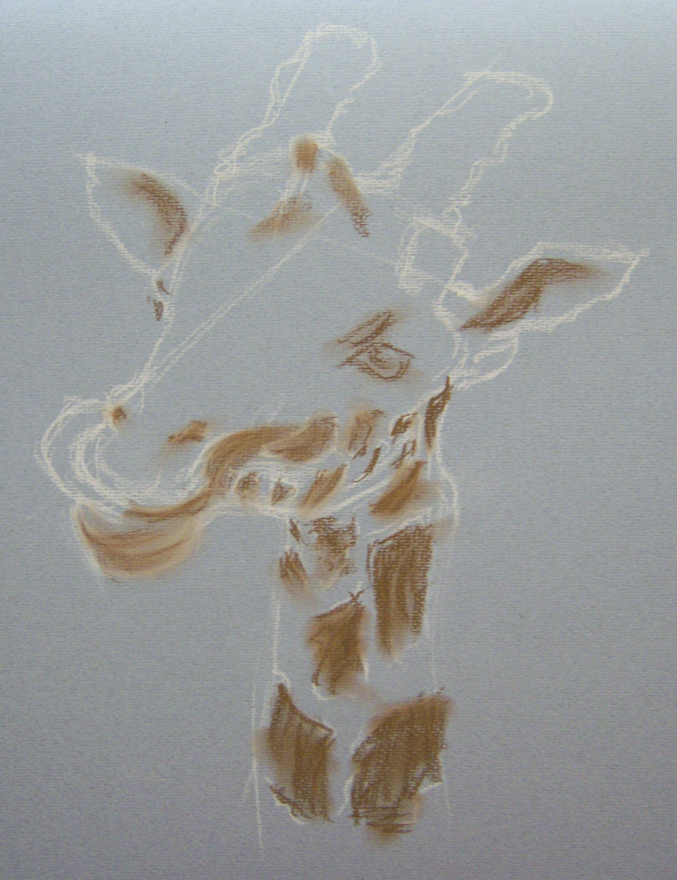
Giraffe in Pastel
The objectives for this painting were to present a picture of a giraffe in pastel which displayed an element of humour. The source was a photograph of a giraffe licking its lips with considerable enthusiasm as feeding time drew close.
Pastels used were a mixture of Winsor and Newton soft pastels, Faber Castell softs and Stabilo pastel pencil. Pastel pencil was used mainly to mark out the composition in the first stage.
Paper was Daler Rowney Murano from a neutral toned 16” x 12” pad.
Using a light coloured pastel pencil the image was outlined. Construction lines were used to indicate the angle of the forehead and of the relative position of the ears.
Burnt umber was used to sketch in the main features and the major markings on the animal’s coat.
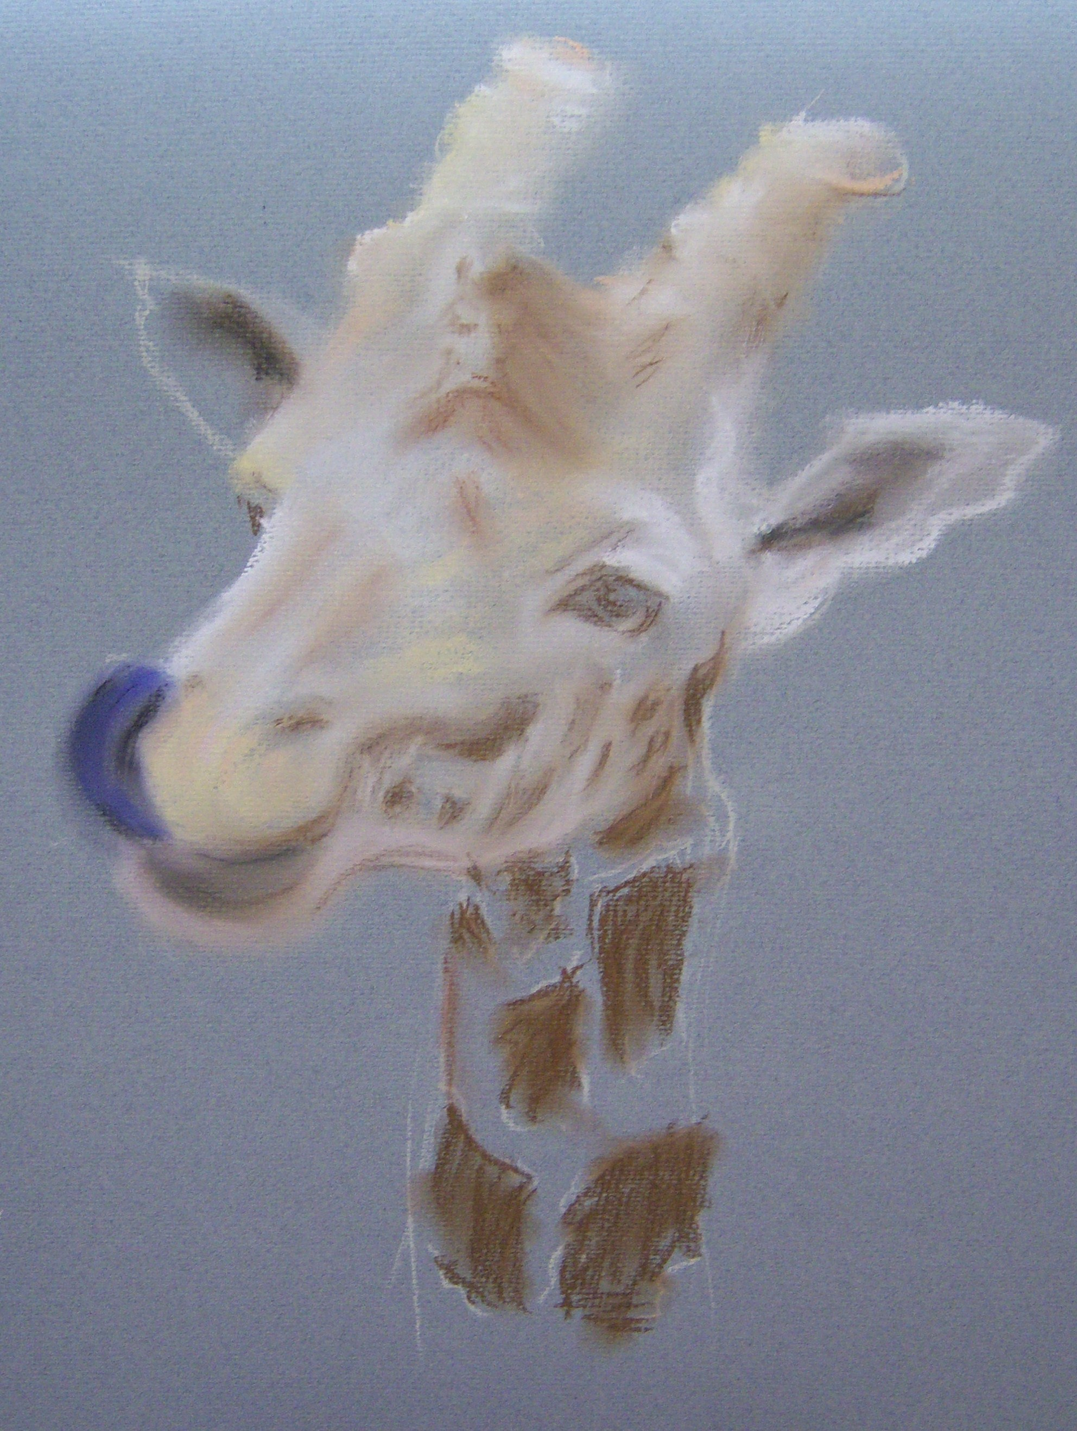
The picture was developed by highlighting the pale areas on the face, around the ears and the horns. Browns and yellows were introduced into the mix and blended by gently rubbing to soften the outlines.

A fairly vivid purple/blue was used for the tongue and black blended selectively to give an idea of contouring.

The chin beneath the tongue was darkened with black and blended in.

Pastel was painted on in streaks to indicate contouring of the giraffe’s head and the lines were smudged to soften the boundaries between colours and bled the pigments.
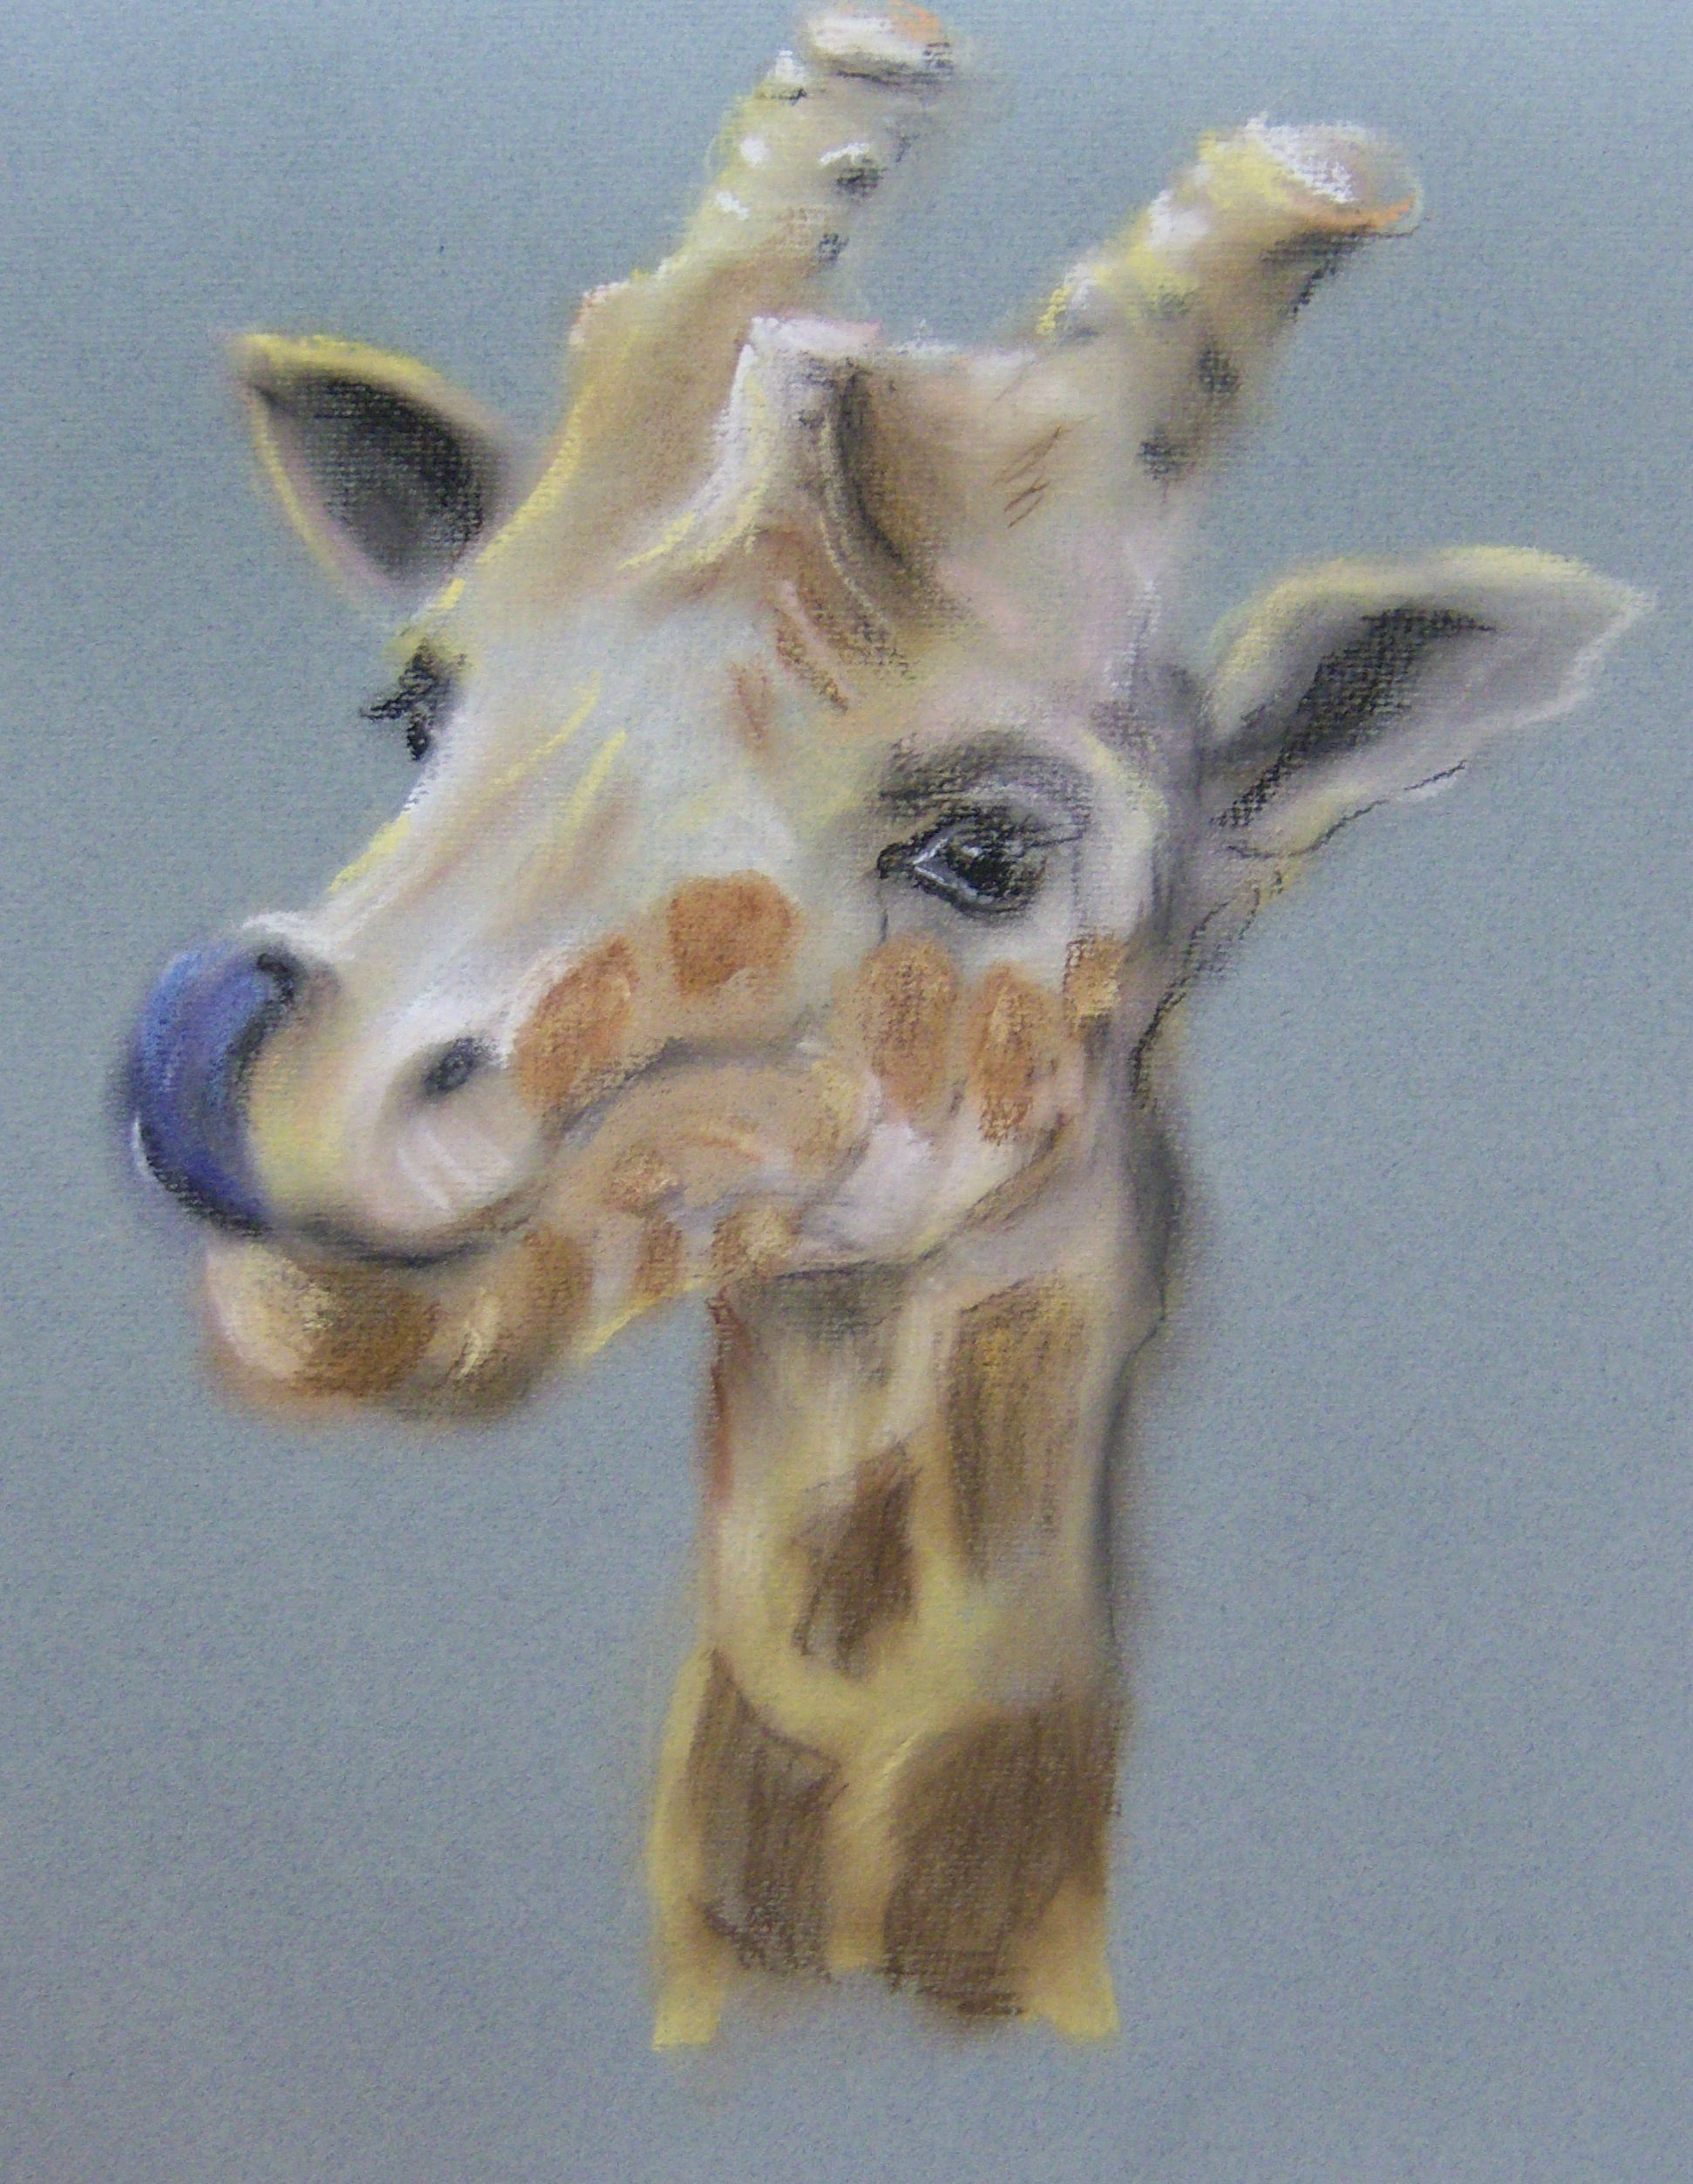
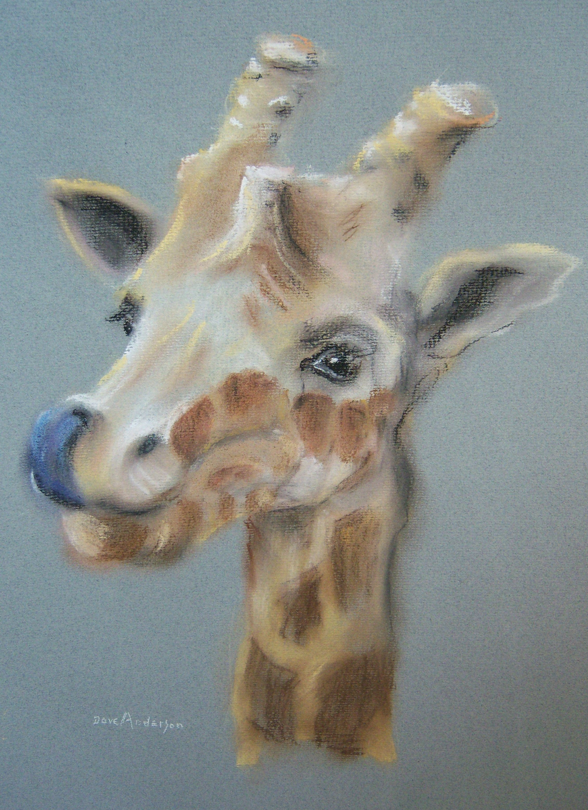
Over- enthusiastic blending created a need to repaint markings here and there.

The picture was built up in layers with selective blending and highlights introduced around the eyes and on the tongue.
Final touches included modifying the colour of the tongue, strengthening the highlight in animal’s left eye (right as we look at it) and modifying the markings on the cheek and jaw. These were lighter coloured on the animal would did not sit easily with the overall composition when painted more accurately.

