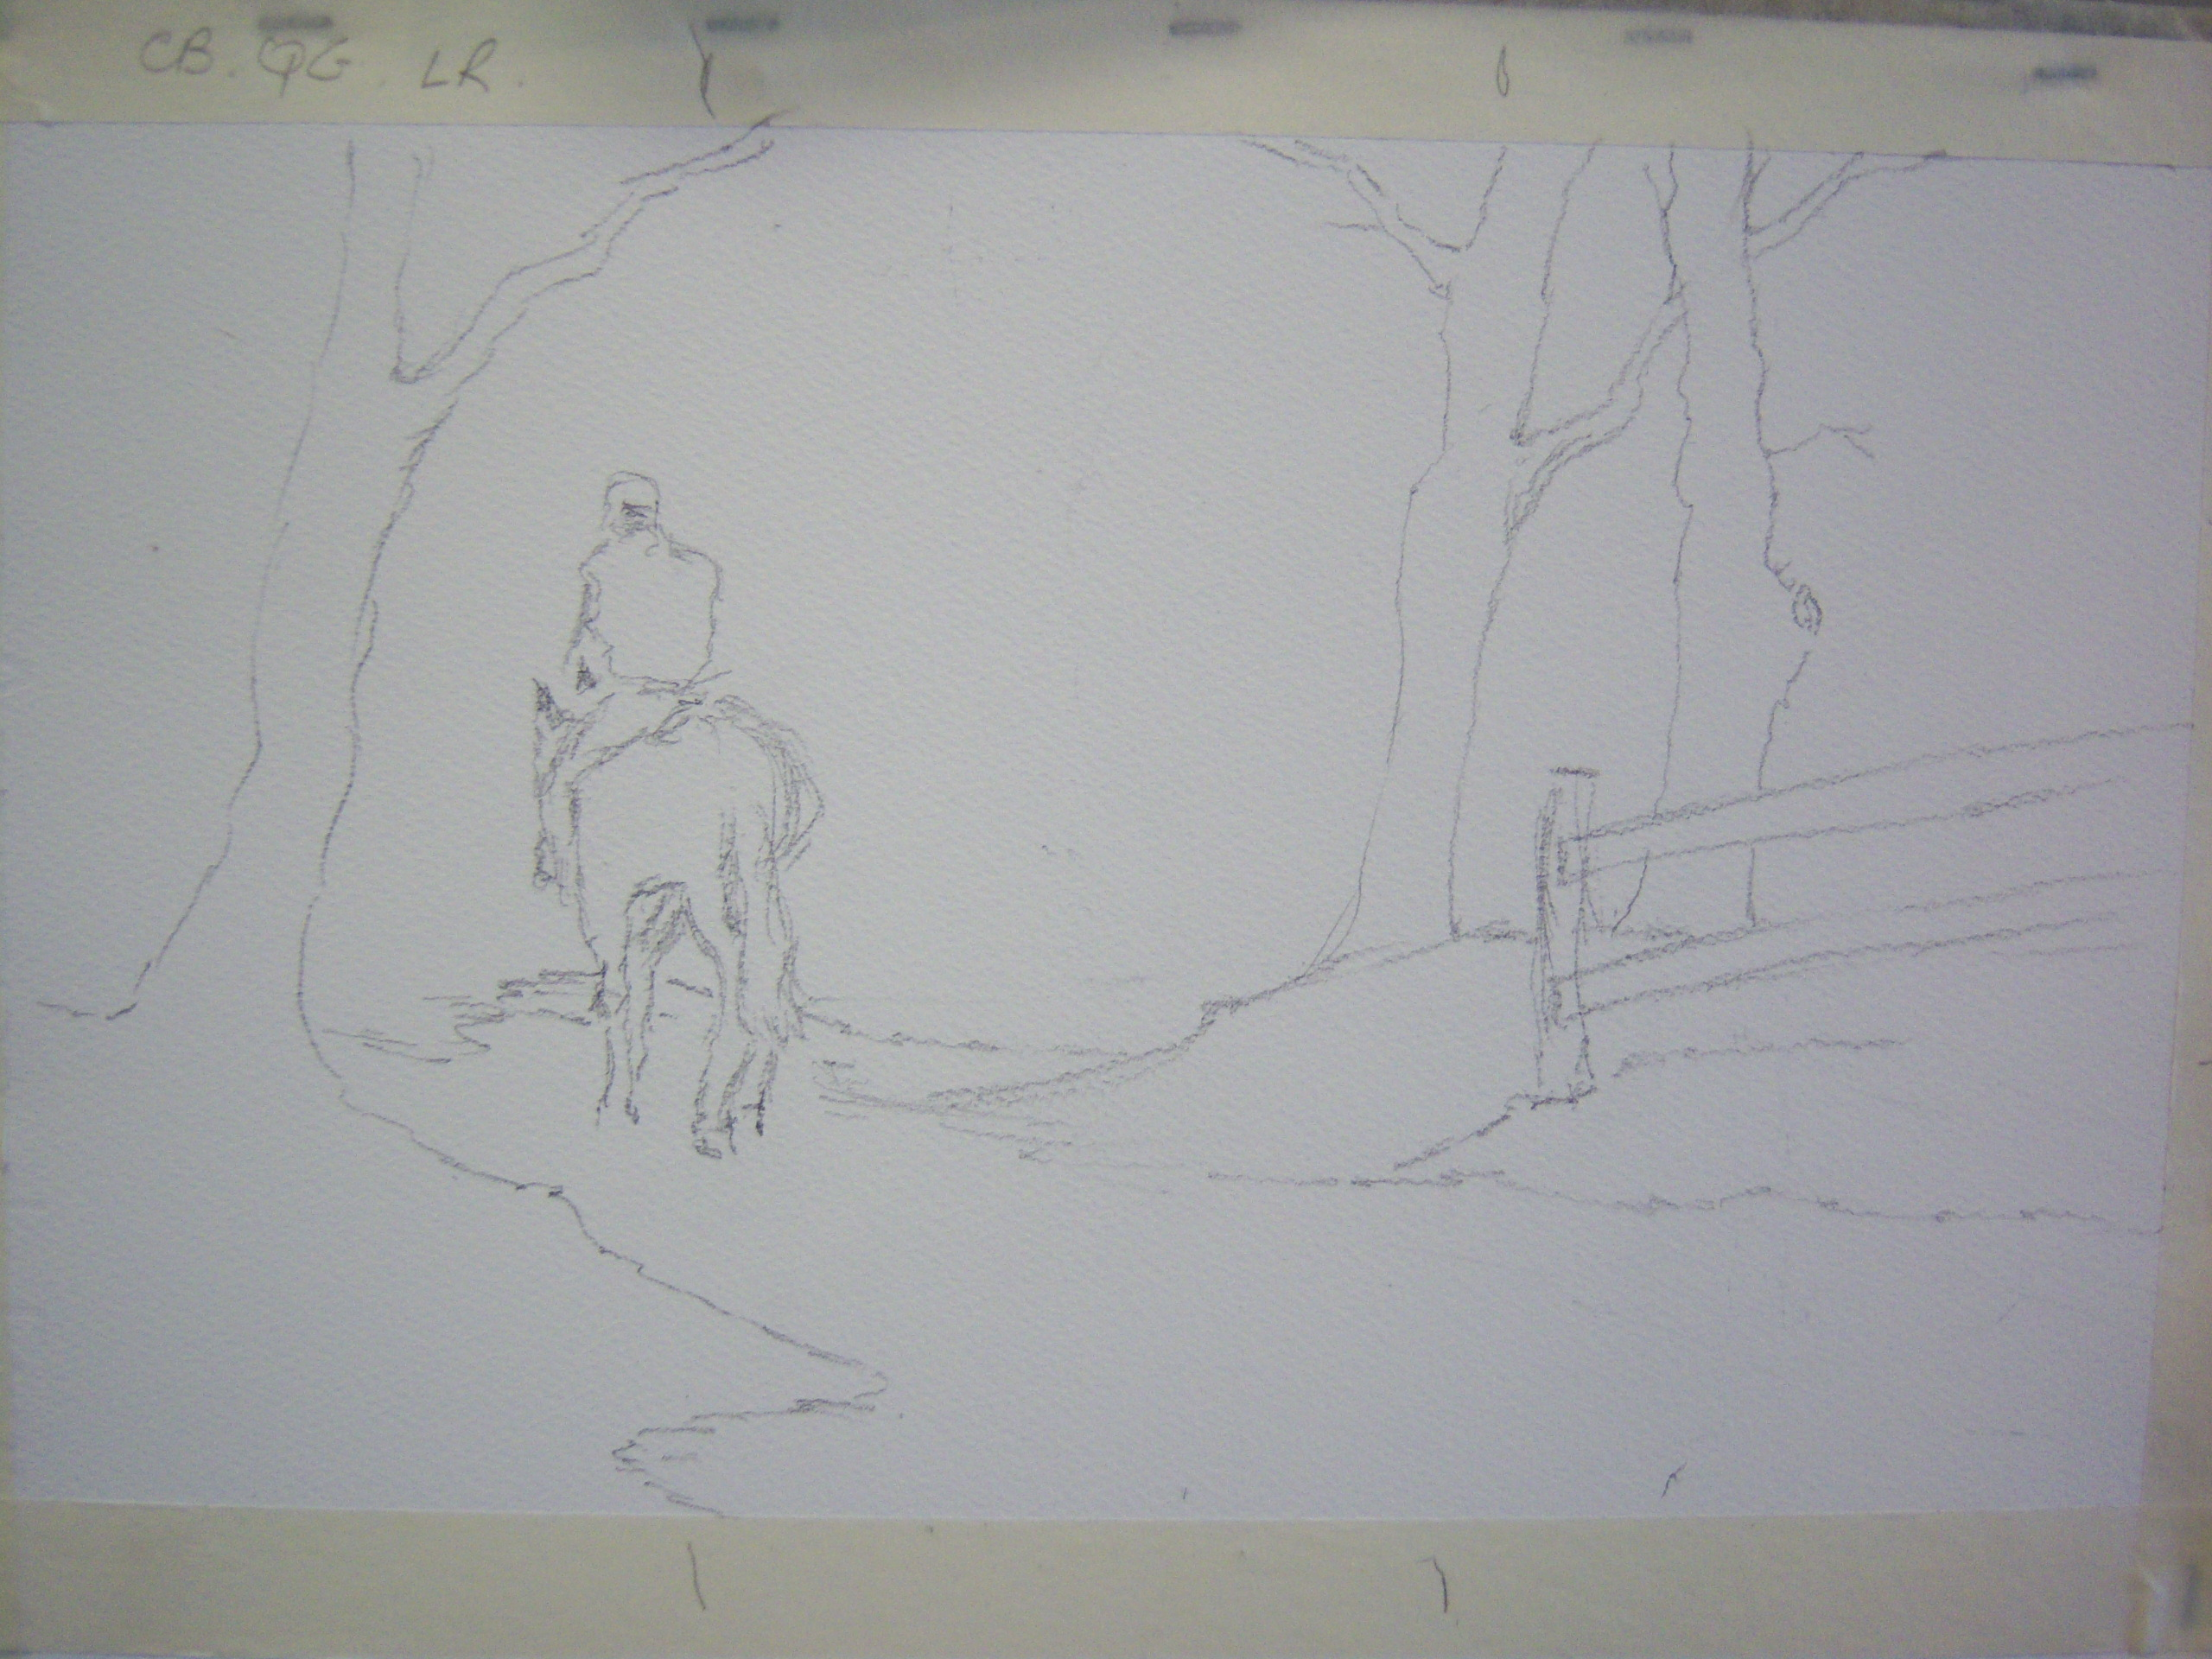
Lone Horseman
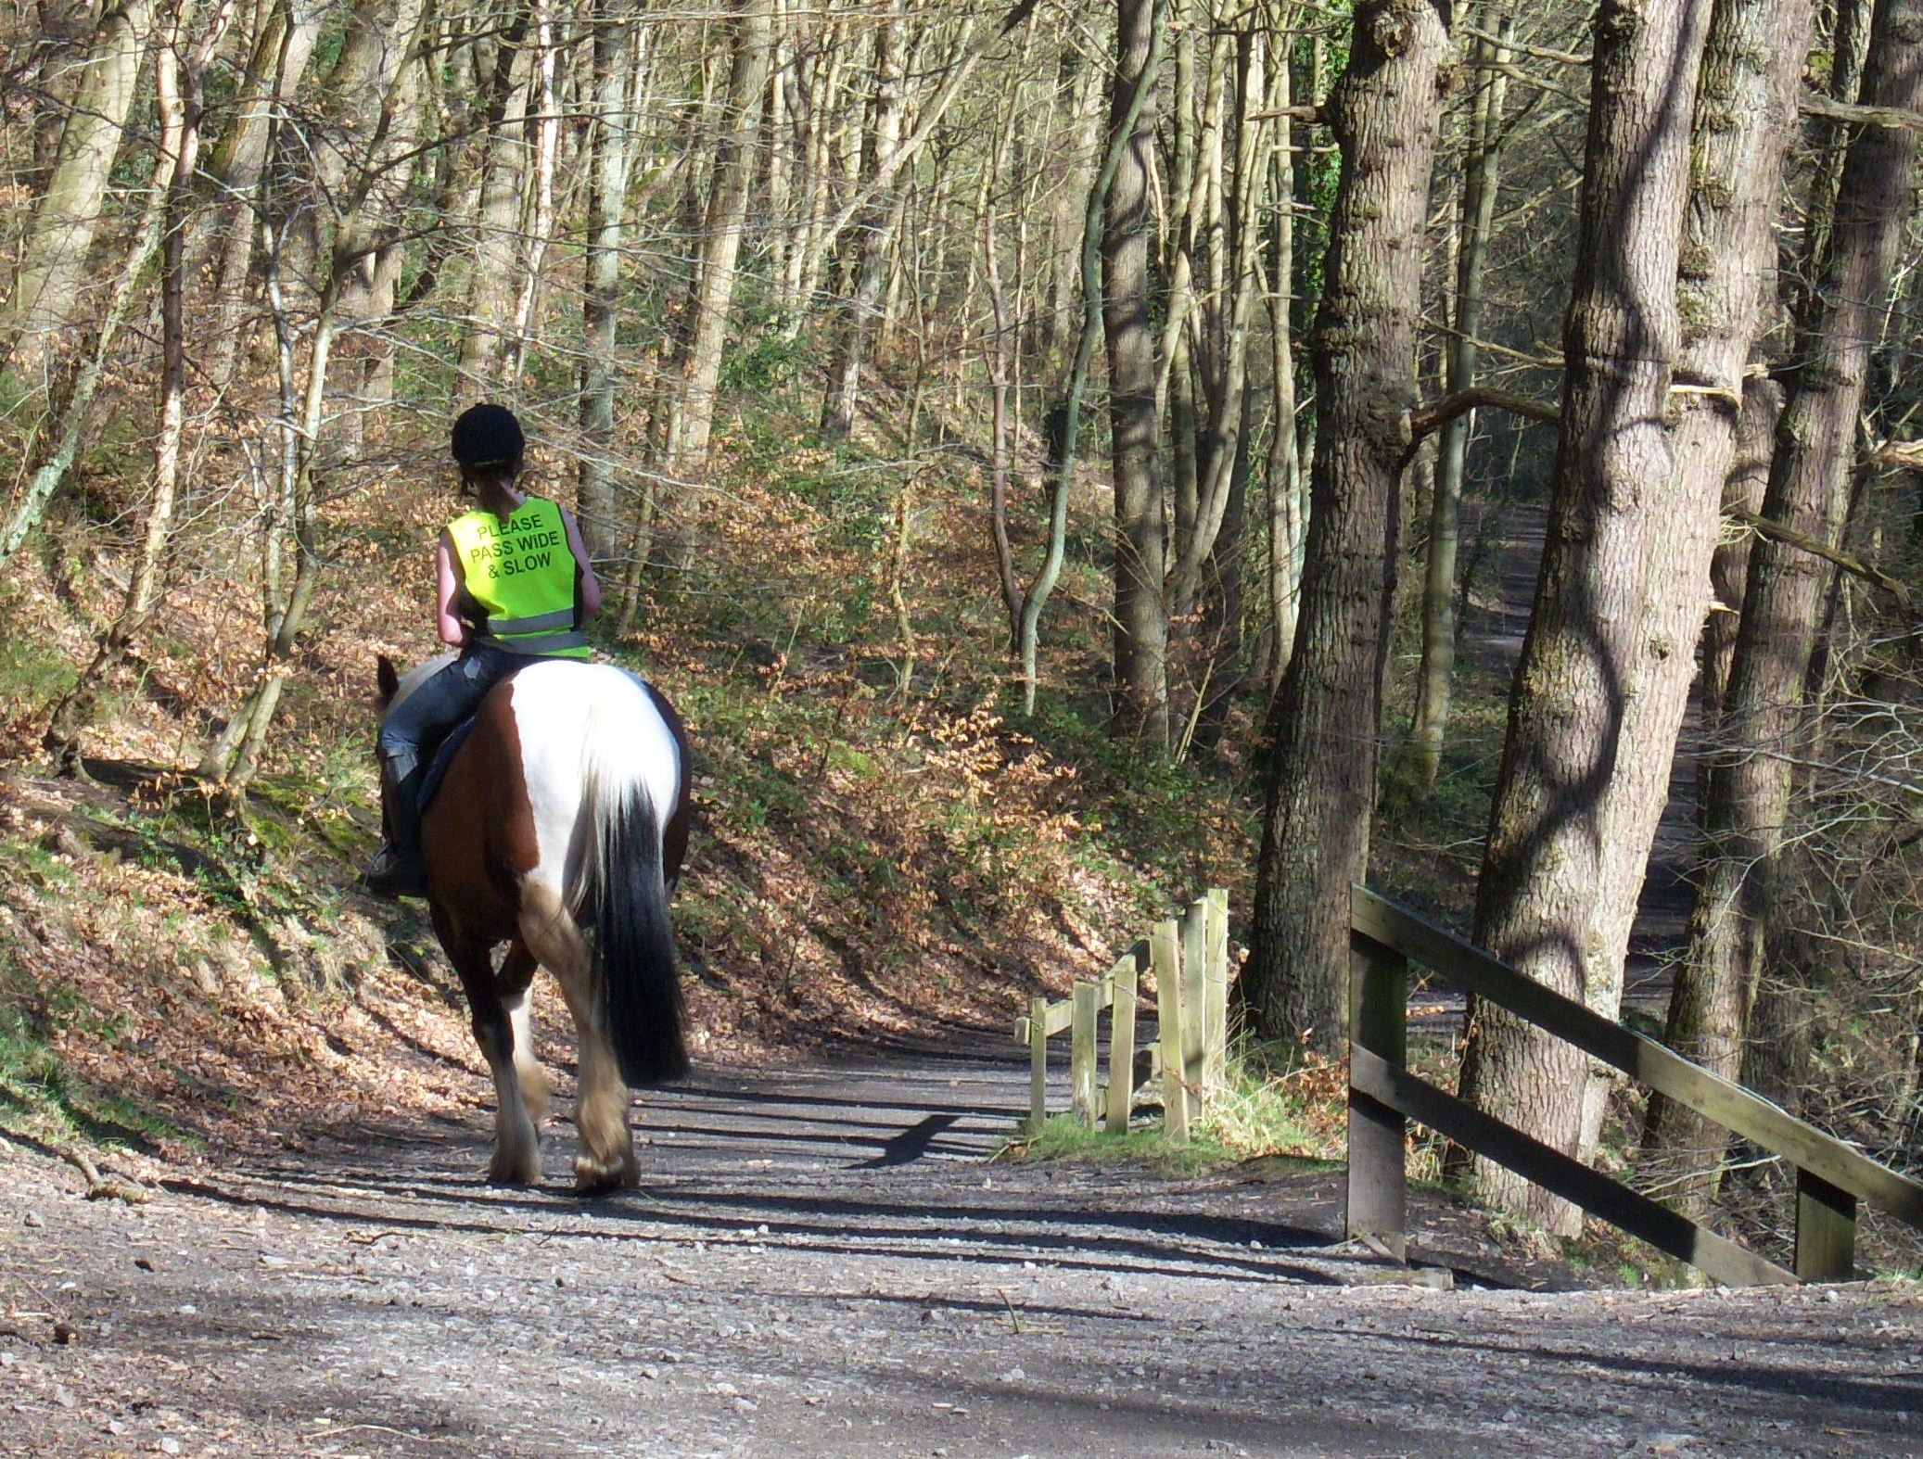
Paper: Fabriano Artistico NOT 140 lb stretched on a board.
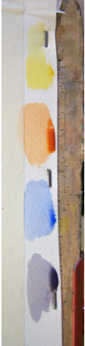
Stage OneThe source material was simplified and the bare details sketched in pencil as the starting point. The fence at right actually descends to the stream below the bank and the angle confuses the perspective, so it was altered to better sit in the composition. Trees were moved or invented as seemed appropriate.

Stage Two
Colours were mixed:
Light Red alone {LR}
Cobalt Blue alone {CB}
Cobalt Blue plus Light Red (Neutral Grey) {NG}
Quinacrodine Gold alone {QG}

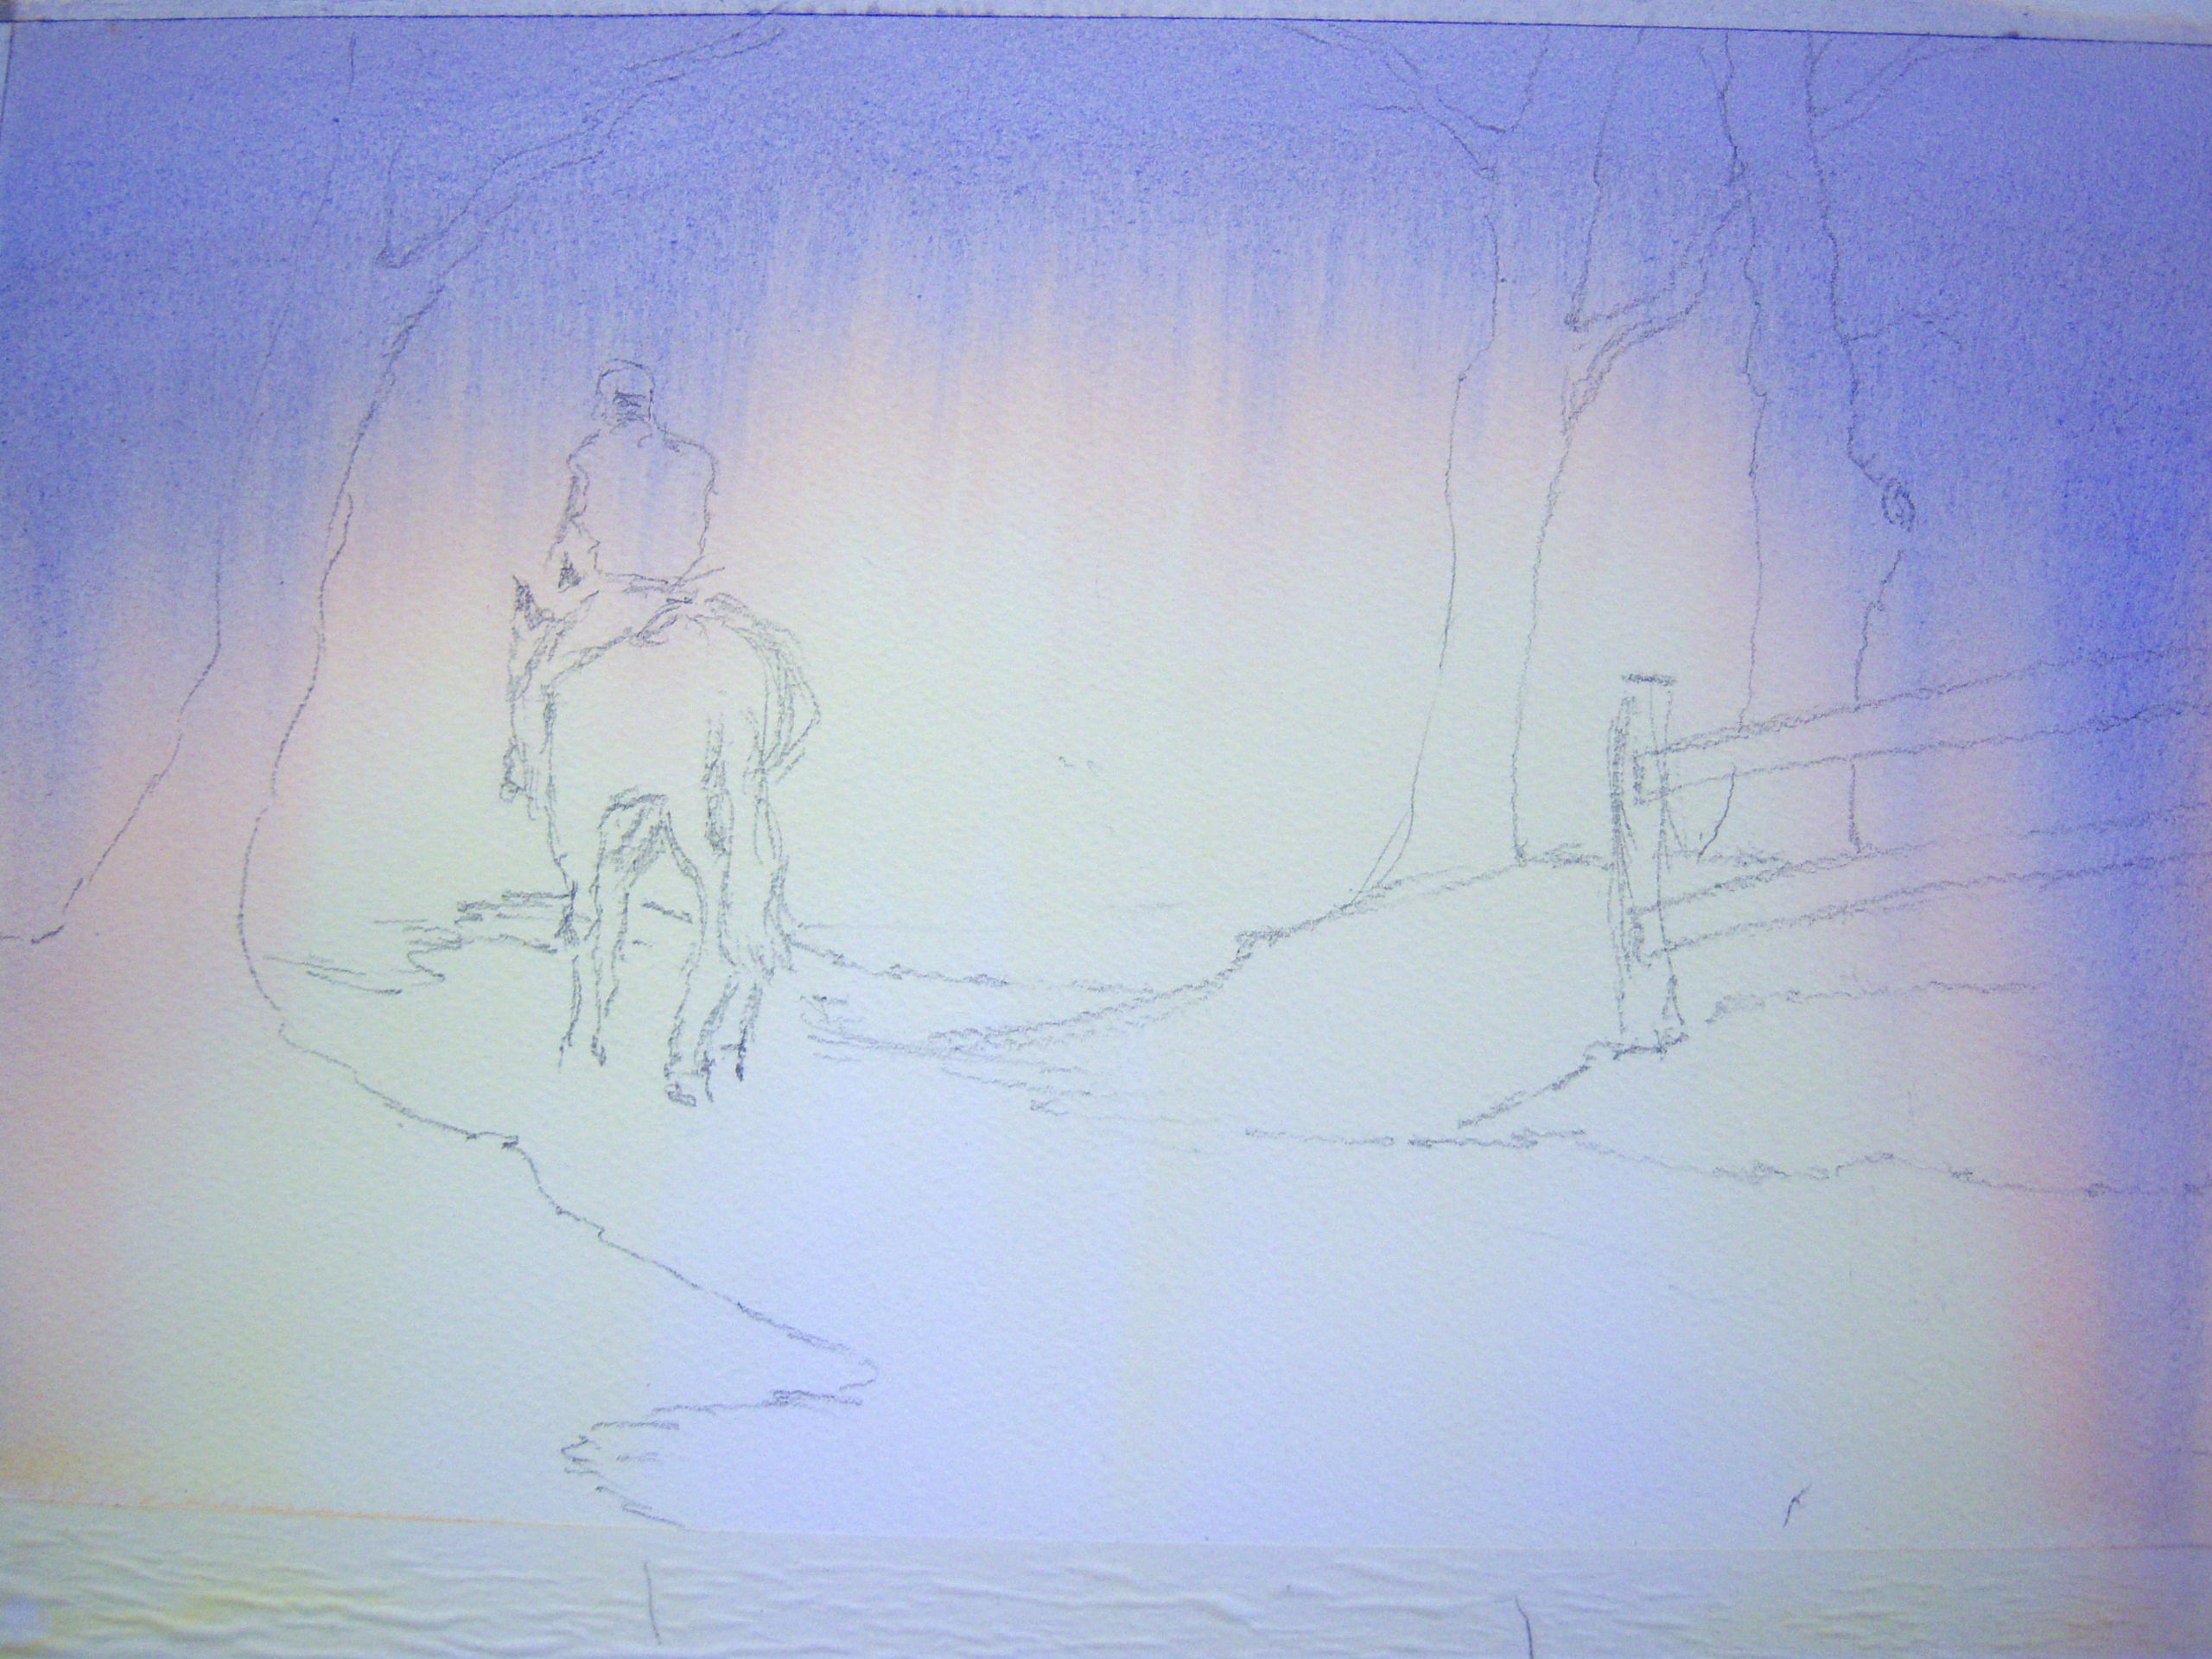
Stage Three
The whole paper was thoroughly wetted.
Colour was applied in a single stroke from the top corners.
QG was first applied with the board at a steep angle. A series of strokes of QG was applied, each starting at one corner (on the masking tape around the rectangle) and stroked across to the far side in a single movement. The QG descended under the effect of gravity and when the advancing paint had reached to somewhere around a third of the height from the bottom edge, the process was repeated using LR. The LR was applied in this way until the advancing paint had reached to somewhere around the halfway mark and then CB was applied in the same way. The CB was applied for a couple or three strokes only and then a quick stroke or two of NG was brushed on to the rectangle.
Note: In this technique, all strokes are applied at the very top of the rectangle of the finished painting and gravity exploited, allowing subsequent paint to push preceding applications down the paper. Apply each in a single movement across the full width of the rectangle. If you apply always from the same corner the effect will be to describe a diagonal rising towards the edge last touched. Alternating between corners will give the above effect- a sort of semi-circular shape.
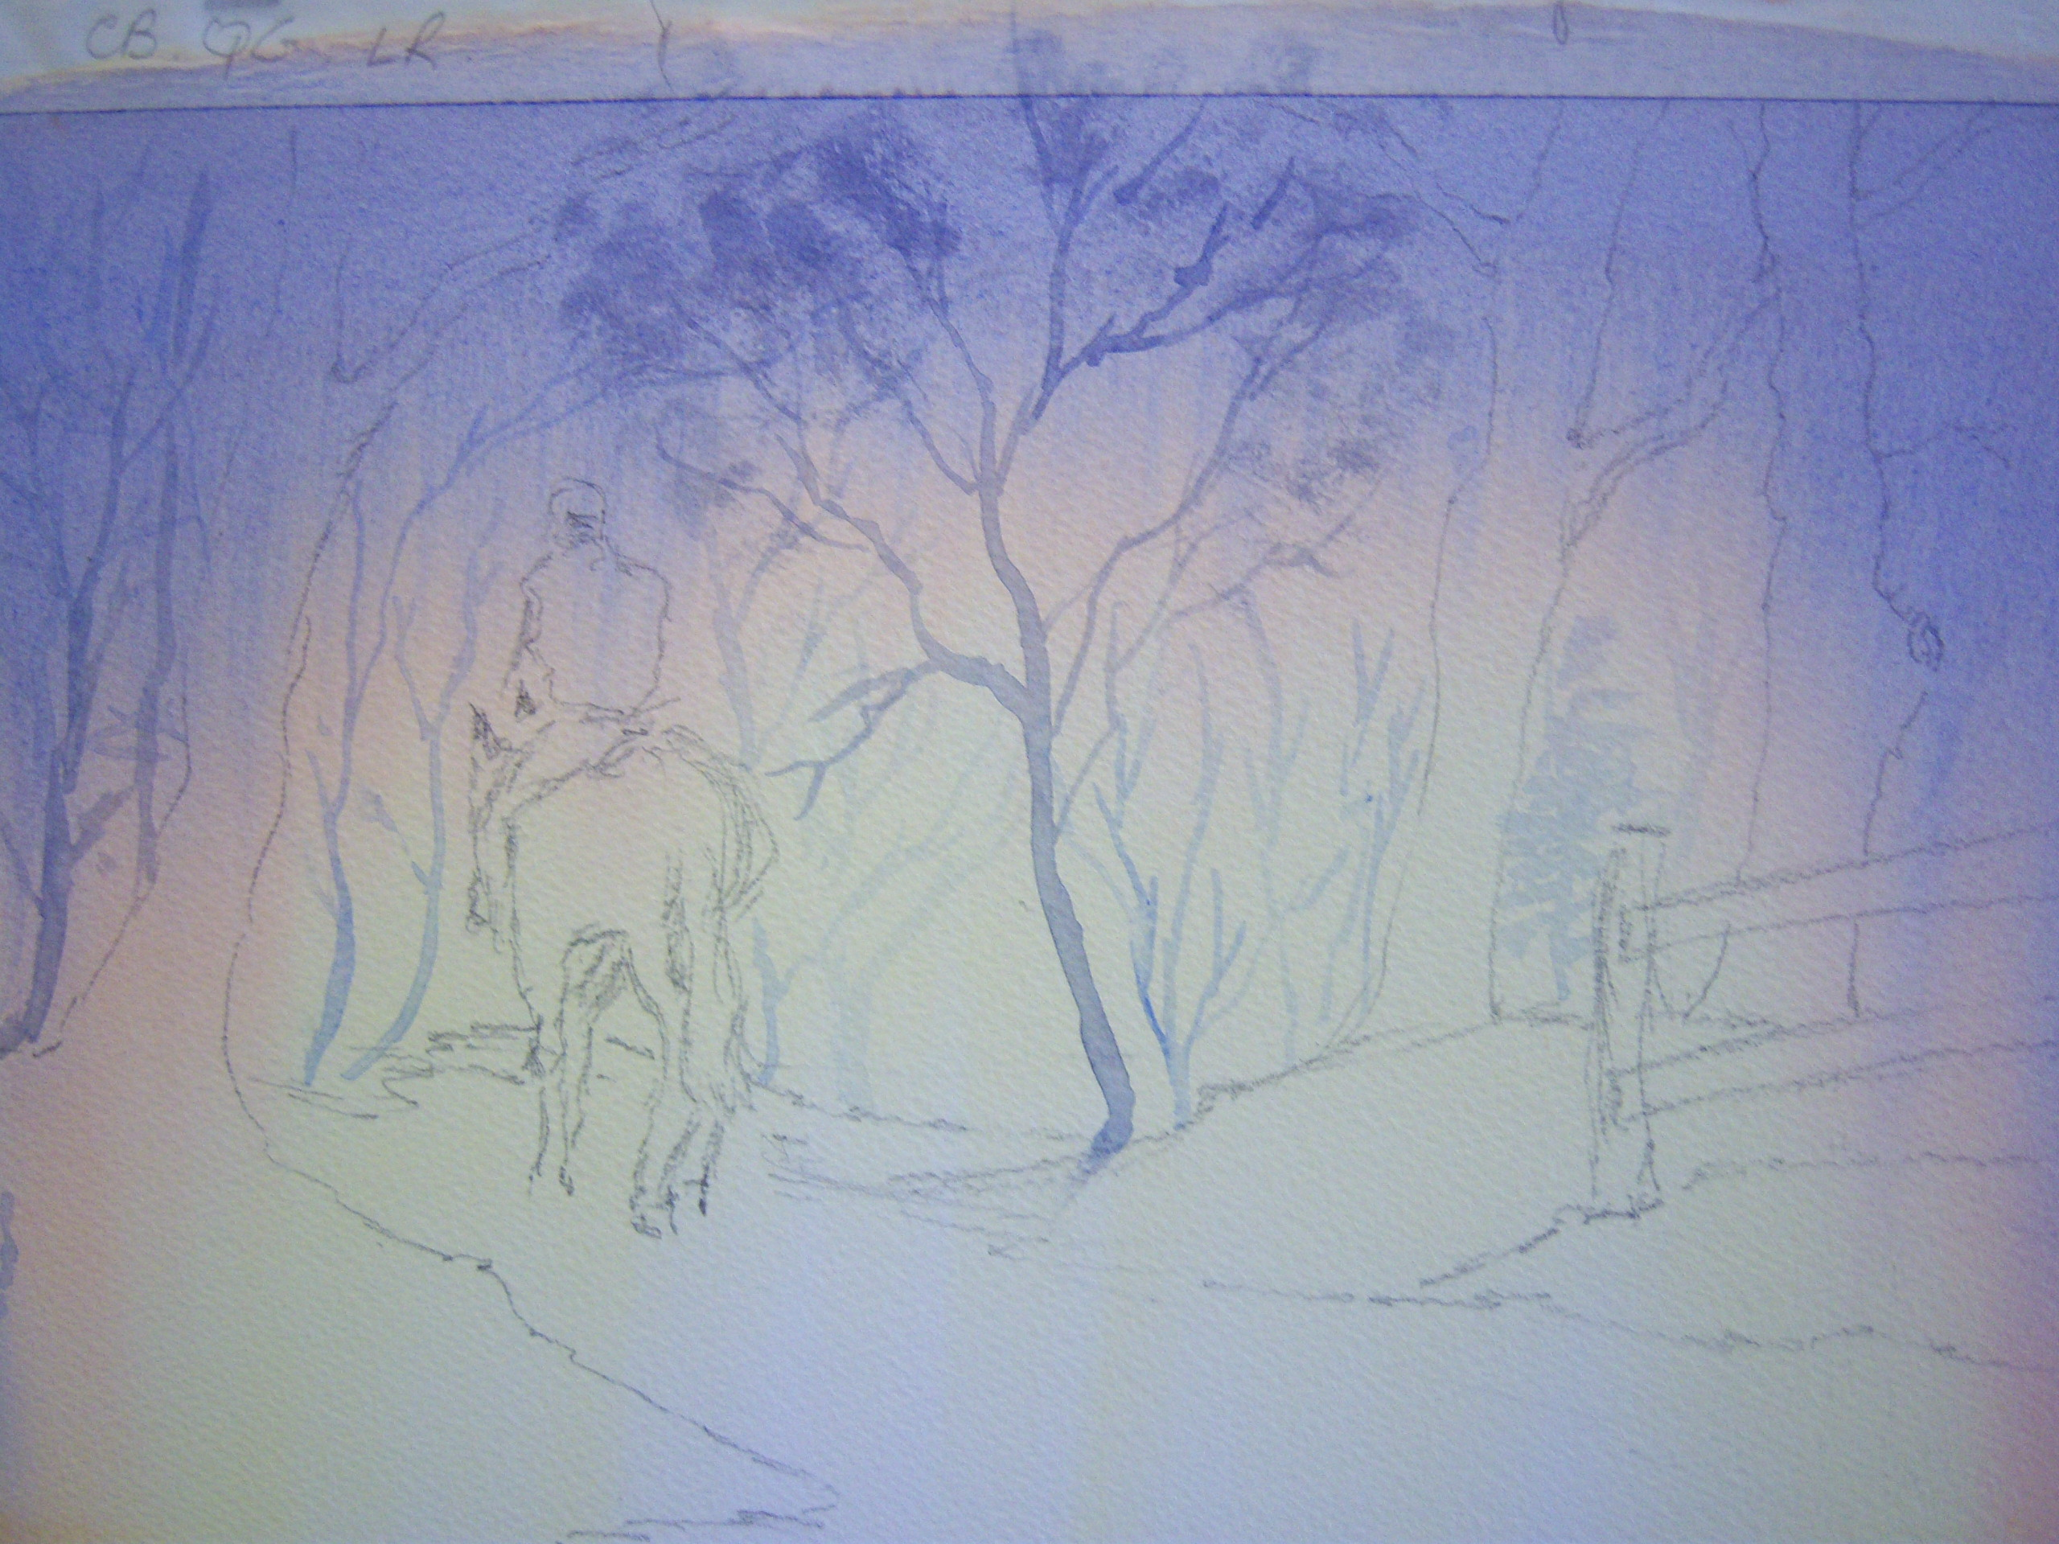
Stage Four
Distant trees were indicated using a weak CB.
Middle distance trees were painted in using CB plus a touch of LR and were a little stronger in tone.
The central tree had the mass of twigs implied by lightly dragging a Prolene filbert over the paper to get a broken, dry brush effect.
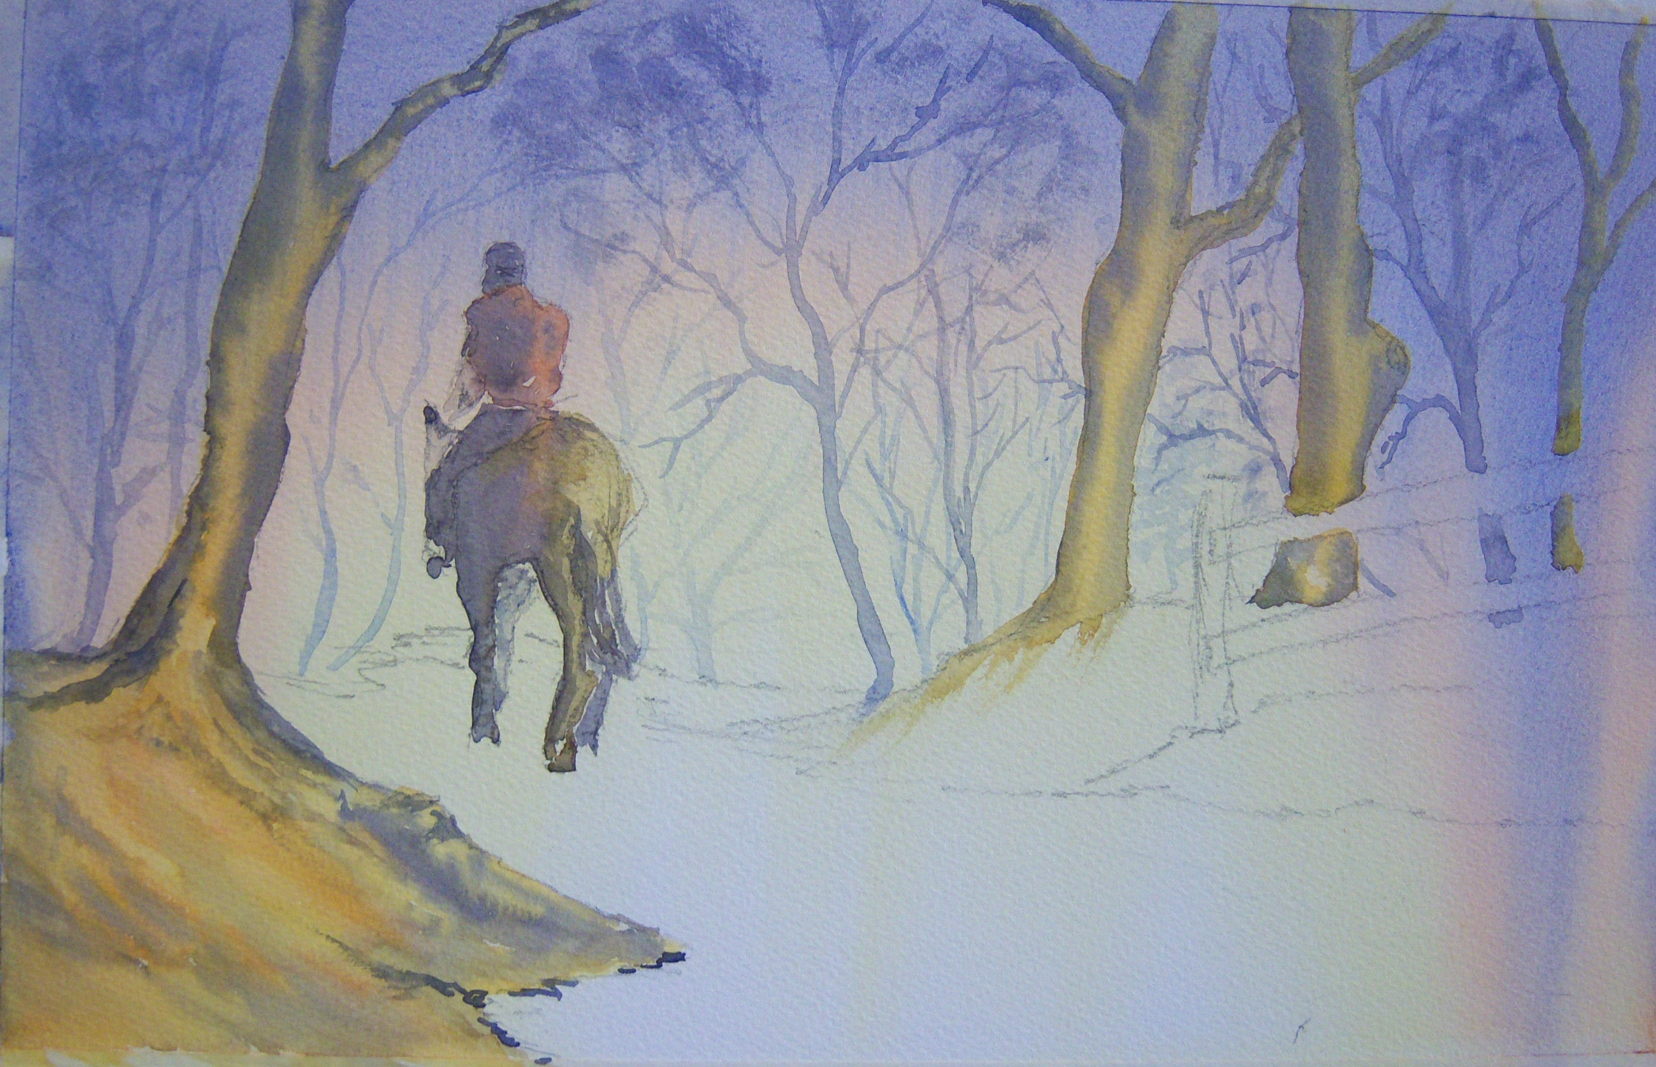
Stage Five
A strong (ie little moisture in the mix) black (BL) was mixed and the major trees were blocked in using QG; the outer edges of the trees were touched in wet-into-wet with BL on a rigger.
The bank at left foreground was painted wet-into-wet with fairly random (inventive if you prefer) strokes of QG, LR and or BL.
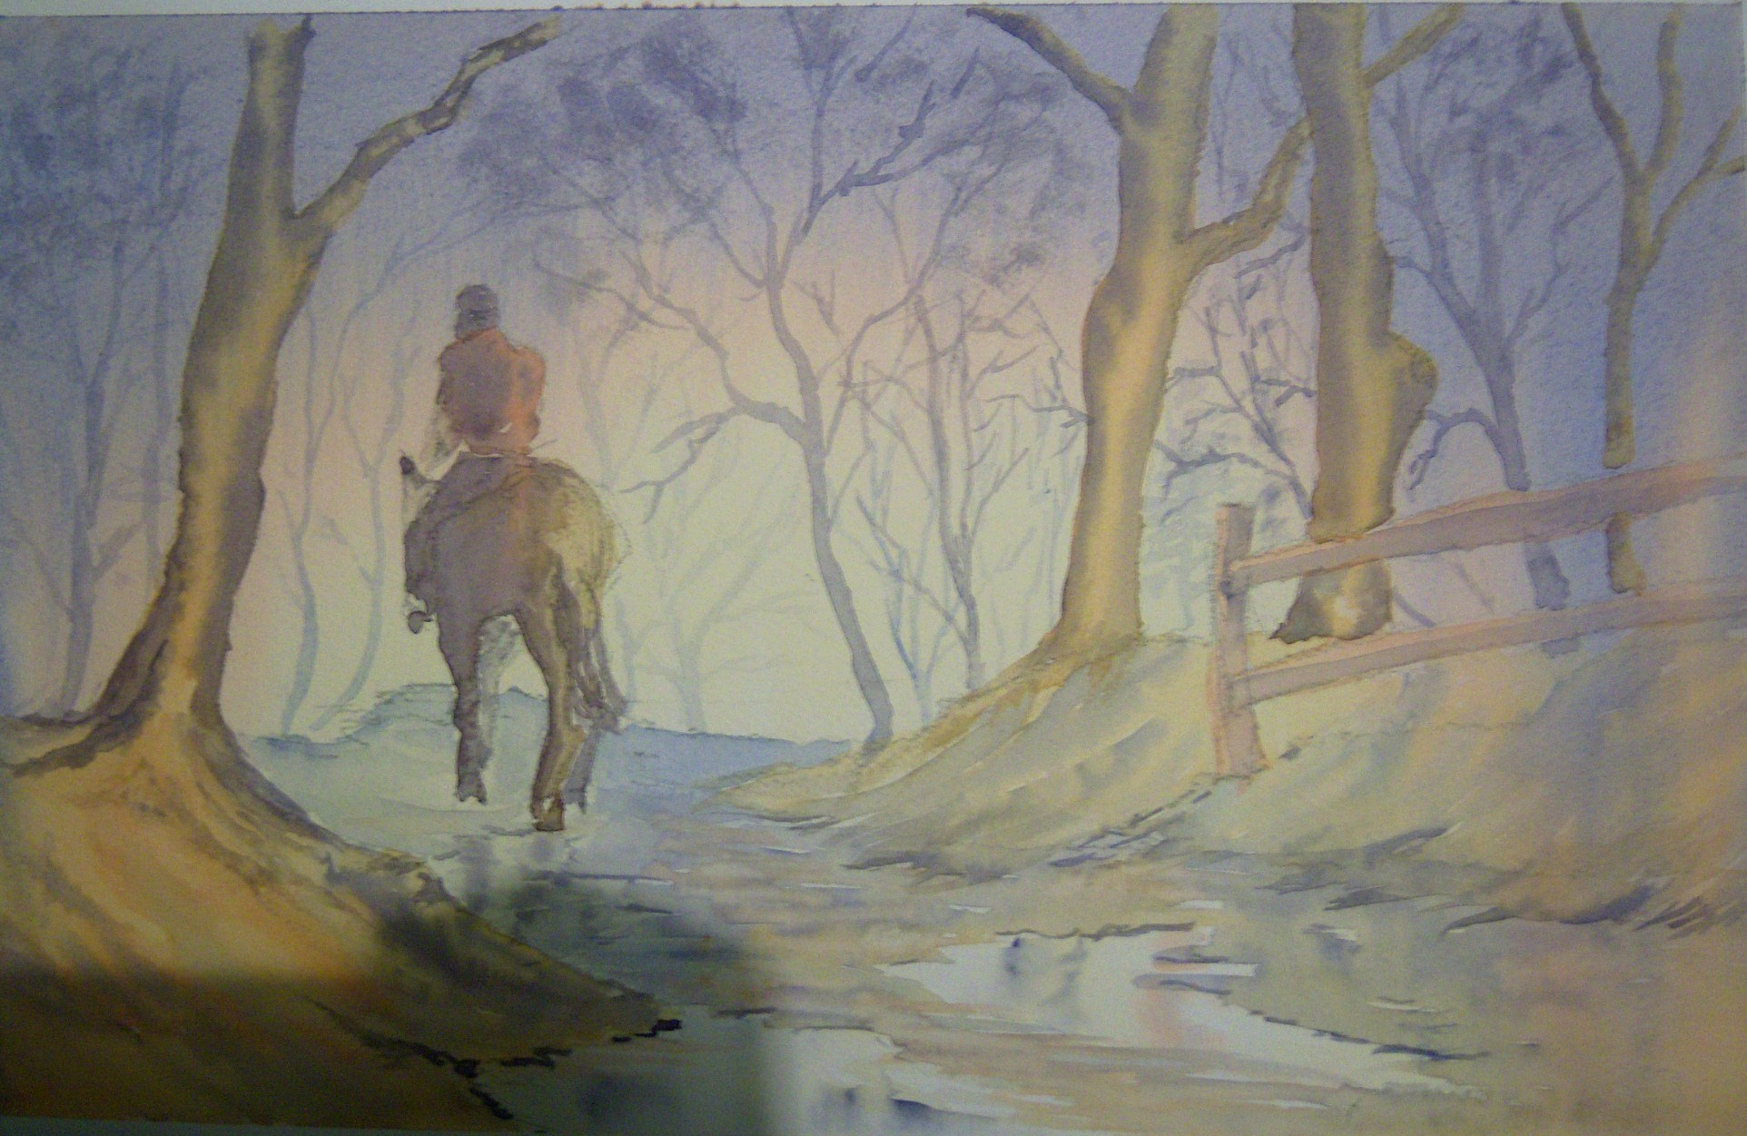
LR was used to paint the back of the rider’s trunk, QG formed the basis of the horse’s bulk and the shadow areas were blocked in as simply as possible using NG with touches of CB and/or BL as seemed appropriate.
Final Stage;
The distant bank was indicated simply with a dilue CB.
The bank at right and fence were painted using the same colours as the one at left, but diluted a little to give a hint of distance. These same colours were used to paint the path leaving white paper where the puddles occurred. Reflections were painted in as appropriate using greys/blues/LR either wet-into-wet having dampened the white paper; or by a simple mark on dry white paper which was then modified by dripping clean water from a No 4 brush down through the mark. BL was used at points along the edges of puddles and banks to give a more realistic feel and to help to establish distance.
Oops! Sorry about the shadow

