WATERCOLOUR

PALETTES

First, a look at what’s available:
In terms of equipment, the word “palette” refers to the surface upon which watercolour paints are mixed prior to painting.
The choice of palette is a personal one. There is such a variety of palettes on the market that there is almost bound to be one that suits every individual artist.
Palettes are normally made from one of three materials:-
- enamelled metal
- plastic
- porcelain
* * * * * *

Metal palettes tend towards the expensive. They can be heavy, but are exceptionally durable. Metal palettes generally come as a flattened rectangular box which is hinged to open out and display its mixing areas and storage for pigments.
They normally contain spaces for pans or half-pans but tubed paint can be squeezed into these spaces if preferred. Metal palettes designed for tubed paint may be difficult to find.
Mixing areas tend to be quite shallow.
* * * * * *

The cheapest options are the plastic palettes. They come in a confusing array of shapes and sizes, but the slant well tile with small circular wells for paint-from-the-tube is very serviceable.
Most have areas for paint with separate mixing areas.
Some are flimsy.
Plastic is the most likely material to stain.
Plastic ice cube trays can be pushed into service as improvised palettes.
* * * * * *

Porcelain makes for a heavy palette. It is more expensive than plastic and is more likely to suffer damage if dropped. There is a good selection of models in porcelain, although there is less variety than with plastic.
Plates and saucers can be, and often are, used as palettes.
* * * * * *

MAINTENANCE is minimal. Keep the paints uncontaminated and clean mixing areas with water and an old toothbrush when necessary.

If plastic stains (generally with an aggressive staining colour such as Winsor Blue or Alizarin Crimson) the palette can be soaked in a mild bleaching solution. A good choice is baby’s sterilising fluid. Personally, I rarely, if ever bother with this.

PLANNING THE PALETTE is important.

By working with the palette in the same way every time, it becomes second nature to reach for a particular colour. It also helps to prevent (or at least limit, in my case) cross-contamination of pigments.
A well ordered palette takes away one stumbling block.

Some artists recommend working from warm colours (reds) through to the cold ones (blues). How you lay out your own palette is down to personal choice. The important thing is that you do it the same every time.

Cobalt Alizarin Raw Hookers Burnt
Blue Crimson Sienna Green Umber

ABOVE: Possible lay-out of two slant well tiles for landscape painting
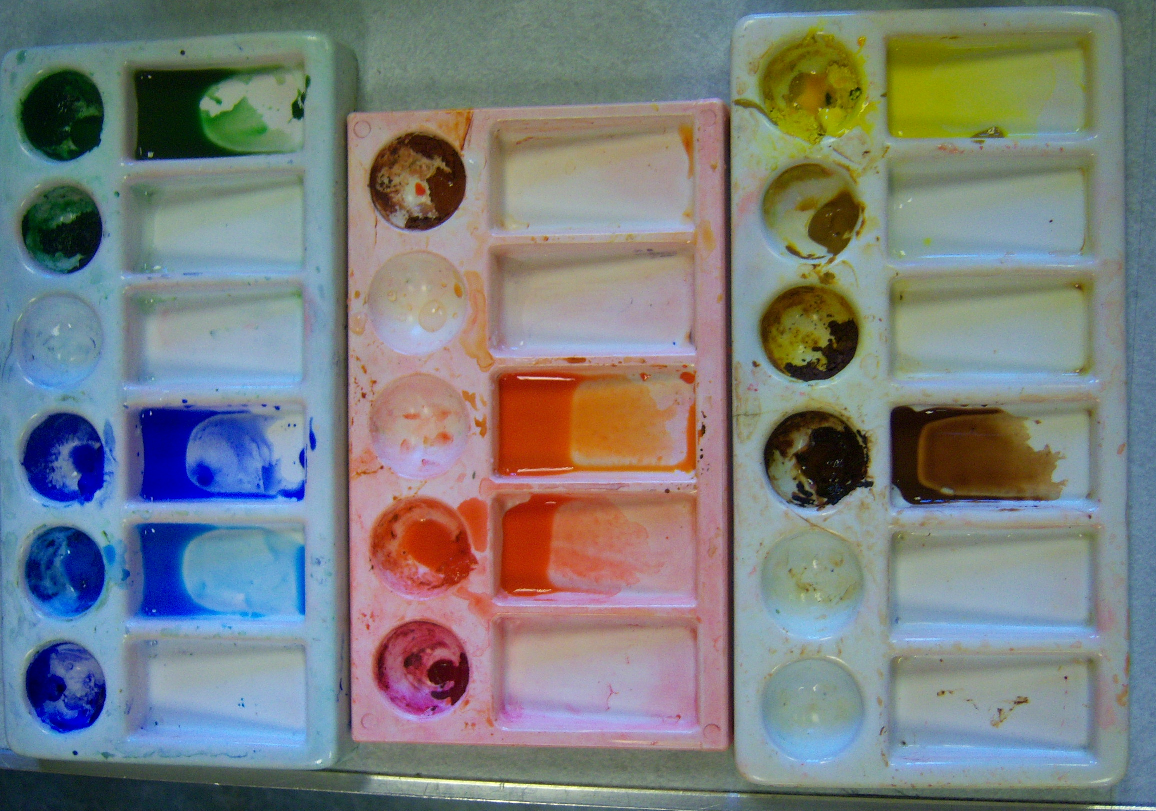
My own layout is shown here. The reserve wells (the round ones into which I squeeze colours from tubes) are used for:
Left hand palette- ultramarine blue, cobalt blue, manganese blue, viridian green (rarely used nowadays), hookers green.
Middle palette- permanent rose, scarlet lake, light red.
Right hand palette- burnt umber, quinacrodine gold, raw sienna, transparent yellow.

I am happier working with three palettes, it gives me lots of wells to play with colour mixes whilst retaining the principle of a limited palette (palette in this context meaning the different pigments with which one works).
The photo shows that I’ve mixed a scarlet lake on its own and a mix of scarlet lake with transparent yellow in adjoining slant wells. An advantage of slant wells is that they allow for the mixing of relatively large quantities of paint.

