Monochrome Study with a shock of Colour
Watercolour
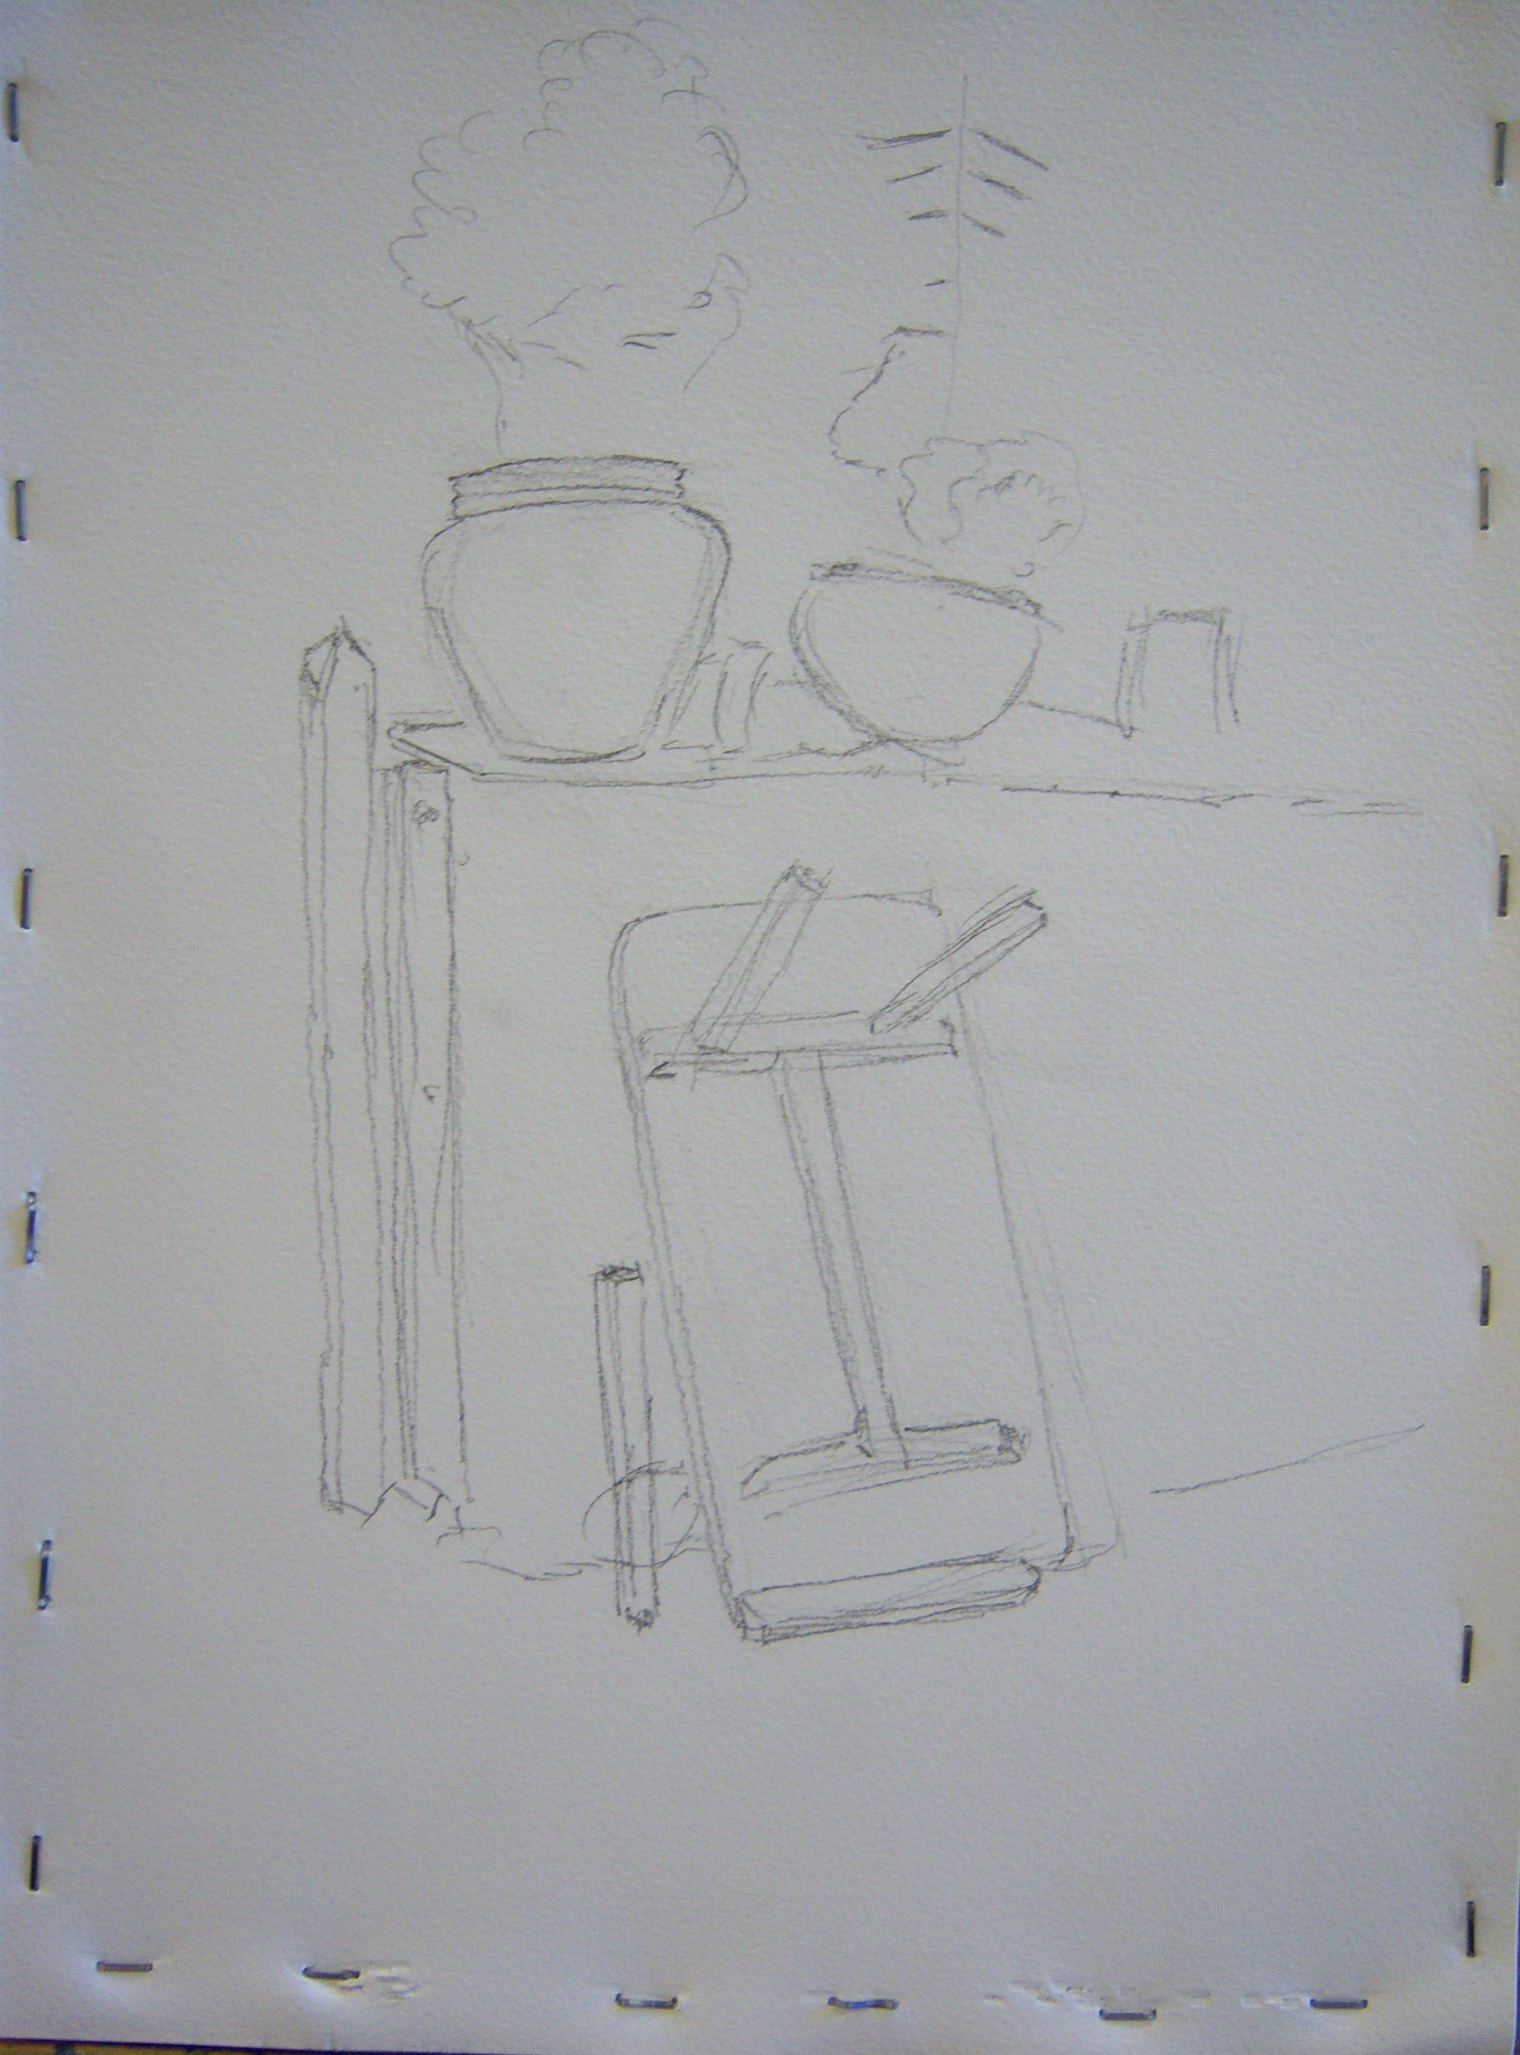
A Quiet Corner, Watendlath
The starting point was to draw in the basics with pencil. At this stage it was necessary to make decisions which would affect the final image and I chose to omit the gate at left which seemed to be a distraction.
We began with a plan, simply stated, that we would create an image in monochrome and finally highlight one element with a contrasting, but harmonious colour.
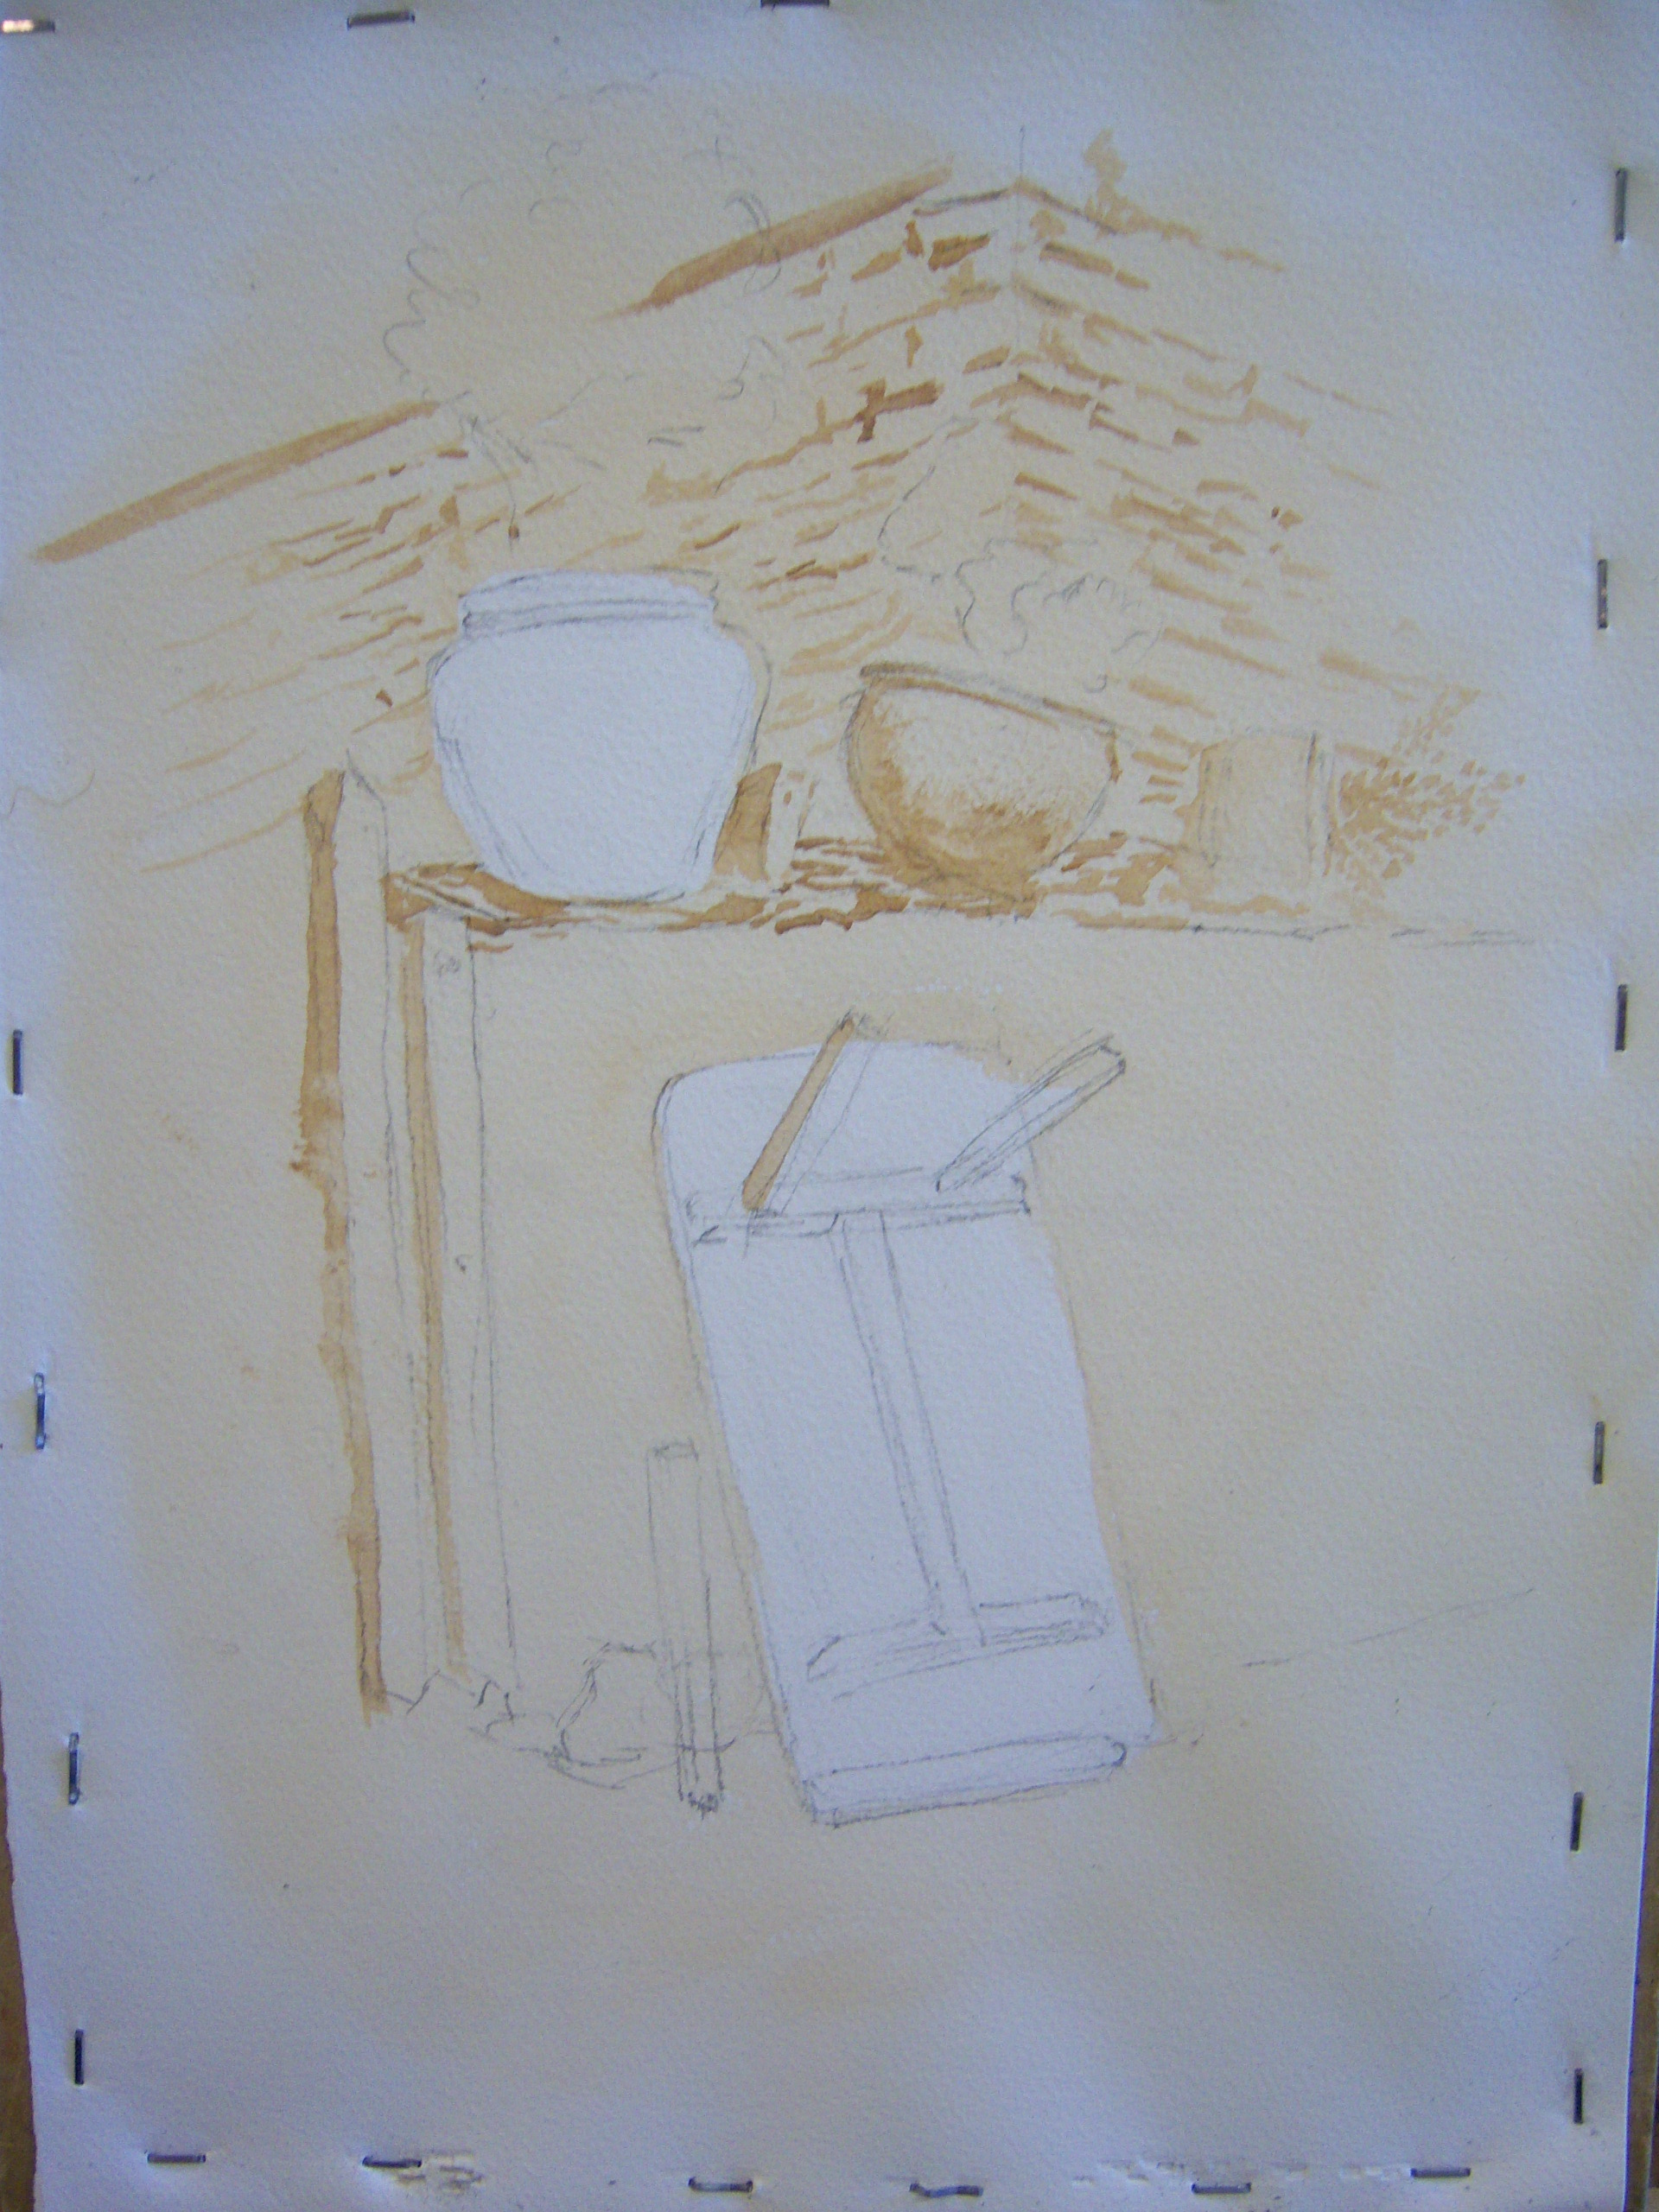
The choice of pigment for the monochrome element needed to be one that could produce a strong dark. I chose burnt umber which gives an old fashioned, “sepia photo” feel to the final image which would be contrasted with a bright shock of (probably) light red on the left hand planter on top of the wall in the final stages. The choice of colour(s) will influence the mood of the final painting. Reds will give a warm feeling and blues a cold one, for instance, the contrasting colour can be in harmony with the whole (choose from the same side of the colour wheel) or a complimentary colour to give greater drama.
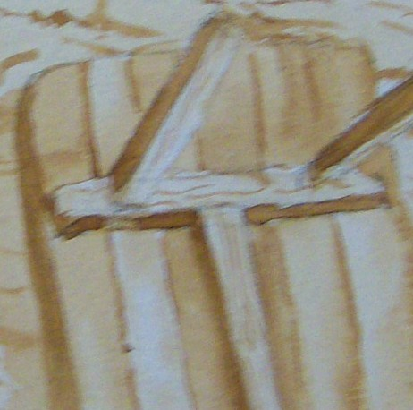
Water was brushed around the outside of the image to accentuate the vignette of the finished picture. A thin wash of burnt umber was applied over the whole of the picture except for the table and the left hand planter. The water around the outside helped to fade the wash to the edges of the image. When dry, simple marks were over painted to indicate the corner of the stone building in the background and some shadow areas in the foreground.
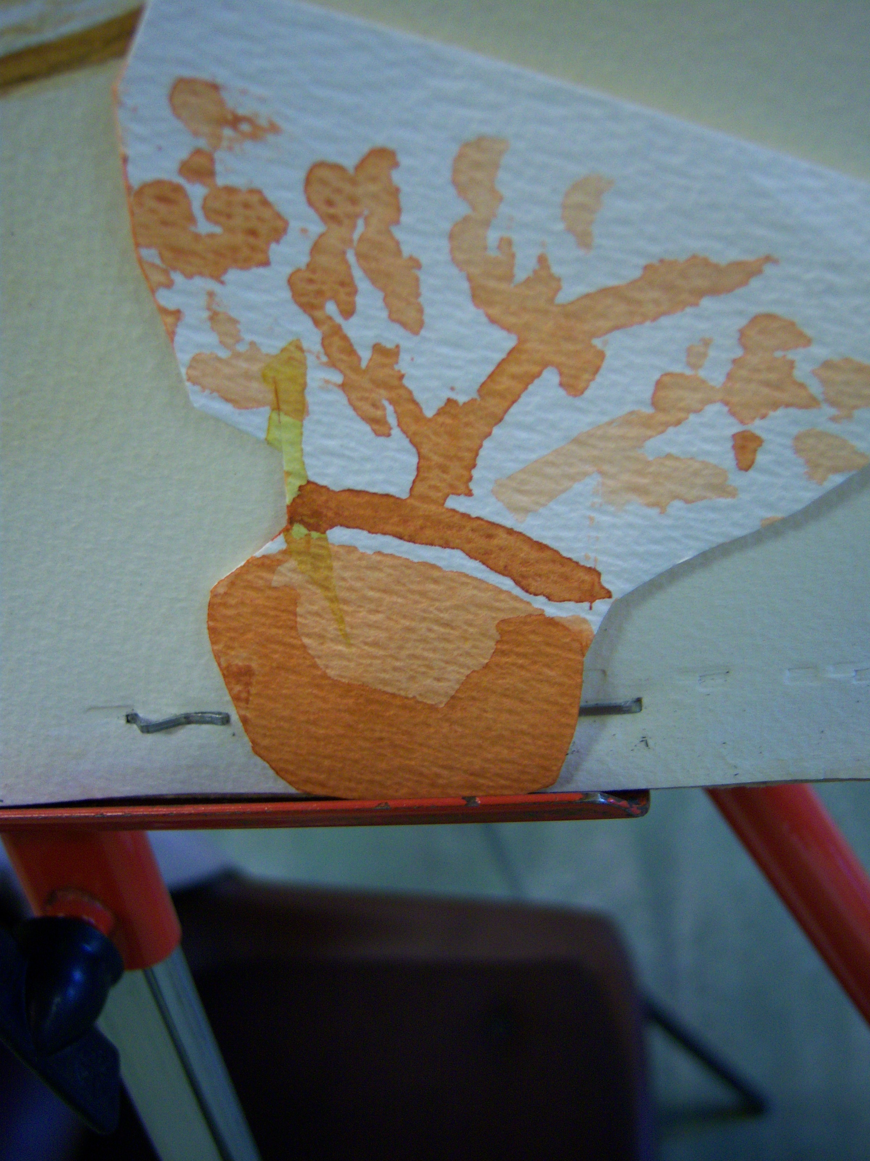
The picture was developed, using a stronger mix of burnt umber in the foreground, indicating texture on the floor with random marks and describing the boards in the table. The boards were varied in tone to give variety and the gaps between loosely described with broken lines.
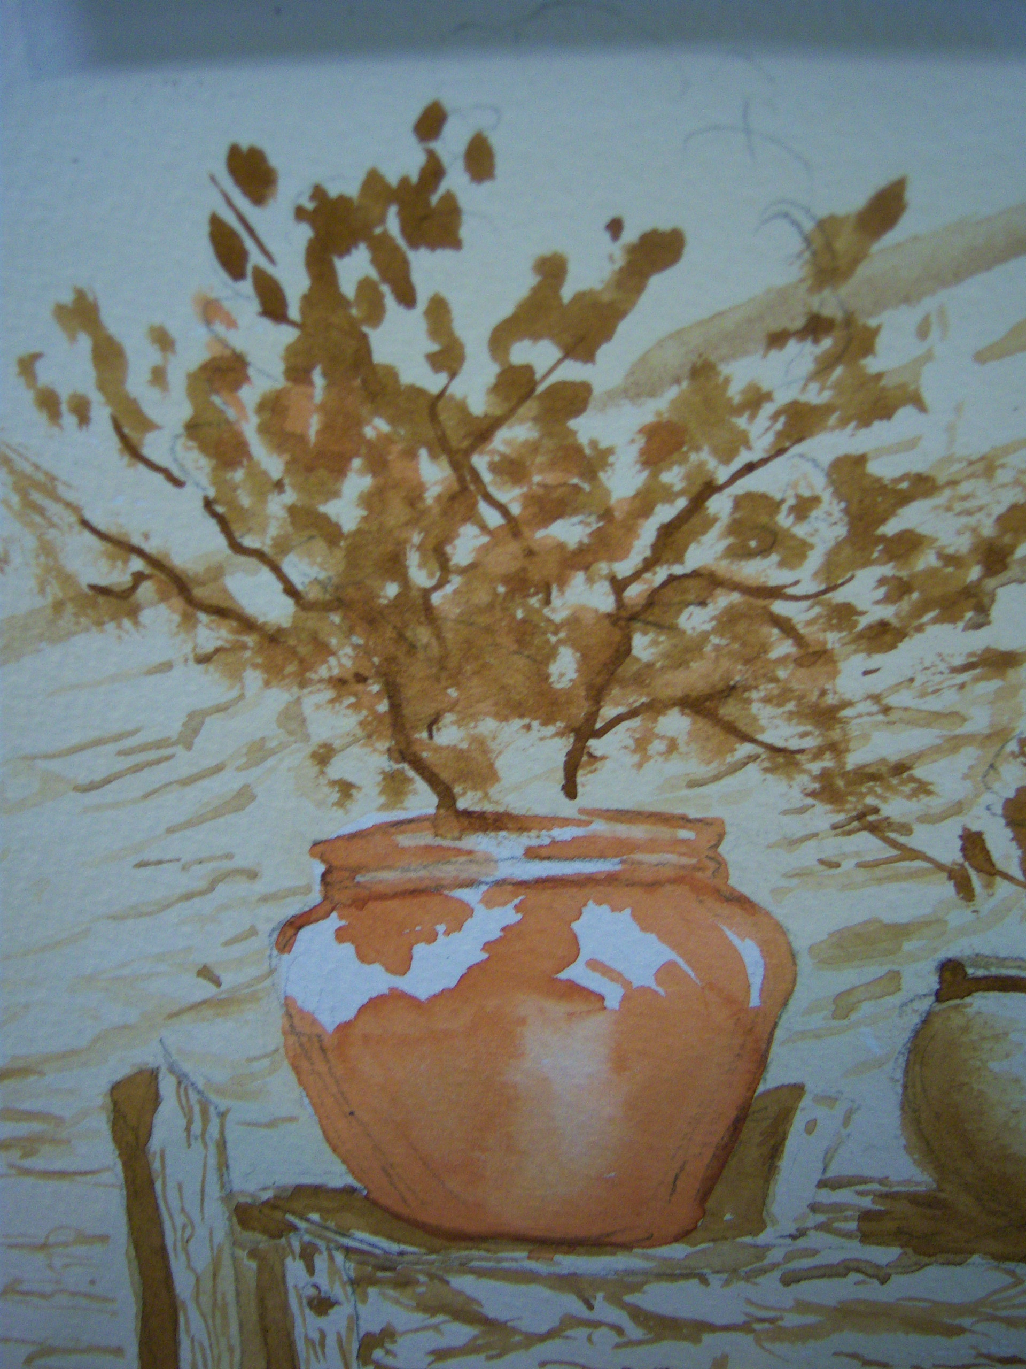
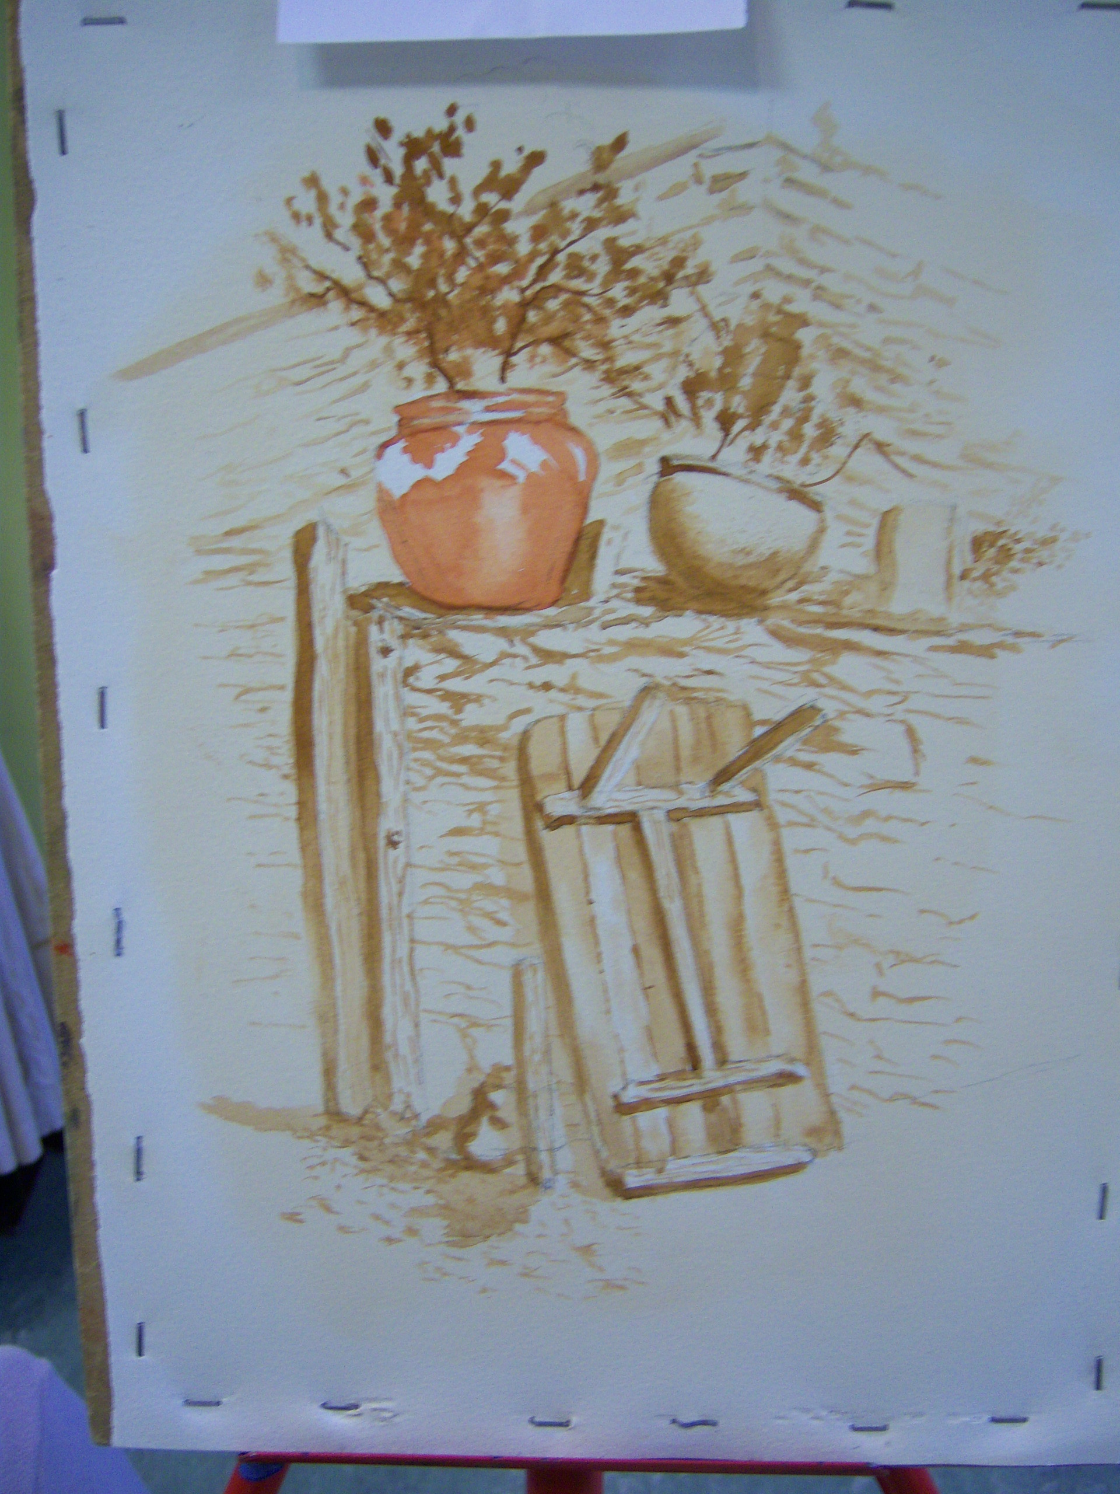
At this point it was necessary to decide upon a suitable colour for the main pot. The first choice was light red and this was used to roughly imply a pot on a scrap of paper which was then held in position on the main painting to assess its effect. Having accepted the colour as appropriate, the pot was then painted in on the picture. The foliage of the plant in the pot was described with fairly random marks, using a printing block technique in burnt umber and, near to the pot, some light red. Branches of the plant were loosely painted in with a rigger, holding the brush at the tip of the handle between finger and thumb and allowing the brush to dictate the marks.

Fairly loose marks were used to indicate stonework in the wall and shadows were painted over the composition with a weak mix of burnt umber.

I thought that the picture was complete at this point, but a couple of days of examining the picture at leisure suggested modifications.

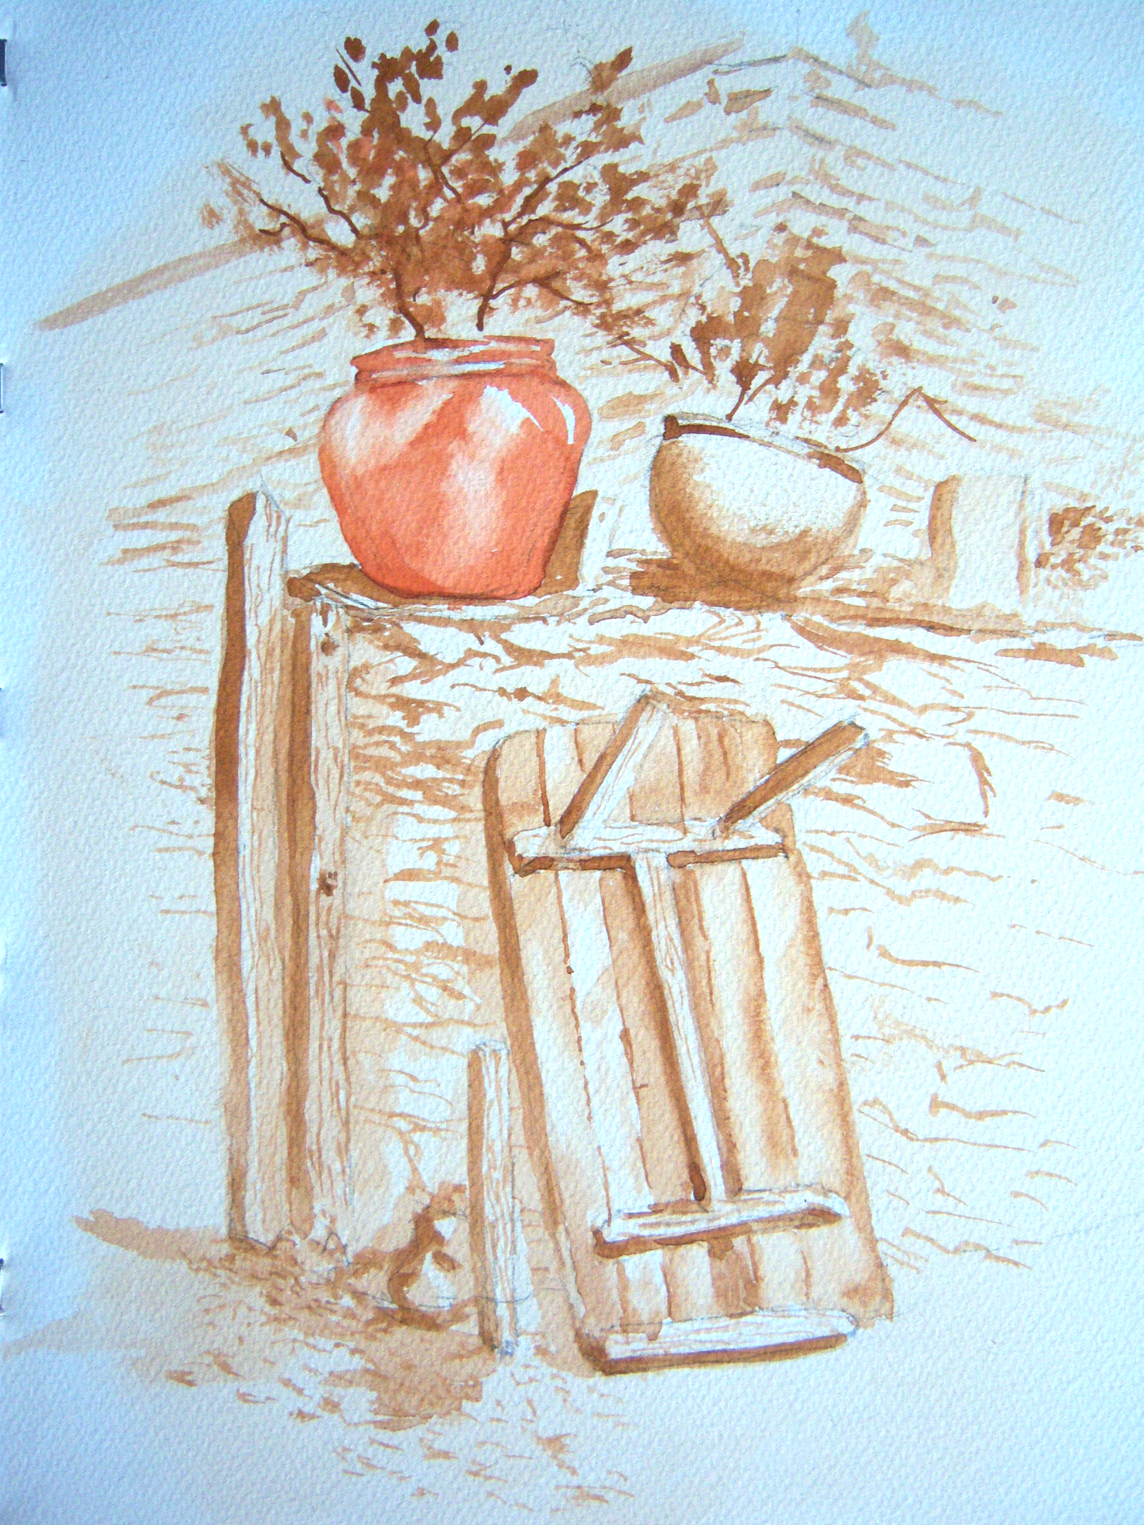
The white highlights on the pot were too insistent. They were modified with a moist brush. Light red was then used to define the left edge, this mark was also modified with a moist brush

A thin mix of burnt umber on its own was used to hint at:
The end of the wall

Shadow cast by the table legs

Shadow cast by the table, the leg leant against the wall

