Summer in Keswick
Palette: Cobalt Blue (CB), Light Red (LR), Burnt Umber (BU)
Paper: Fabrian Artistico 140lb NOT stretched on a board.
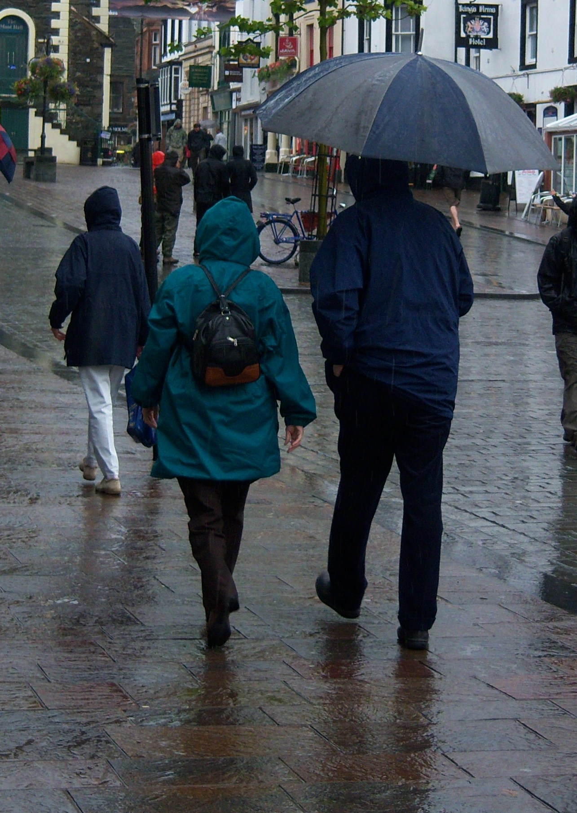
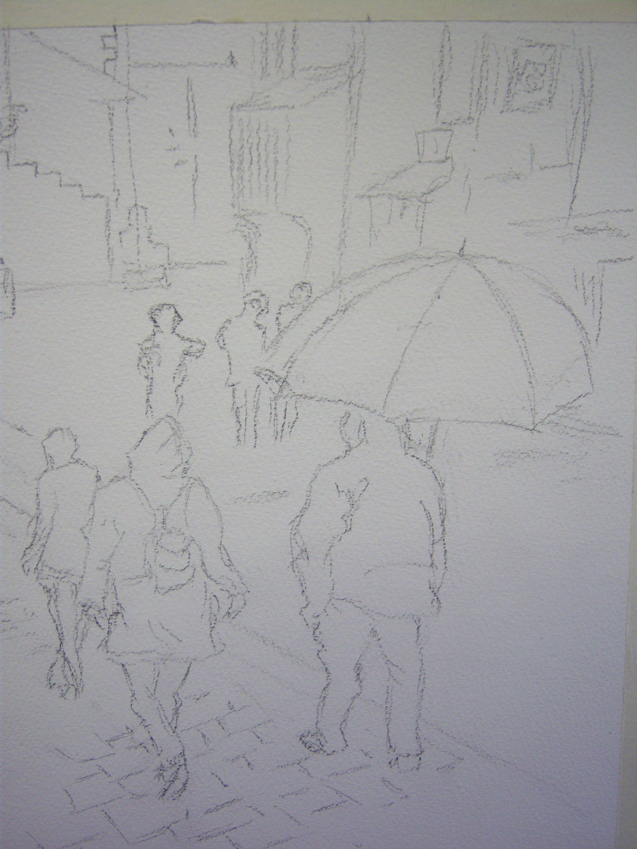
Stage One: The source material was used as a starting point and a pencil sketch prepared for painting. The idea was to retain enough detail to make the context clearly Keswick whilst not becoming bogged down with detail that would detract from the central theme of people in rain.
The building at top left is important in setting the scene. Anyone who knows Keswick knows the Moot Hall with its distinctive corners. So we need only include very little to establish our location.
A word about perspective; the distant horizon is clearly higher than the eye level of the foreground figures which tells us that they are going up hill.
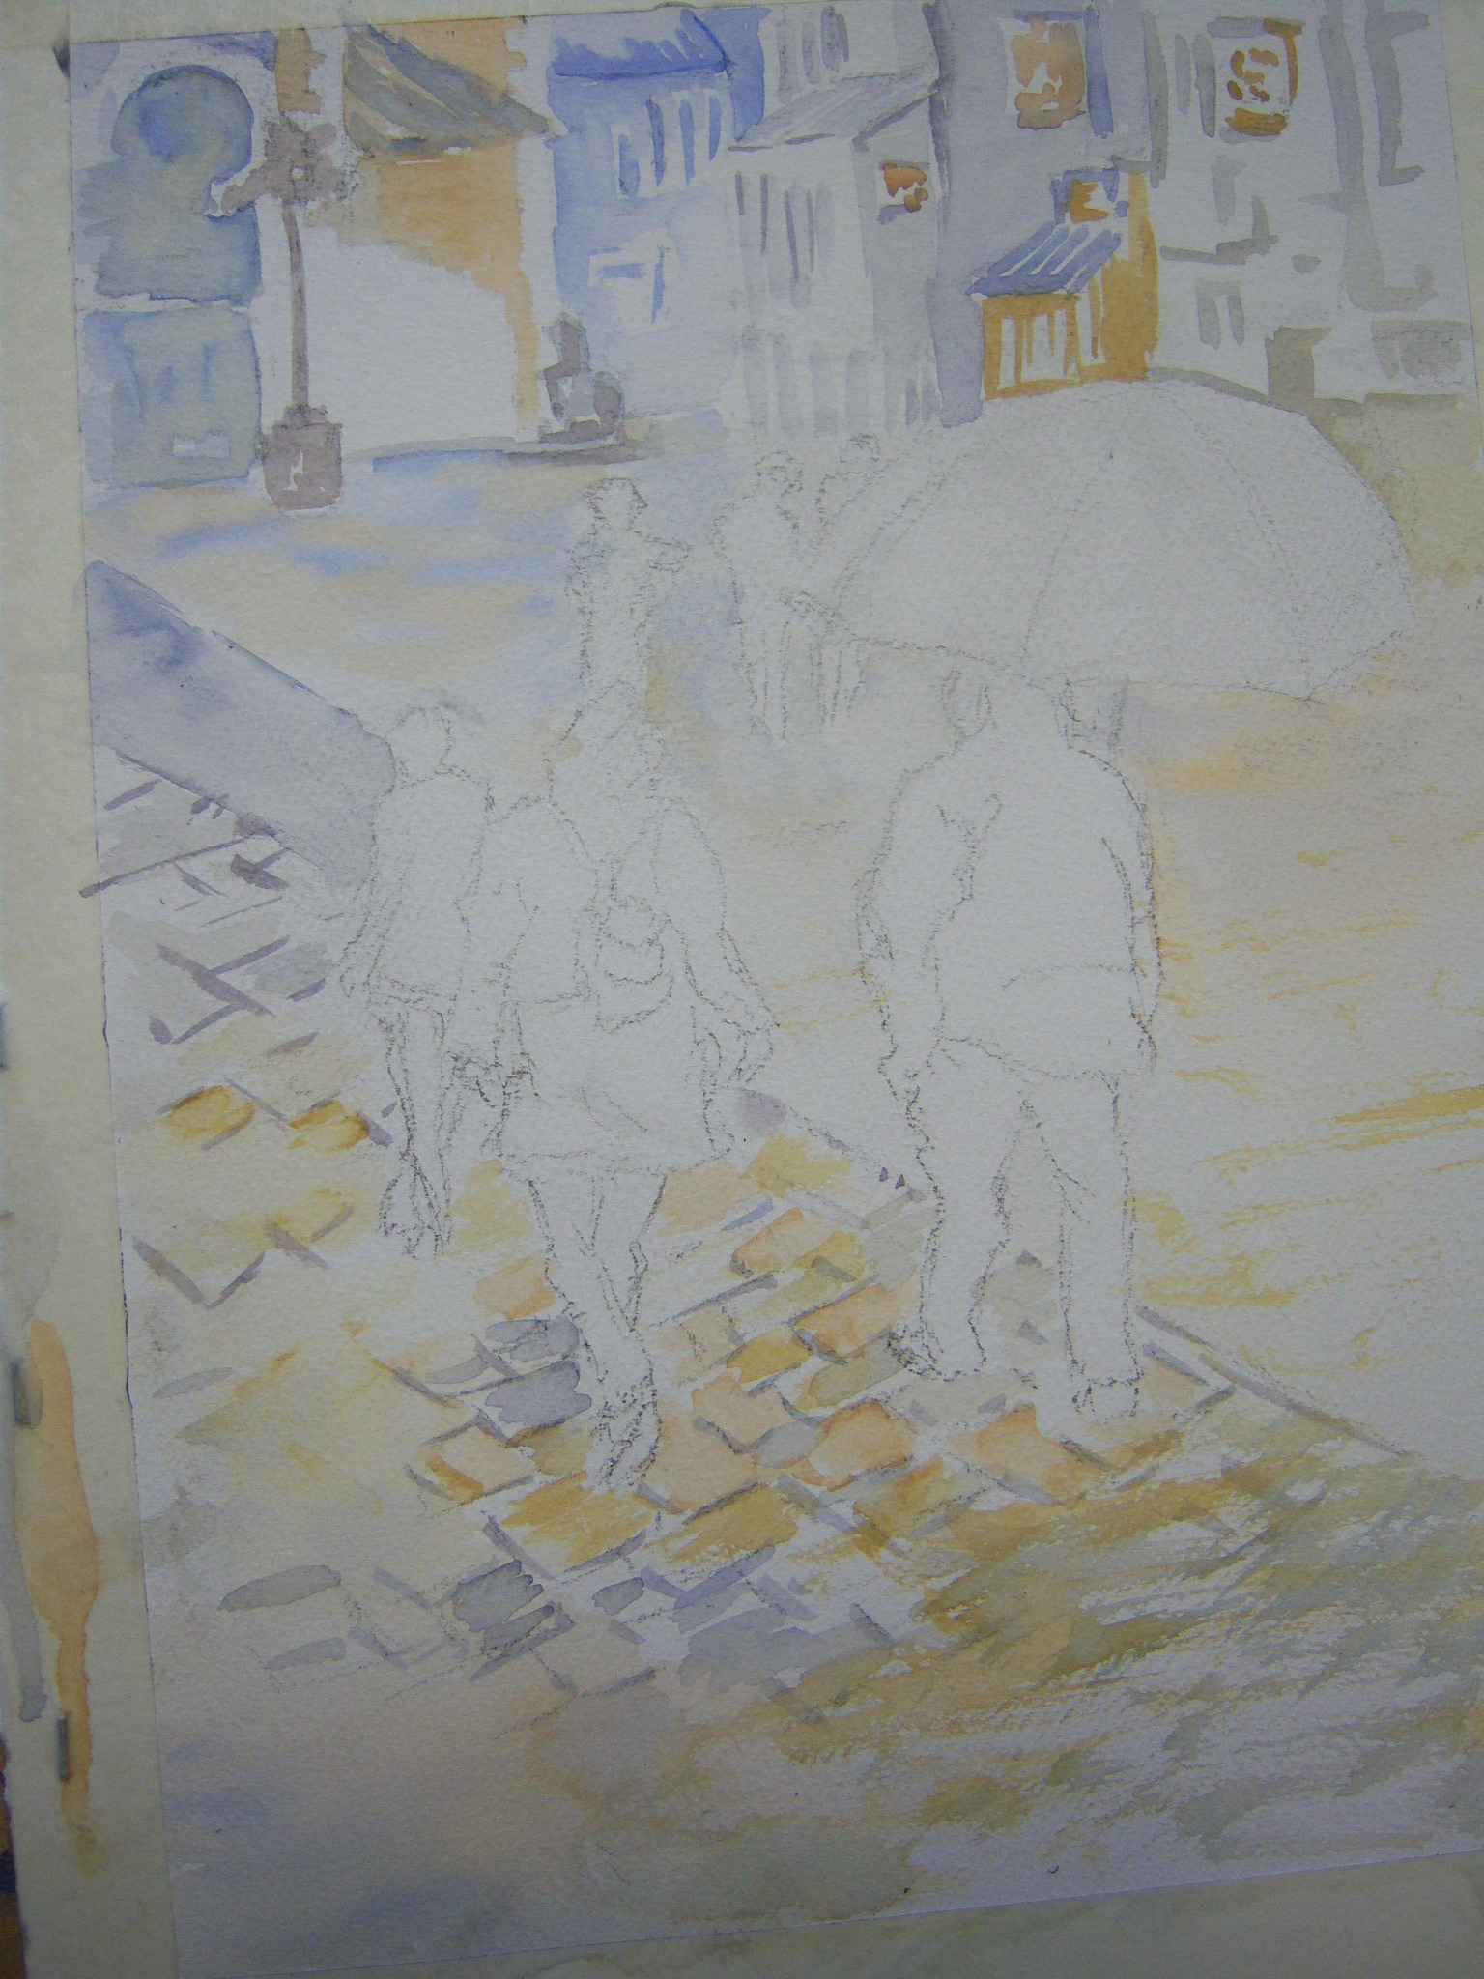
Stage Two: Distant buildings were sketched in, wet onto dry, selecting from the palette as seemed appropriate. The palette included a grey (G) mixed from CB + LR and a darker grey (DG) – same mix less water. The central cobbles were ignored (although they may pick up some detail at some point in the future) but the paving stones were indicated with DG between the slabs here and there. A bit of dry brushwork (and a lot of artistic licence) at bottom right left light paper which may come in handy later on. The majority of paint on the road was applied wet on dry and then pulled and manipulated with a moist/wet brush.
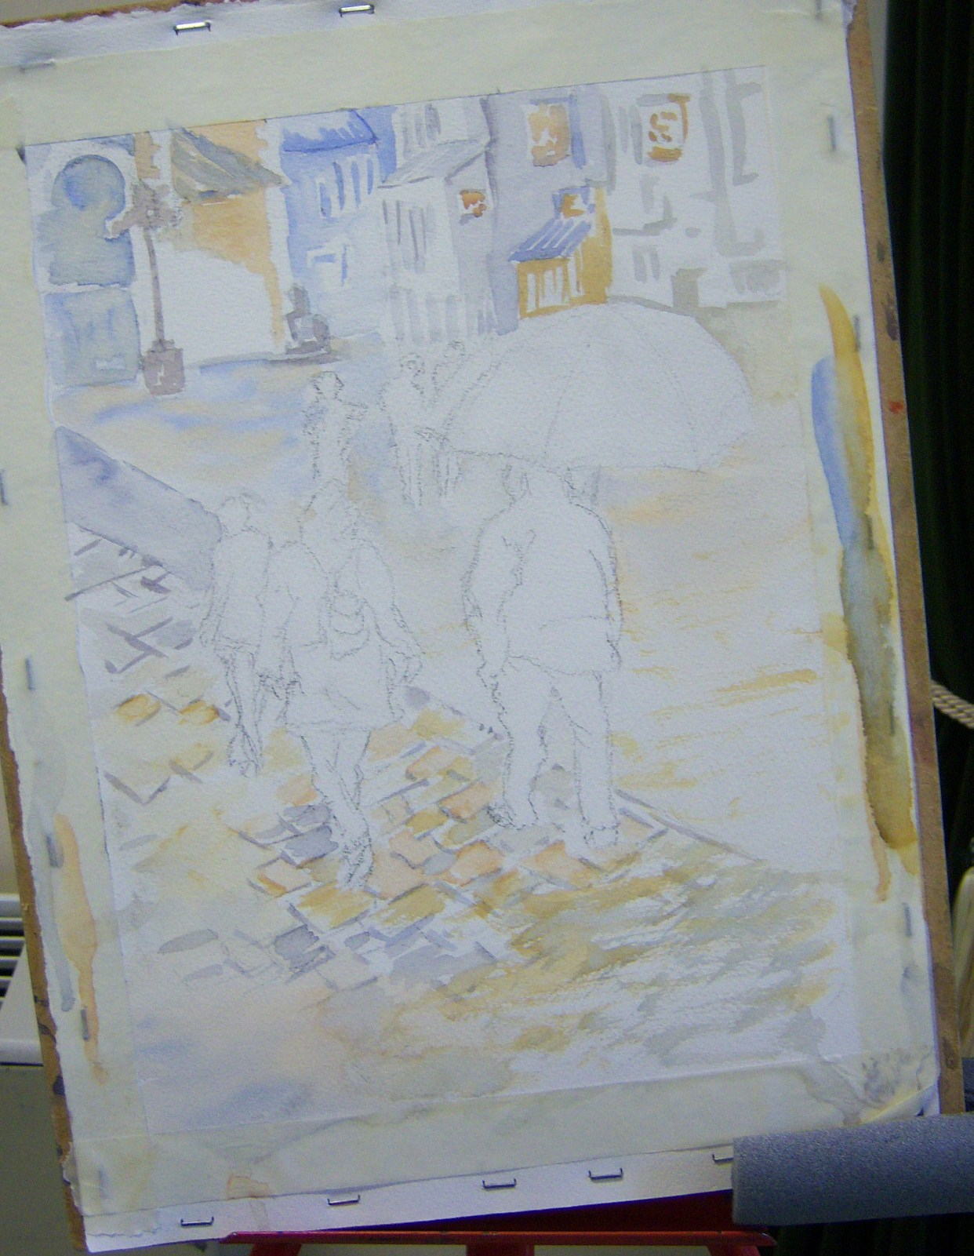
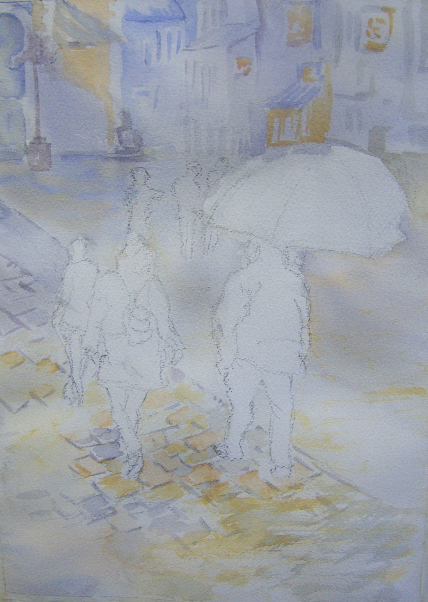
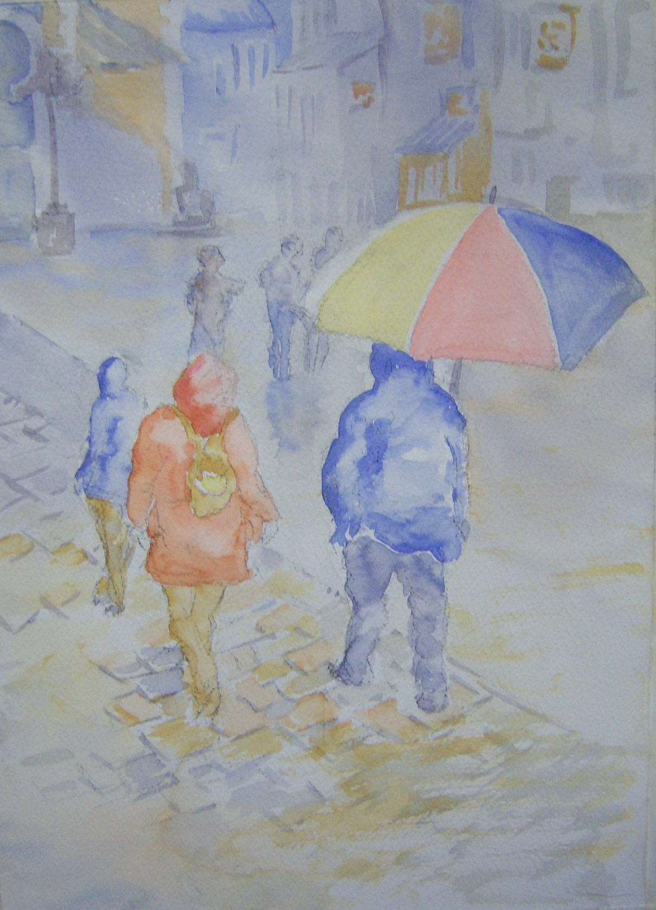
Stage Three: The board was tilted, using a piece of insulating foam at one corner. The idea is that the applied wash will follow gravity and we should get lines of grey rain with fringing at the bottom implying rain coming in at an angle on the wind. The whole was wetted except for the three main figures and stripes of DG painted across the paper. Gravity was allowed to pull at the paint to form fringing but failed to co-operate. We will try again later on. In the meantime.. The painting was allowed to dry completely. The distant group of figures was painted in by making marks wet onto dry and then pulling the paint around with a moist brush. A small area was wetted beneath these figures and reflections painted in wet into wet.
Raw Sienna (RS) and Scarlet Lake (SL) were introduced to the palette and the main figures and golf umbrella painted using the same, wet onto dry pulled through with a moist brush technique.
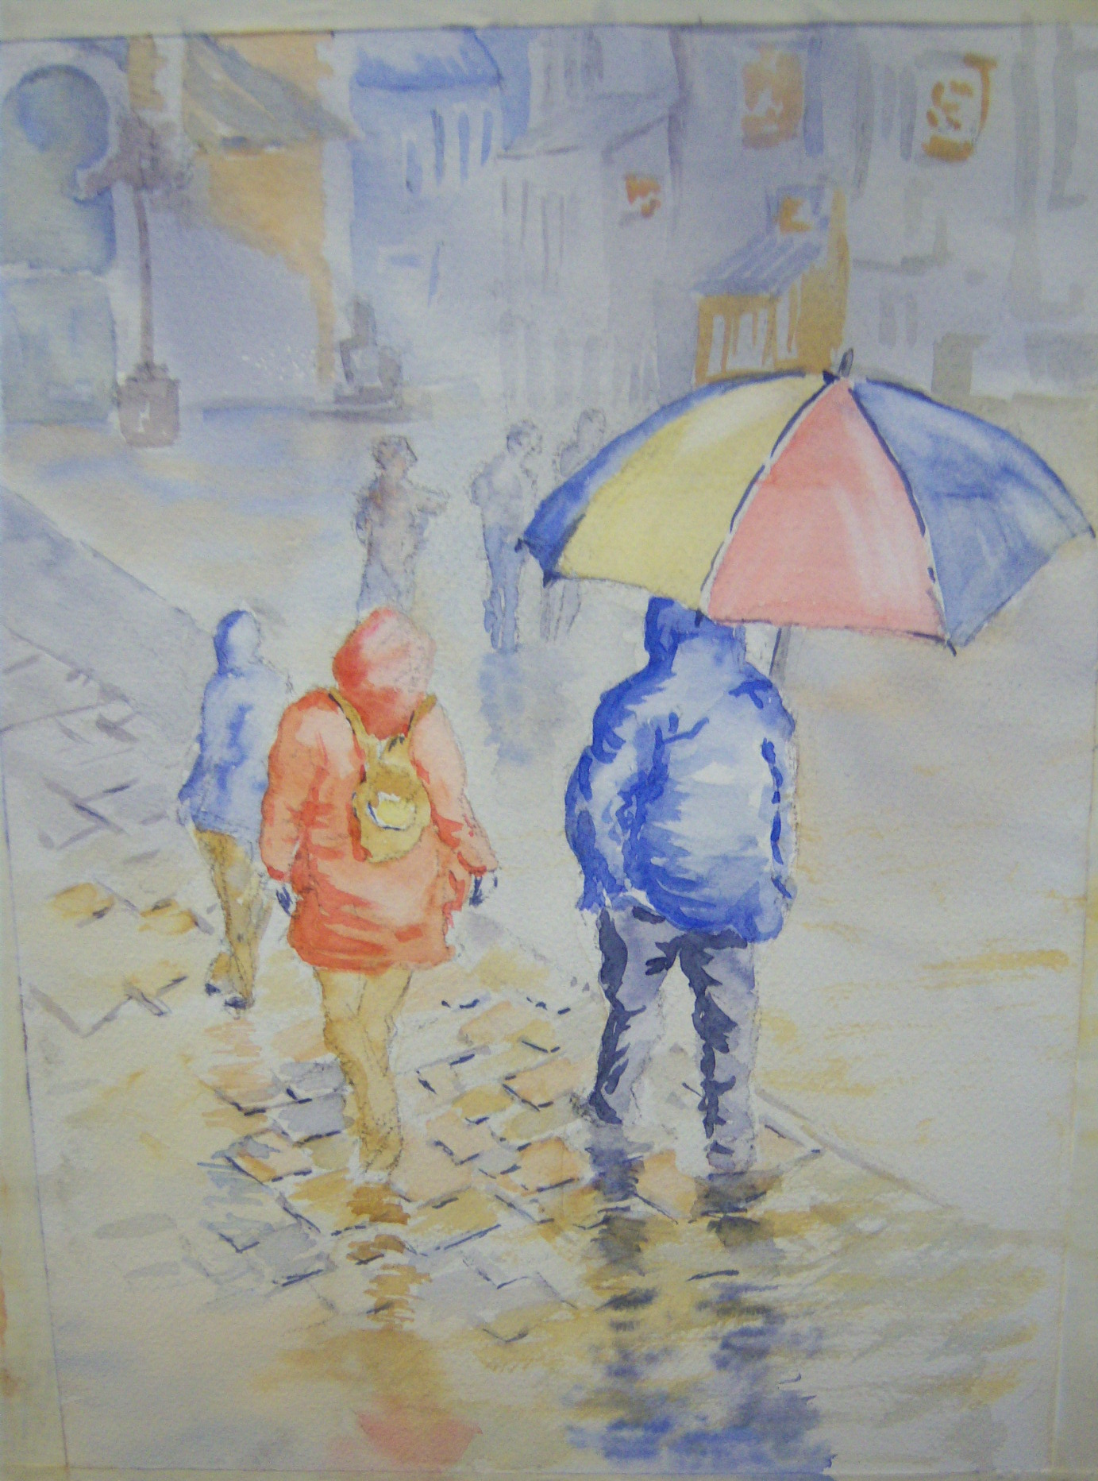
Stage Four: A black (B) was mixed from CB plus LR, using as little water as possible. This was used very selectively to indicate the edges of the paving slabs, the ribs on the umbrella and the odd little mark where it would enhance the composition. Next, the main figures were given modelling by using the same colours as the kagoules etc but applying a mark wet onto dry and not further modifying the mark. This has the effect of hard-edged marks which help to bring the figures forward in the composition.
The reflections were now added sing the same colours as the objects creating the reflections.
Here the reflection is on wet slabs. A number of “wiggly” horizontal marks were made with a rigger with gaps here and there (ie not a continuous mark), then modified with a moist bush to soften the effect.
Here the reflection is in a puddle. The puddle area was wetted with clean water and the marks made again with a rigger, horizontals more or less continuous and allowed to “do their thing” without further modification.
A little colour was lifted from the umbrella in places to imply wet fabric. An attempt to give an impression of wet, semi-transparent fabric was not successful- can’t win ‘em all.
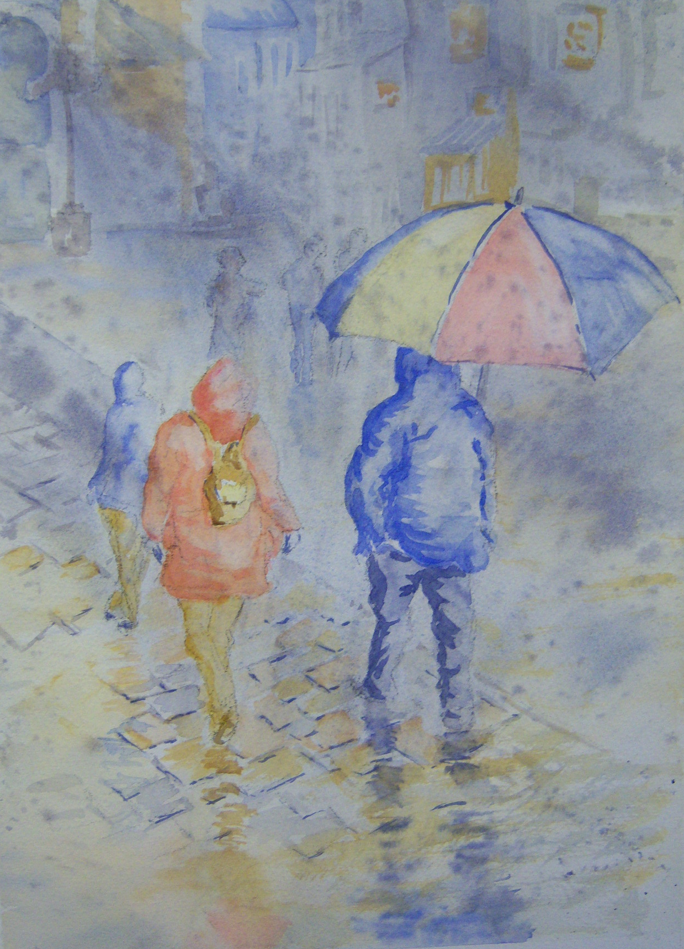
Stage Five: Finally we came to the end, which is where finally generally is. This was a grit your teeth moment.
An angle was established using the foam as in Stage Three, above.
The entire painting was thoroughly wetted with a hand-spray. Then, muttering the mantra “It’s only paint and paper”, B was spattered in diagonal lines on to the wet paper. Two spatter methods were used, flicking the bristles of an old toothbrush and flicking from a round watercolour brush.
Having hopefully given the impression of driving rain, the painting was left to dry.

