Tarn in the Wood
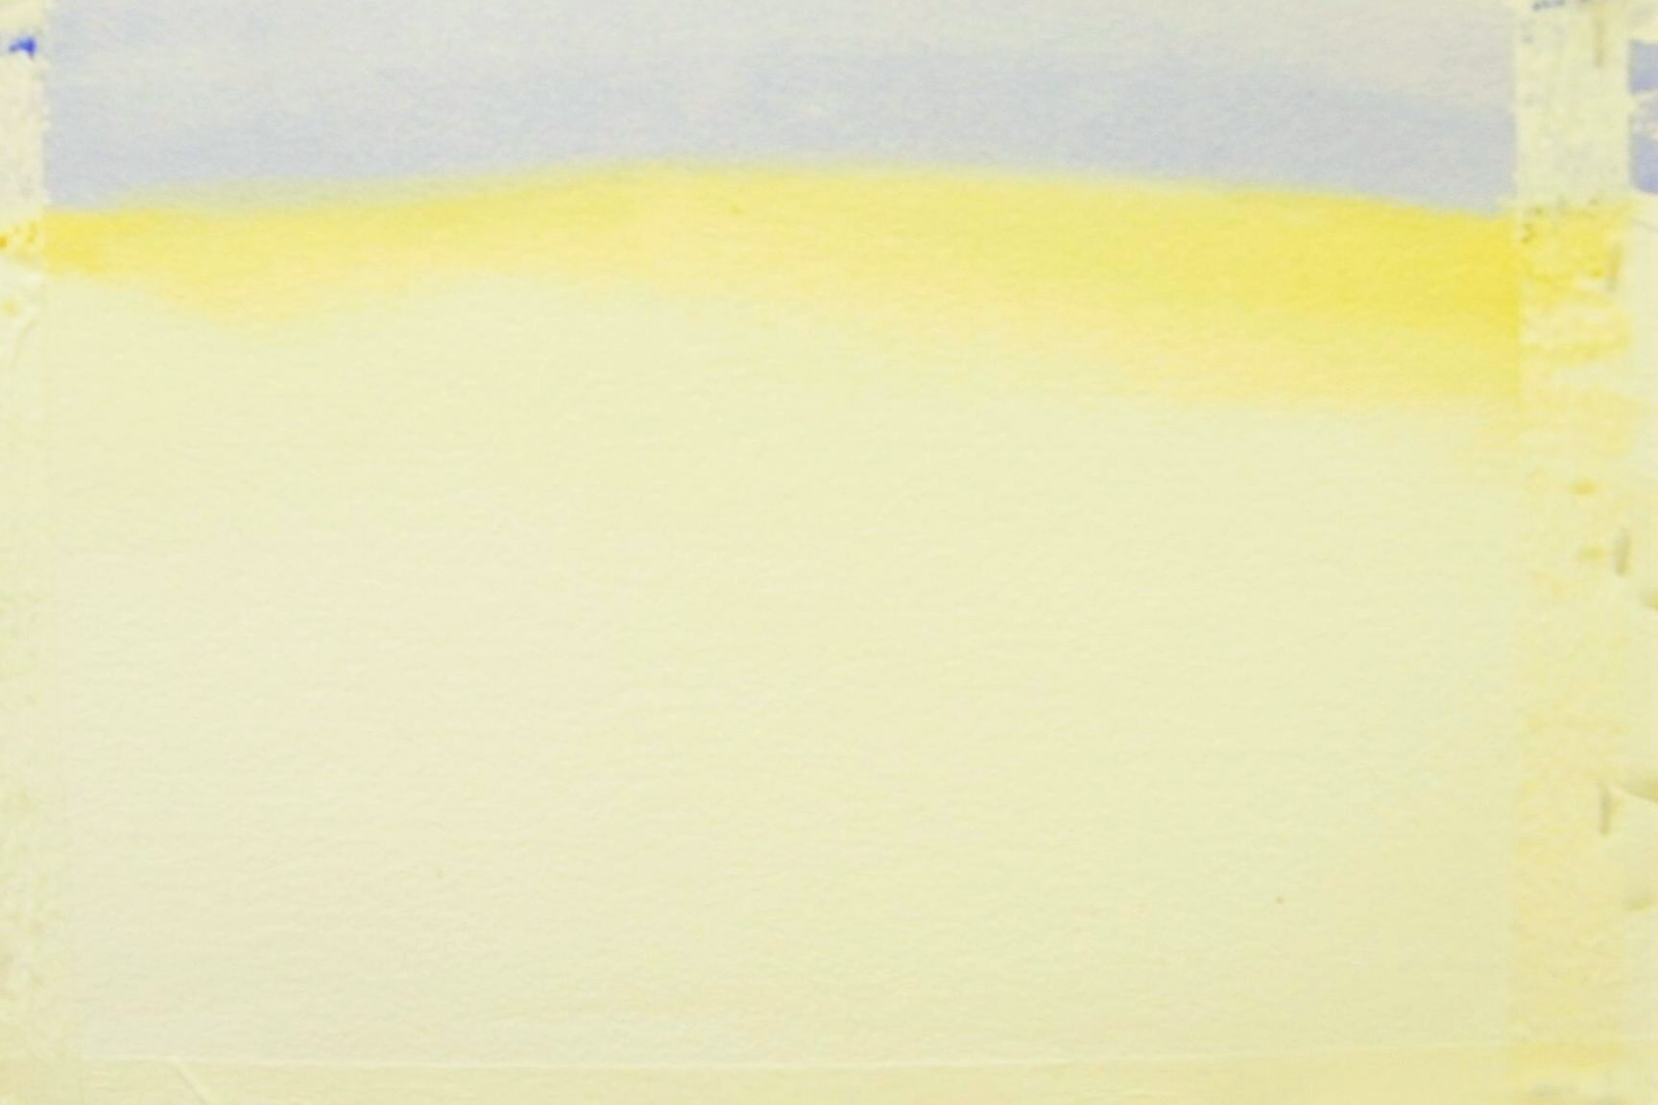
This project was started with two objectives- to paint in pure watercolour (ie with no preparatory pencil sketching) and to demonstrate negative painting.
Palette: blue= cobalt blue; grey=cobalt blue + light red; red= light red; yellow= quinacrodine gold; light green=quinacrodine gold + hookers green; dark green= burnt umber + hookers green; brown=burnt umber.
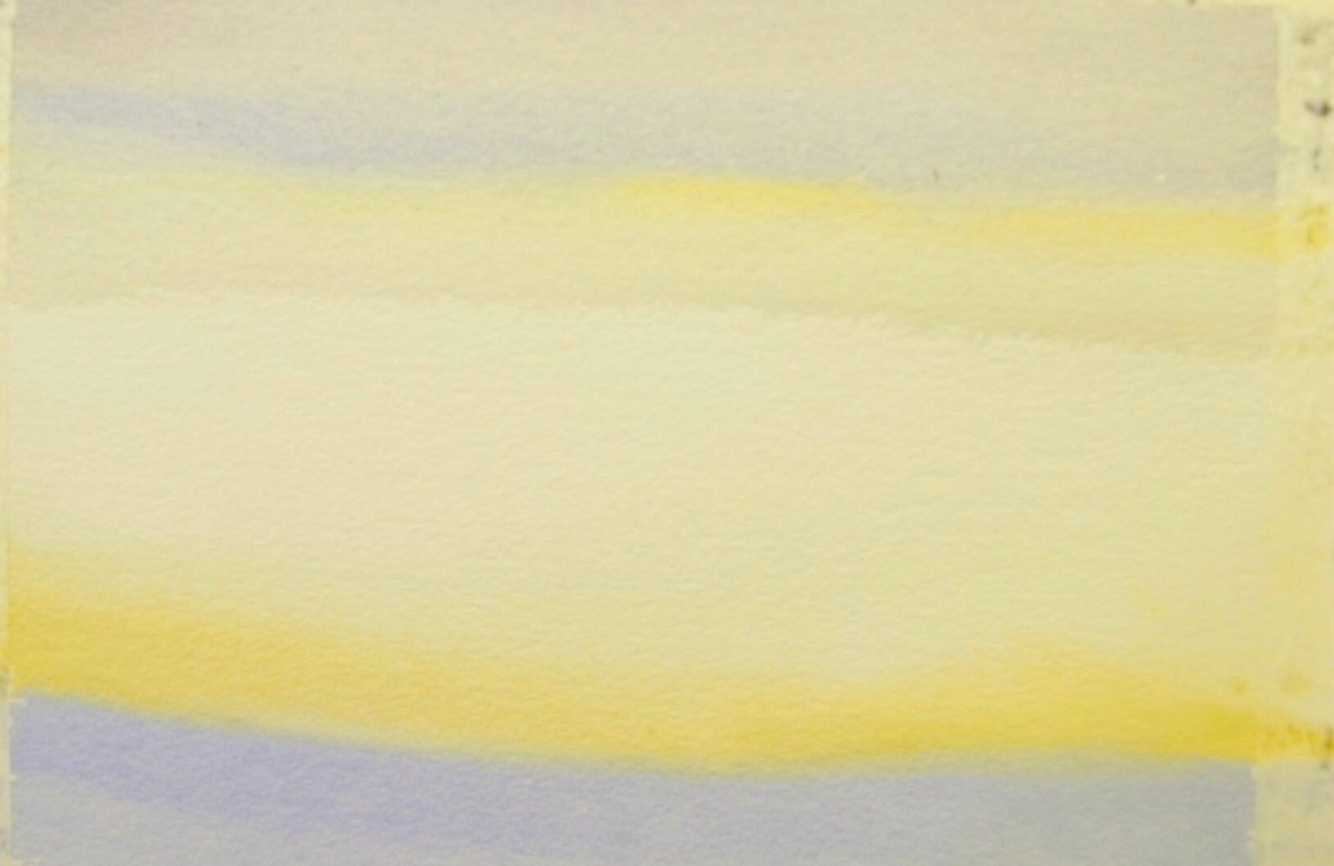
With the board at an angle, blue was painted wet onto dry along the top edge. A stripe of yellow was the painted overlapping this and this was pulled down with water all the way to the bottom of the paper. This was then allowed to dry.
Next the board was turned upside down and a stripe of grey applied along what was now the top edge. Again, this was overlapped with the yellow and chased down the paper with water BUT only to about a third of the way down the paper.
1/3
2/3

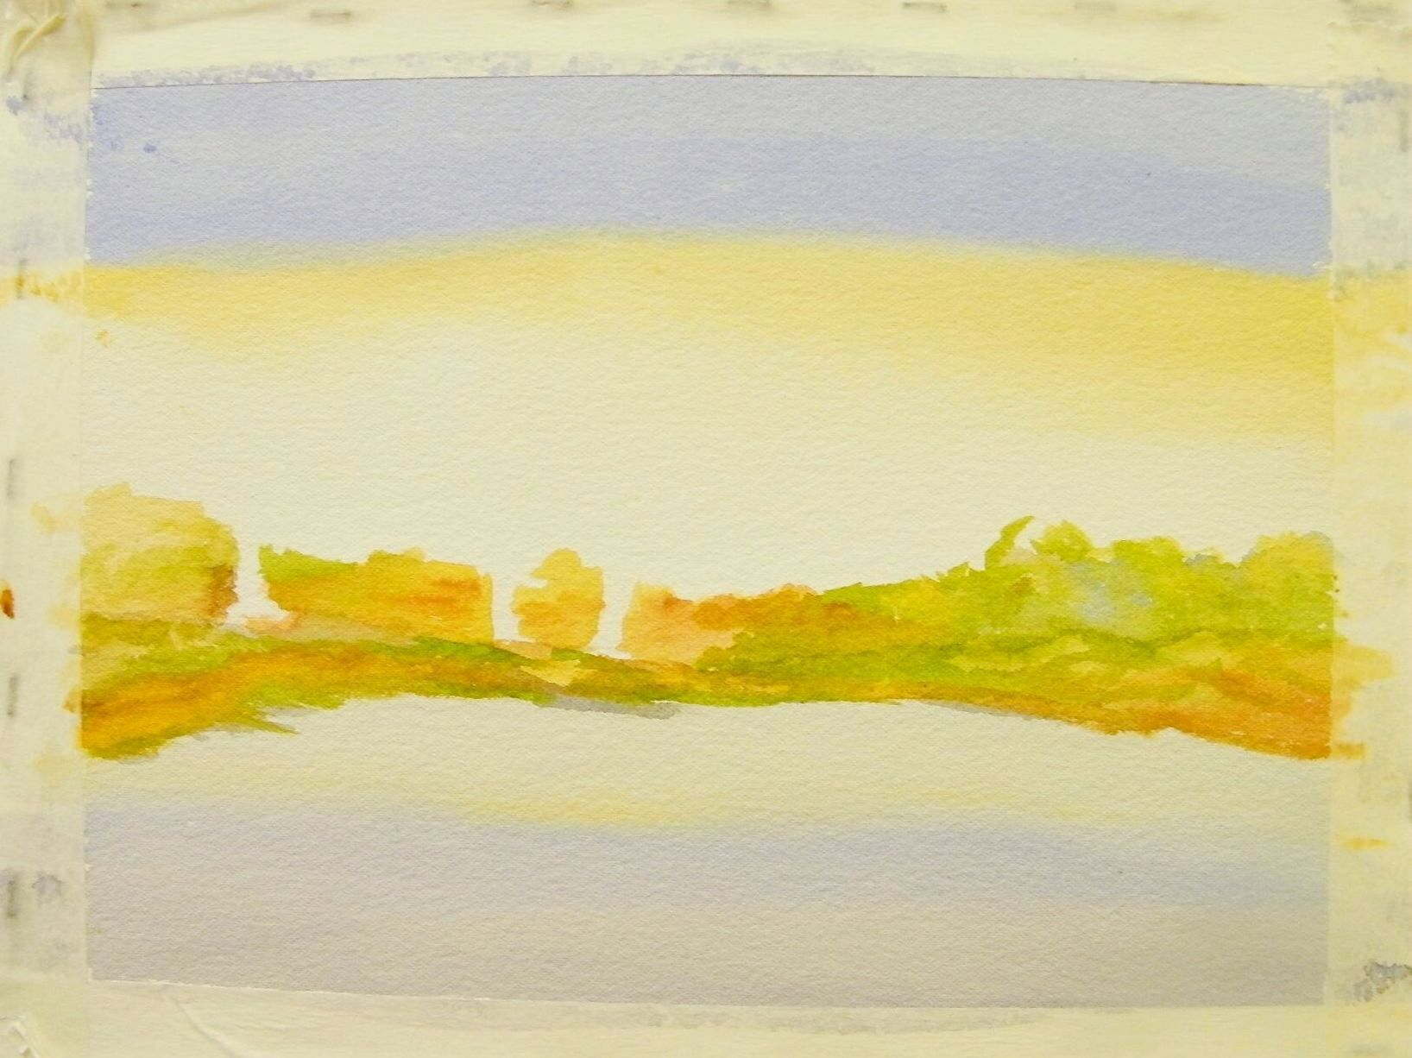
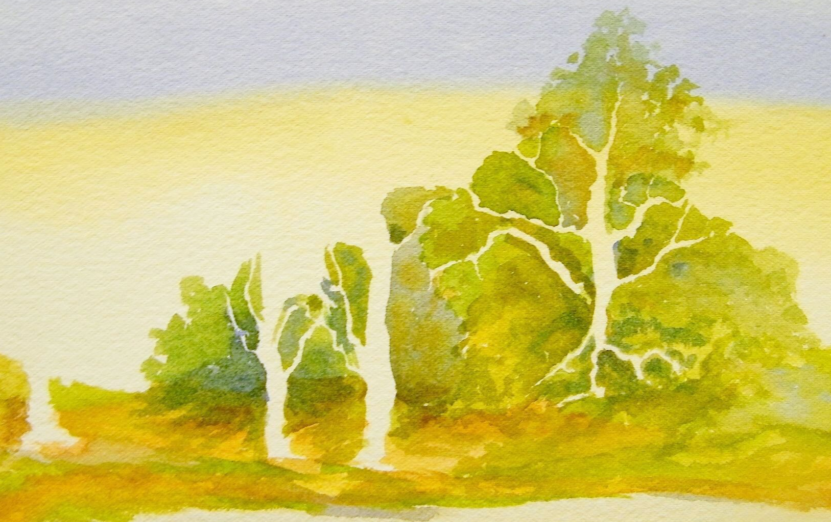
Brush and undergrowth were suggested with a combination of the yellow, light green, dark green and brown.
Where the shattered trees occurred white paper was left untouched to indicate trunks (negative painting).
Here the technique is continued and developed to indicate the shape of the trees. Colours were used from all parts of the palette to give interest and variety.
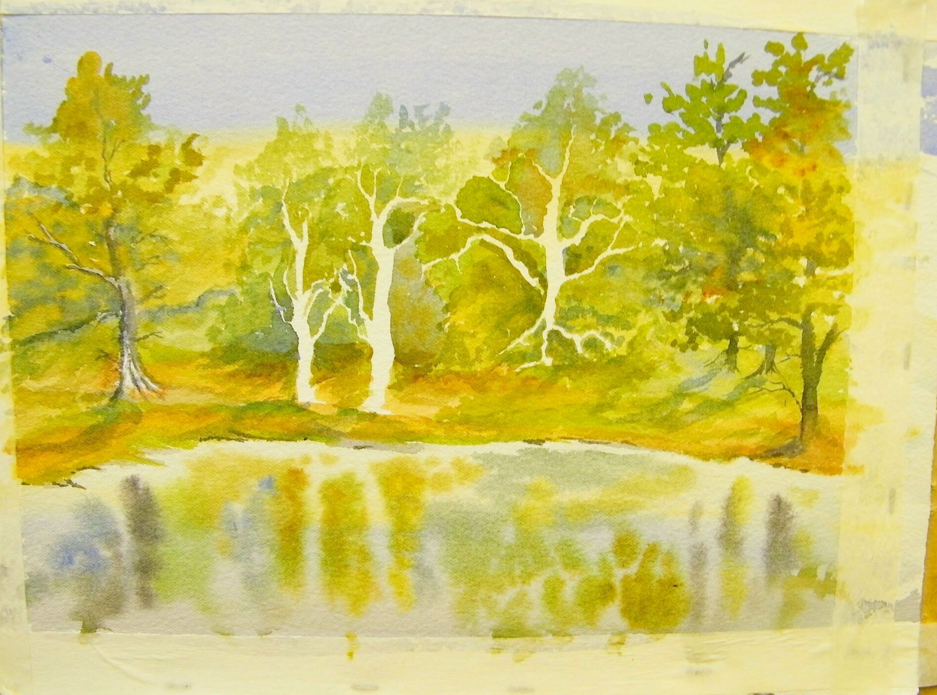
The tree at far left was painted as a dark trunk with some selective painting of the negative shape at base. Other trees were added using positive painting strokes.
The water area was wetted and reflections indicated with wet into wet vertical marks, remembering to leave white for the reflections of the negatively painted trunks.
At this stage I thought the painting finished... now read on-

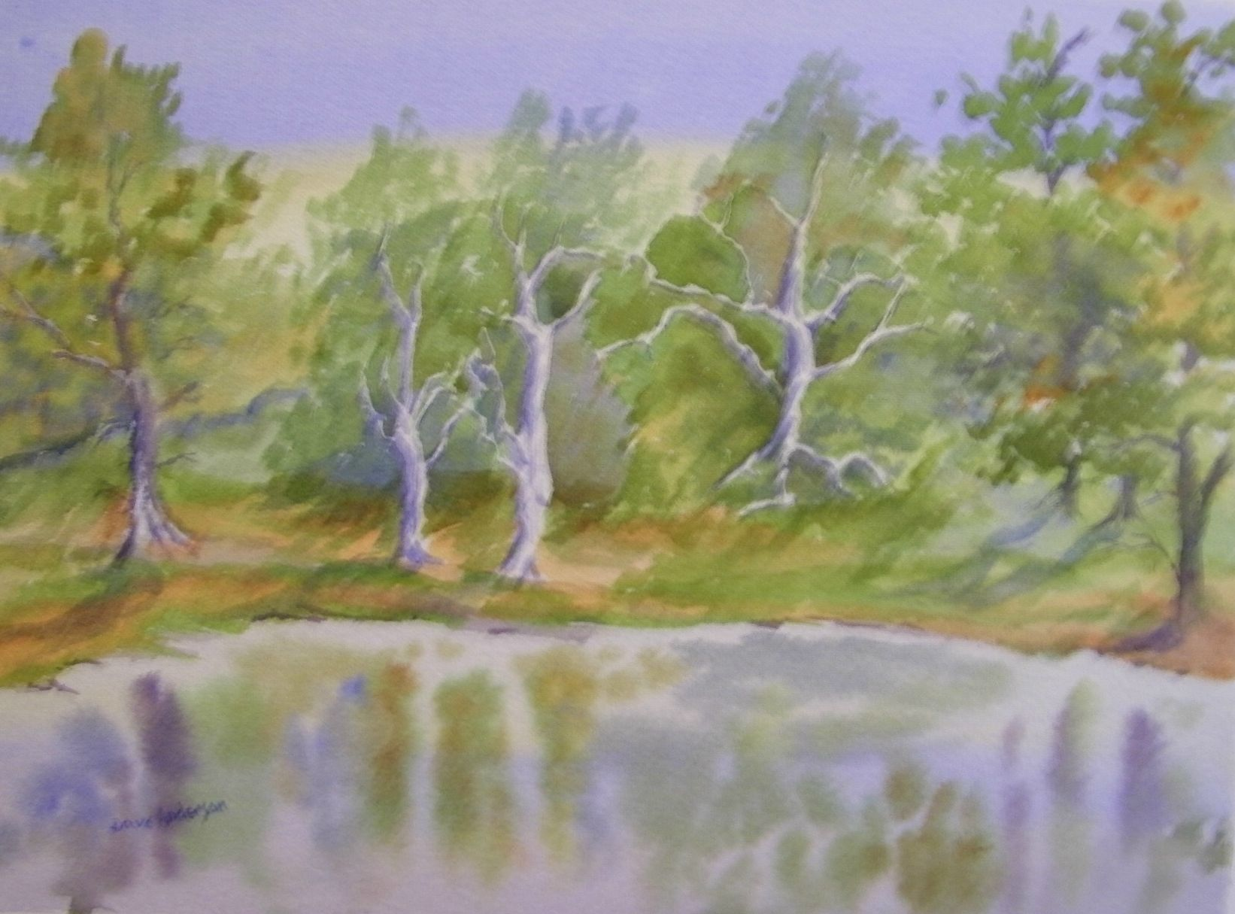
I did my usual thing of leaving the painting where I could see it at regular intervals and, after two or three days, the negative silhouettes of the trees began to annoy. I remixed the grey as before and also a darker grey/black (again from the blue and red, but with very little water added) and painted in greys on the shadow sides of the trees. When dry I added very thin marks with the grey/black. This gave modelling to the trees and the untouched paper suggested to me that the difficulties of negative painting had been justified.

Personal thoughts:
- Negative painting scares many. If you are nervous, think of it as positive painting of the spaces between the shapes you wish to leave unpainted.
- Working with pure watercolour is also daunting, but is very rewarding. It is easier to approach it, as in this case, by making the vast majority of marks wet onto dry.
- Try laying a mark and then introducing another colour to overlap part of that one. Experimenting in this way adds excitement to your painting and interest to the finished work. Yes, it does go wrong at times, but it’s only paper and paint at the end of the day.
- By the time you read this, I should have posted a better quality image on my other website- http://andysartwork.weebly.com

