Row Beck, Sandsend, North York Moors: Wash and Line

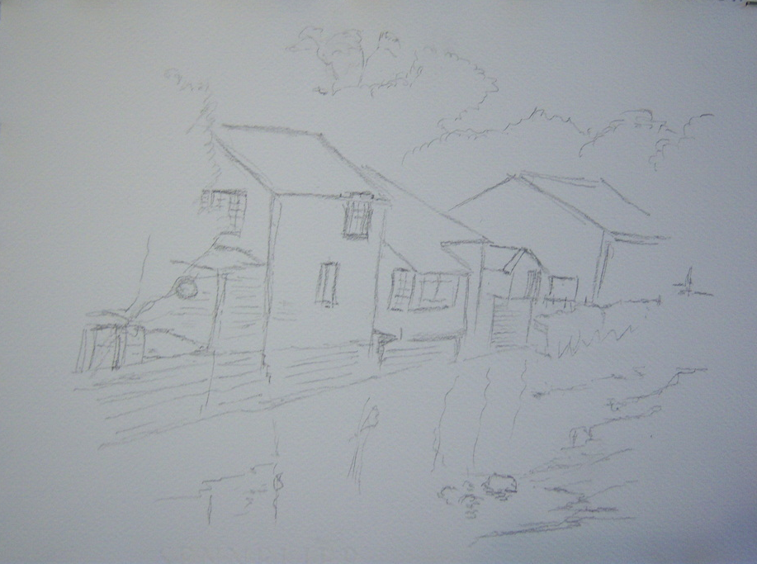
Paper was stretched Sennelier 140lb NOT.
The project was begun with the inevitable pencil sketch. Detail was kept to a minimum.
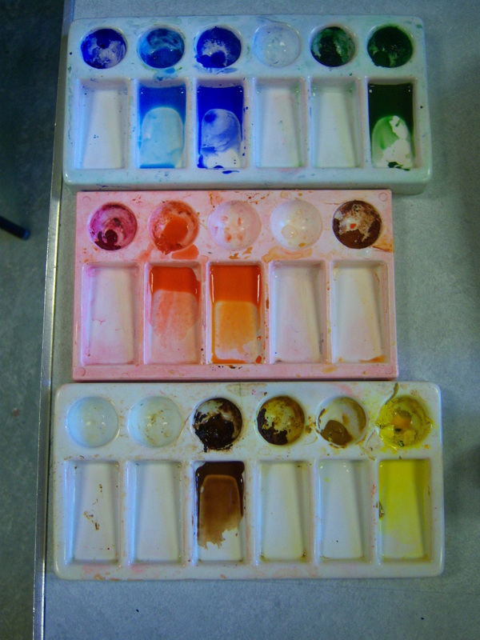
The Palette
From left to right. Abbreviation with full name in brackets.
Top- man b (manganese blue); cob (cobalt blue); hookers (hookers green) plus b umb (burnt umber).
Middle- s lake (scarlet lake); s lake plus t yell (transparent yellow)
Bottom- b umb (burnt umber); t yell

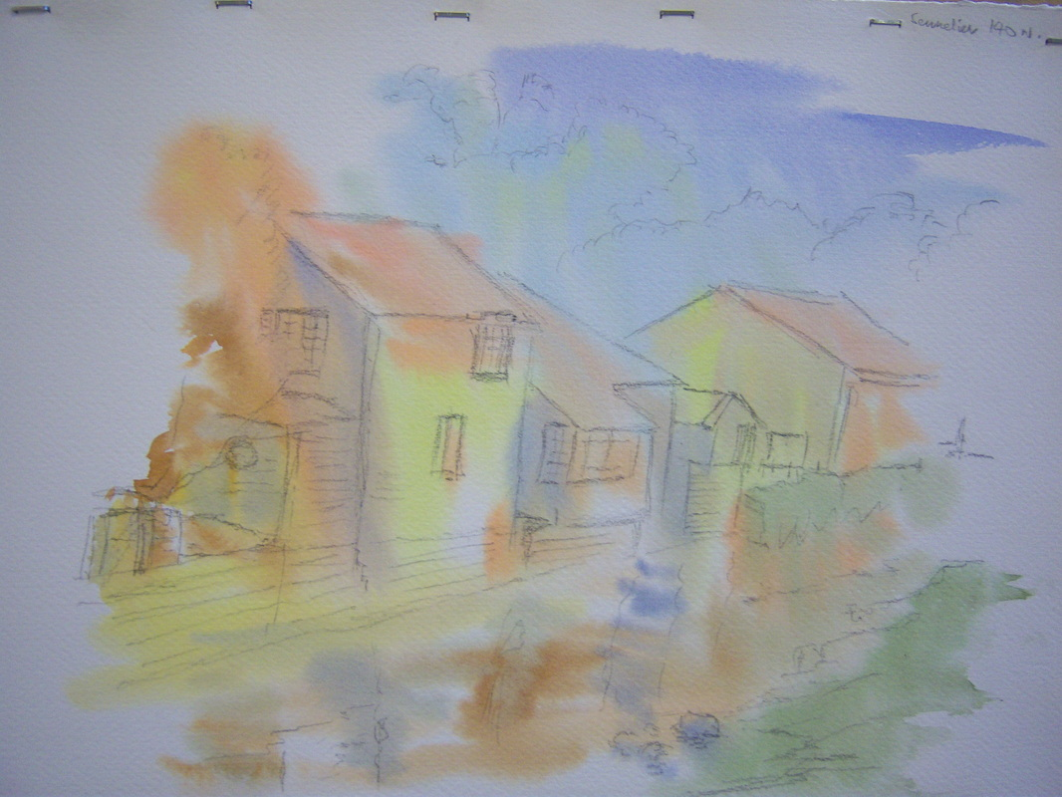
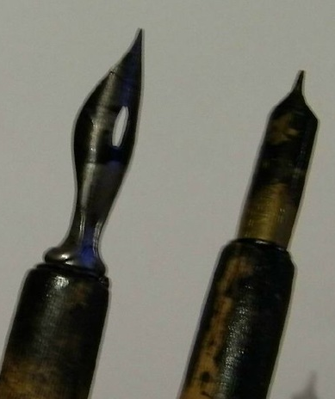
The paper was thoroughly wetted in all but the corners (to leave a vignette). Appropriate colours from the palettes were loosely applied in the places required and, with the board at an angle, gravity and the paint were left alone to do their thing.

Two nibs were selected, a chisel ended one at right and
A curvy, sharper one left. The one at left is the nib
I tend to favour for the majority of my ink work.

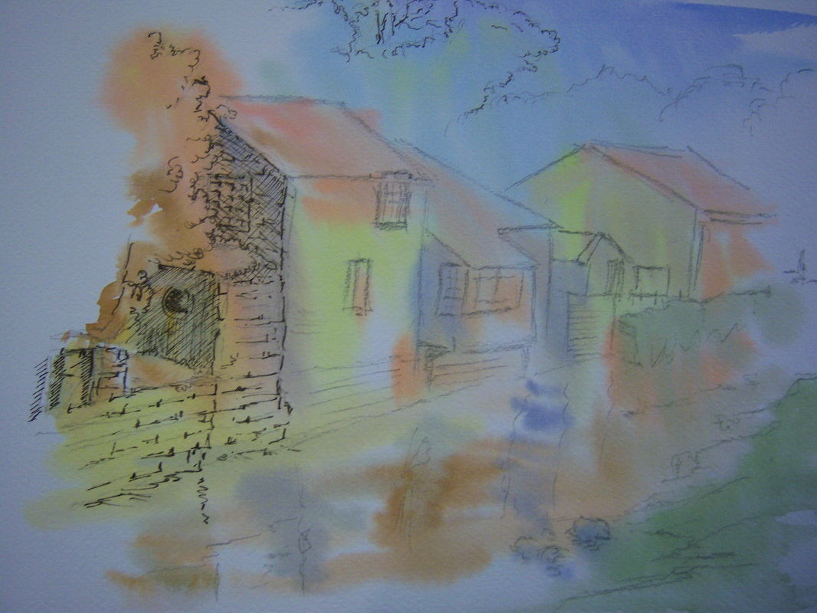
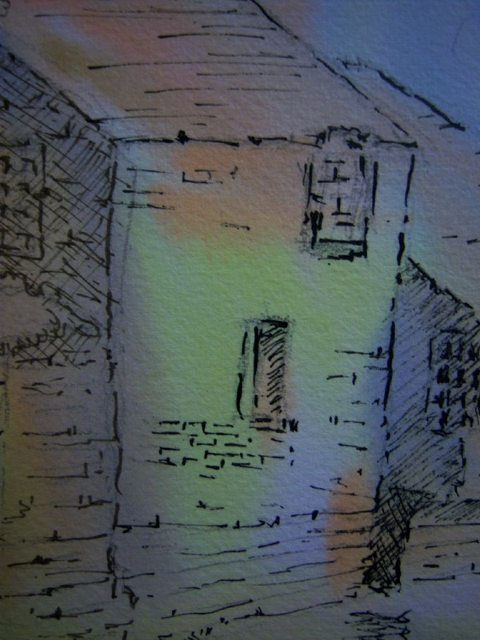
Ink work began with the chisel nib (1 at left) using an acrylic sepia ink that is now so old it appears almost black. A change to the curvy nib gives a subtle but influential difference to the line produced in the detail (2).
1
2

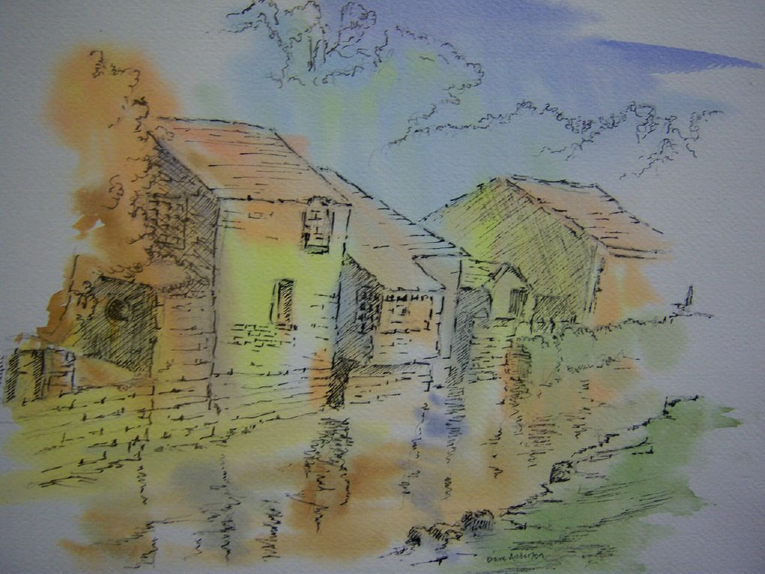

The picture was completed by inking in the rest of the image. Detail was lost as the image receded into the distance and some strong marks were used on the bank at right in the foreground to emphasise the recession into the distance.

