A Simple winter Scene
The appeal of this picture is its simplicity which will (hopefully) instil a sense of calm in the viewer. It relies on a lot of white paper and fairly stark trees in the foreground for its effect.
Palette: Cobalt Blue (CB), Raw Sienna (RS) and Permanent Rose (PR).
Paper: Arches 140lb Rough stretched on a board.
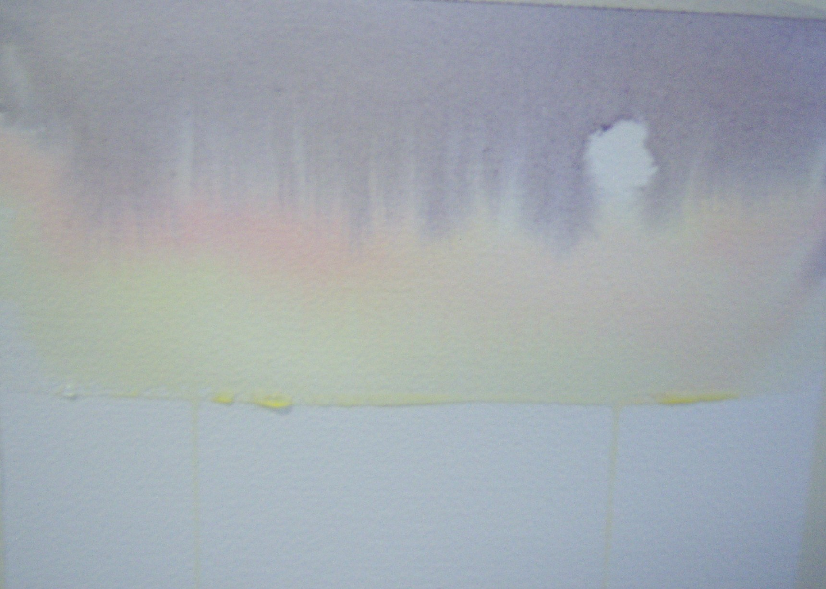
Stage One: With the board at a steep angle, the paper was well wetted with clean water for the top two-thirds or so. A small piece of kitchen paper was balled up and pressed gently onto the paper to dry out what would be the sun.
RS was painted across the paper in single strokes just level or slightly below the sun. Don’t go over the sun.
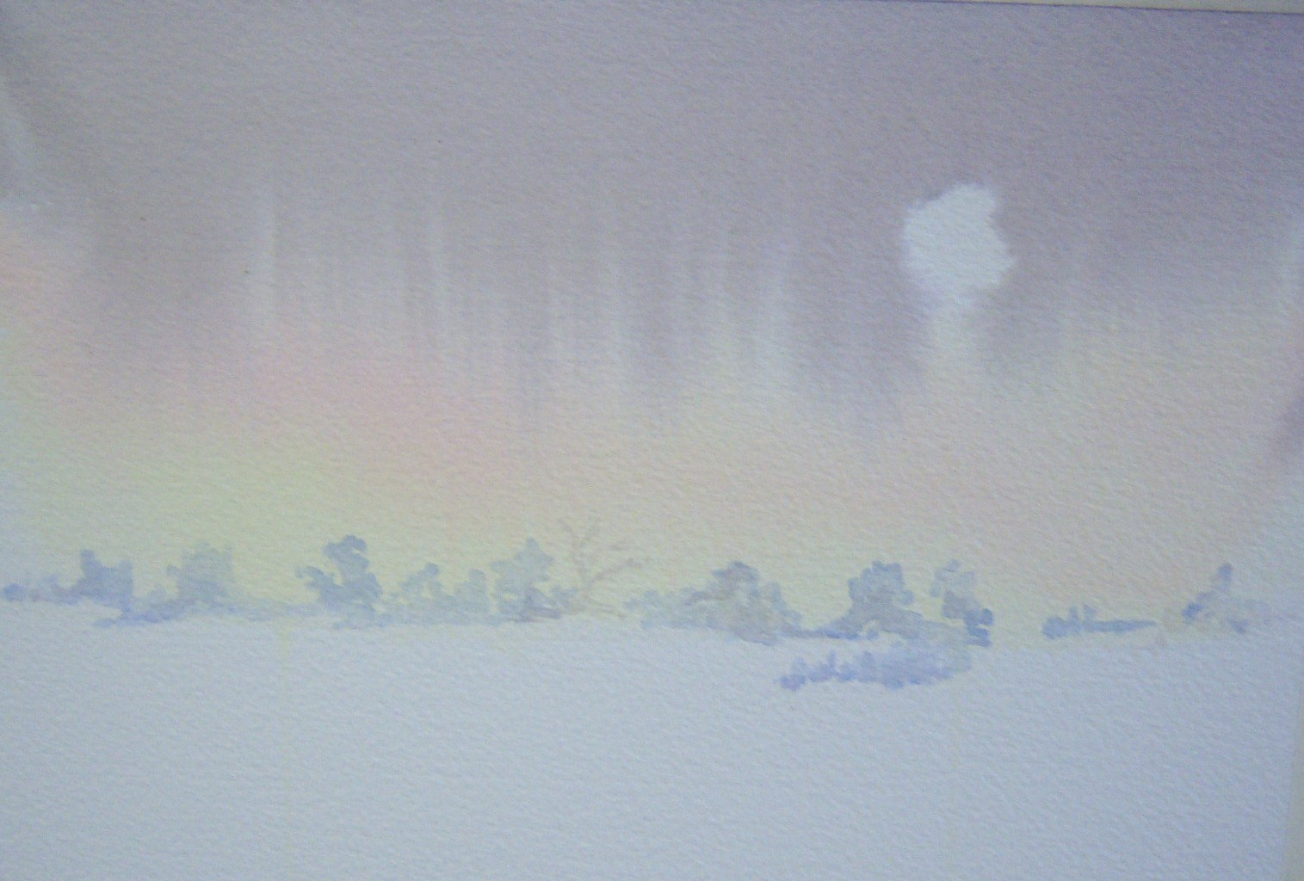
PR was streaked across below the sun. Finally a mix of the three colours (making a neutral grey) was struck across the paper at the top, this stroke was repeated and the grey descended into the RS and PR to give a ‘curtain fringing’. The sun remained dry and thus unpainted.
Stage Two: The painting was allowed to dry. Note that water and paint collect along the snowline and need to dabbed with kitchen paper or touched with a brush to prevent drips down through the snow. If a drip does occur, as in my painting, don’t panic, quickly dry up the drip with kitchen paper or a moist brush, gently washing with a little clean water if necessary.
The distant hedgerow was painted using CB on its own.
Stage Three:
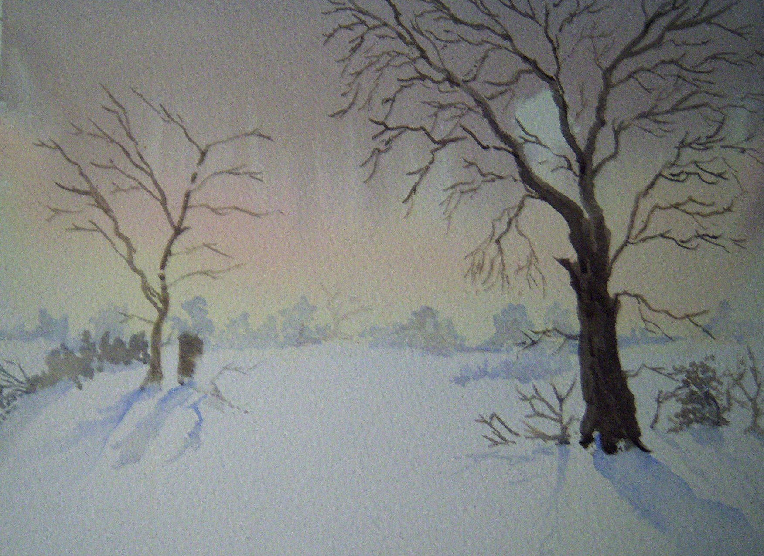
A grey was mixed from the three pigments with a bias towards the PR, giving a fairly stark brownish image. Trees and hedgerow were painted in the foreground and middle distance. It’s a good practice to start at the base of the tree, gradually decreasing pressure on the brush as it progresses away from the ground. This gives a tapering stroke for the branches. Finer branches/twigs were indicated with a rigger.
Finally shadows were indicated with CB alone, remembering to slant them away from the sun. This gave marks leading the eye into the picture towards the distant field edge.

